Friday 9th October 2020
Weekly Newsletter Update – WEEK 6
Dear Parent/Carer,
Welcome to the Week 6 edition of the CHPA newsletter. It is scary to think that it is only 2 weeks until the half-term break.
Covid updates
At this time, there are no updates to CHPA procedures regarding COVID. However, in light of the huge rise in cases within Sheffield, can I please remind you to remain as socially distant as possible, particularly if you are queueing to get into the site as part of pick-up or drop-off.
Although at this time there have been no further announcements regarding a local Sheffield lock-down, with increasing Covid numbers, this is becoming increasingly likely. With this in mind, Sheffield have produced an updated information sheet to support you in knowing what to do in the event of symptoms or a positive test outcome for your family (I also posted this via our social media accounts yesterday).
Should we be required to change or update any of our procedures, I will always provide you with as much notice as possible.
Start/Finish Times Reminder
A huge well done with how you have adapted to the new start and finish times. It did confuse a few people when it started but you have done really well with this, so thank you. As a reminder, these are the start and finish times –

Year Group | Start Time | End Time
Reception (Class 1 and Class 2) | 8:30am | 2:45pm
Year 1 (Class 3 and Class 4) | 8:40am | 2:55pm
Year 2 (Class 5 and Class 6) | 8:50am | 3:05pm
Year 3 (Class 7 and Class 8) | 8:30am | 2:45pm
Year 4 (Class 9 and Class 10) | 8:40am | 2:55pm
Year 5 (Class 11 and Class 12) | 8:50am | 3:05pm
Year 6 (Class 13 and Class 14) | 9:00am | 3:15pm
Staffing Updates
We are very lucky to have a great set of staff here at CHPA and it is with some sadness that I have to inform you that Miss Reid will be leaving us at Christmas. Miss Reid and her partner have been offered a life changing opportunity to live and work in another country and as a result, she will be leaving us at Christmas. We will miss you Miss Reid!!!
However, I am delighted to be able to tell you that following a recent interview process, we have appointed a new teacher for Class 6, so welcome to Miss Hilton. Miss Hilton joins us after a successful year at Birley Primary last year and we are really looking forward to her starting. Pupils in Class 5 and 6 have already met Miss Hilton as she has already started working with us to support pupil development. Parents of pupils in Class 6, Miss Hilton will be part of the upcoming parents evenings, so you will be able to meet her properly then.
As a result of Miss Reid leaving, Mr Stewart has been appointed the new English Lead following his great success in leading Maths over the last 2 years. Because of this, Mr Gabbitas has been appointed as the new Maths Lead. Good luck in your new roles gents.

Catch up classes
In order to address the learning gap that has developed during the lockdown period, we will be putting into place catch up booster classes for all year groups from Y1 to Y6. We are able to run these classes due to the additional funding schools across the country are being provided with to specifically address this issue. Upon their return in September, pupil were assessed to identify their individual and collective strengths and development points. This has allowed teachers to then plan sessions to address the required new learning, but importantly address and gaps in knowledge and understanding, whilst supporting them re-adjust to the return to CHPA life. Up to half term, teachers will be undertaking further assessments to identify how the gaps have closed and the next steps in pupil development.
To ensure maximum impact for these classes, we do not want to take time out of the normal CHPA day, as this would result in pupils missing other curriculum areas that remain very important. Therefore, as a result, these sessions will take place before and at the end of the CHPA day, with details to follow before half term. To ensure the highest quality of teaching and effective use of limited time within these sessions, CHPA staff will be delivering the learning. I understand that some schools are using supply agencies to do this, however we all feel, that as we know the pupils best, it is best that we deliver them.
After half term, the Y6 and Y1 classes will begin and at this time, we are hoping to have provision for 8 Y6 groups and 8 Y1 groups – however this will be confirmed.
Not all pupils will be invited to attend all sessions, as the idea of them is to address the lost learning during lockdown. Initial assessments indicate that there are a large number of pupils who we do need to support further through these classes, but there are also many pupils who have shown no adverse academic effects of lockdown to this point.
In the New Year, we will be undertaking classes for Y2 and then later in the year, classes for Y3, Y4, and Y5 will be arranged.
These classes have the potential to support huge impact due to the approaches we will employ and the number of staff able to support individuals and small groups – if invited, please support us by sending your child as required, as this helps them to be the best they can be!
Times Tables Rockstars & Bug Club
At CHPA we use TT Rockstars to support pupils with learning their times tables, through healthy competition with themselves and across the year groups, even staff are taking up the challenge.
Times tables knowledge is key knowledge that all pupils must have if they are to succeed in maths. From this year, all pupils in Y4 will take a national assessment to gauge their table’s knowledge and this will be reported upon in a similar way to SATs in Y2 and Y6.
Each week, teachers will be looking for to reward the fastest times-tables, the most improved times-tables and the person who has earned the most coins/stars.

During lockdown, we invested over £2,000 in Bug Club as a way for your child/children to read at home. Bug Club captures children’s imaginations nurtures lifelong readers as it develops word and reading comprehension skills. Reading is such an essential life skill and we want to instil a love of reading in our pupils. It is an expectation that every pupils reads at home at least 4 times a week.
Please see the embedded documents for more information about TT Rockstars & Bug Club and how to use them.
What have pupils been learning?
YR
We have settled in really well! The progress made has really amazed us and I know some parents have also commented favourably too. We have been reading the book 'Everywhere Bear' in our English lessons. This has inspired some lovely interpretation of the setting and performance of the story. Our topic this term 'What's that sound' has produced some fun listening and music performing activities.

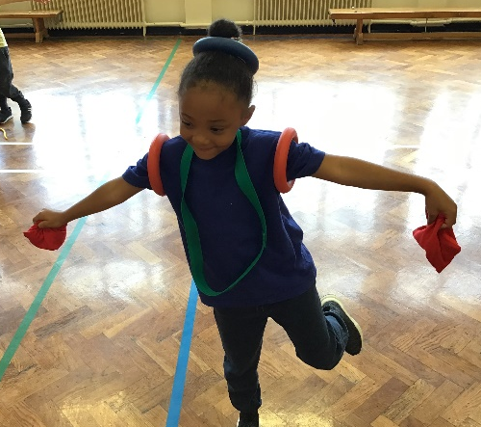
Y1
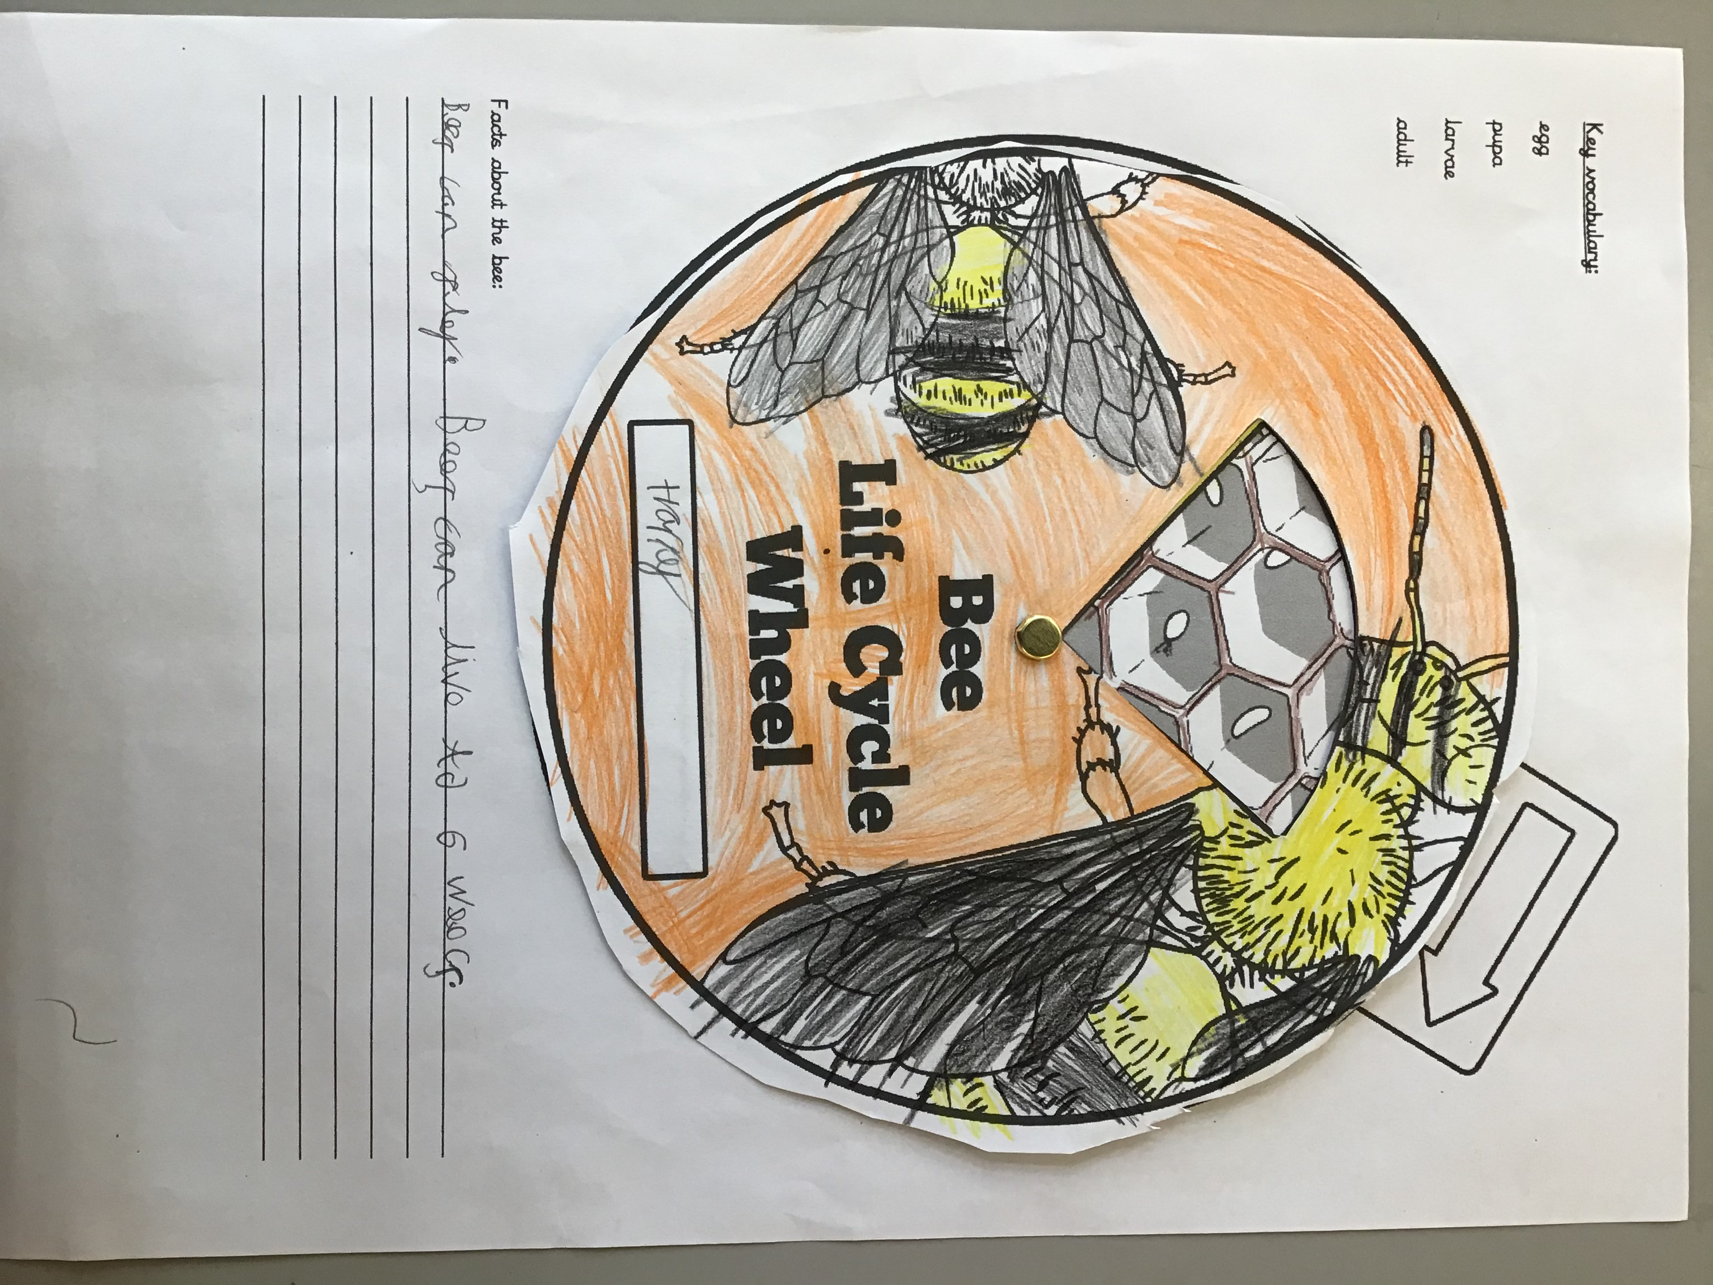
Year 1 have had a brilliant week! We have been comparing amounts and numbers in Maths from largest to smallest and used maths resources to support. The staff in Year 1 are extremely pleased with the children’s writing this week. We have been focusing on writing sentences in a diary entry for Traction Man. The children are really enjoying their Superhero topic and investigating Superhero powers.
Y2
Year 2 are having fun learning about minibeasts! We have focused on bees this week, looking at the life cycle of a bee, the hive and practising our ‘waggle dances’ that the bees perform in the hive, as part of PE. This has linked well with our English as we are reading ‘The Bee who Spoke’ by Al MacCuish and Rebecca Gibbon. We have written a letter to advise, a set of instructions and a diary entry. In Maths, we have been learning to partition numbers to 100 using different methods and comparing numbers. Our learning has progressed to addition, which we are now understanding fact families.
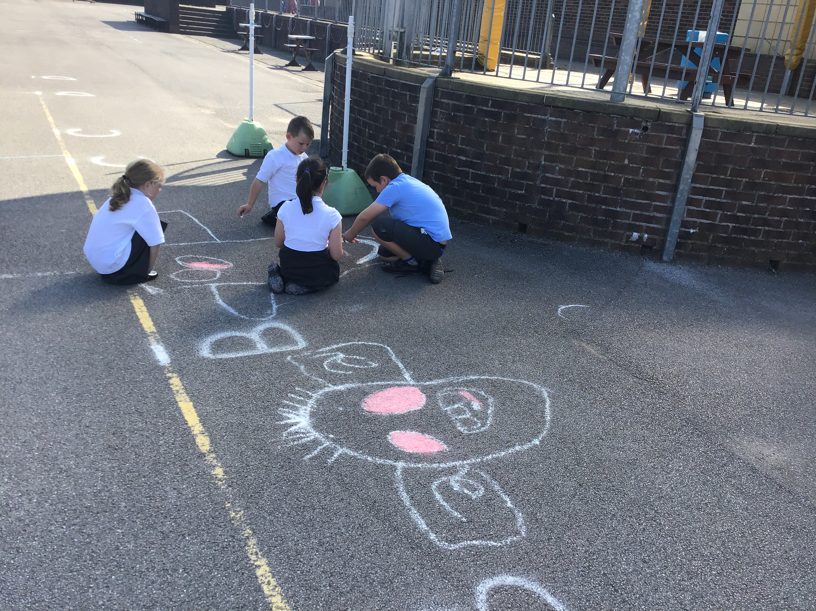
Y3
Year 3 have continued their great start to the year. We are learning more about the Iron Man each week and cannot wait to see if the farmers plan is successful! We have found Maths a little tricky but their resilience and perseverance has kept them going! In topic, we have continued to carry out a range of experiments in science linking to our theme of metals and forces. We have been having great fun along the way. The Iron Man has sparked some fabulous artwork too. Keep up the great work Year 3!
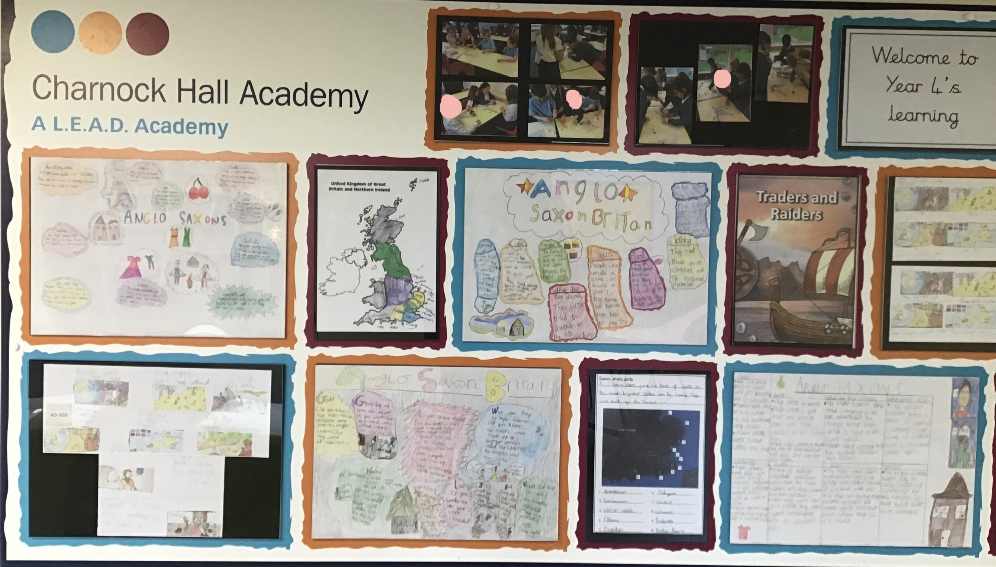
Y4
We have been really impressed with how the Y4’s have worked their way through this half term so far. They have been focussed, their learning behaviours have been great and they have produced work to a high standard. In Maths, we have been increasing our fluency of place value and applying it using reasoning and problem solving situations, and are now in a place to move on to addition and subtraction. While in English, we have been using the book ‘How to Train Your Dragon’ to influence our writing. The children have produced a character description, using a range of sentence types and vocabulary, putting their editing skills to good use and up levelling to produce final drafts. We are finishing the half term off by writing a non-fiction text about dragons from the same book. In Topic, we have been learning about the historical period where the Anglo-Saxons and Vikings ruled parts of Britain, placing events on a timeline and understanding how the rule of Britain changed during that time.
Y5
In English, we have been following the adventures of Sinbad. Using the new writing format, we have written a letter in role and practised using expanded noun phrases, similes, and varied range of punctuation to engage the reader. We have also written some poetry inspired by Sinbad and his adventures.

In Maths, we been focusing on ‘Place Value’ with a specific focus on rounding, ordering, and comparing numbers to 1,000,000.

This term our topic is pharaohs. We have researched how different pharaohs influenced ancient Egypt during their reign. We have discussed the actions of Howard Carter and considered whether he was right to open the tomb of the lost king, Tutankhamun and have studied the process of mummification.

Y6
We have made a good start to our work in Y6 during these challenging times, especially in English where Goodnight Mister Tom has been our focus, which has been great alongside our World War 2 topic. We are also continuing to develop our mathematical understanding, which has started to improve over this half term.
In English, we have written our own diaries from the perspective of Tom and we have also written postcards home from the perspective of William Beech based on our text – Goodnight Mister Tom.
As our cross-curricular topic, we have focussed on A Child’s War and produced some fabulous research-based work, especially on The Holocaust. We now need to focus more on being independent when producing and presenting our learning. As always, we encourage children in school to practice spellings and X tables focus weekly. This also needs to continue to be reinforced at home along with regular reading. Thank you again from the Y6 team for your support with this. We want our children to enjoy their learning at school and your continued support and communication really does help with this.
Break time Snacks
Since pupils returned to CHPA in September, I have been impressed with the number of pupils who are having healthy snacks each day at break-time. However, some are bringing in unhealthy snacks, including chocolate bars and crisps.
This week pupils have been given a reminder of the expectations around their snack choices but form Monday, if the snack choice isn’t healthy, pupil swill be asked to put it back in their bags. Healthy snacks include, fresh fruit, cheese, healthy cereal bars (not with a chocolate coating, fruit winders etc.). In YR, Y1 and Y2, fresh fruit is provided free of charge daily, so there is no need for pupils to bring anything else.
Also a reminder that water bottles should only be filled with water for in class use. At lunchtime, if pupils have a packed lunch, they can have a soft drink, but nothing fizzy, either in a glass bottle or can.
I hope that when we get back to more normality, we are hoping to develop a tuck shop, where pupils will be able to purchase healthy snacks at break times. Thanks for your support with this.
Pupil Photos
We are hoping to be able to have individual pupil photos taken. Mrs Lee is looking into this and when we have any updates I will let you know. Unfortunately, due to Covid, it is unlikely that family group shots will be able to be taken this year.
Poppy Appeal
In the lead up to Armistice Day on 11th November, from Monday, pupils will be able to purchase a poppy in support of the British Legion Poppy Appeal. These will be brought round to classes for pupils to purchase at play and lunchtimes. We have a very good record at supporting this charity, which does so much to support those who have given so much for us to be able to enjoy the lives and freedoms we have in this country today.
To ensure we protect against possible infection, we had a delivery of Poppy’s last week, so they have been held in quarantine ahead of them being sold. They will also be available for purchase at the end of the school day on the playground.
Flu vaccinations
Earlier this week, you will have received a communication via SchoolComms regarding the upcoming flu vaccinations. If you would like your child to receive a vaccination, then please follow the instructions to complete the online form and ensure you do this by the closing date. If you have not had this email, please contact the main office.
Parking issues at pick up and drop off
I am sure you will agree that congestion is much reduced due to the staggered start and finish times we are currently using. However, there are still some people who are inconsiderate with their parking and endangering the lives of our pupils. I have seen a number of people parking on double yellow lines, when only a few yards away there is Charnock Park or a safer space to park. I have also had communication from several local residents who have explained people are parking dangerously and blocking people’s drives.
In addition to this, there was an incident in the Charnock Park Car Park on Wednesday afternoon, where a silver VW Tiguan SUV has been badly dented by another vehicle. Sadly, the person who has dented the vehicle has not left any details. If you know anything about this incident, please contact me directly, so I can forward information on to the necessary people.

I implore you to please be considerate to those who live in the immediate vicinity of CHPA and to ensure you drive and park with care for all. In spite of the incident last week, with Charnock Park we have a superb parking facility, which very few schools have.
Social Media
If you are not yet following us on social media, please follow us on Twitter using @charnocklead as the handle and via our Facebook page Charnock Hall Academy. If you do request to make friends with CHPA on social media, please also send a message stating who your child is. With us all wearing masks, it is difficult to recognise faces and this will then make accepting friend requests easier and quicker.
Info from the PTA
Welcome back to CHPA from your PTA!
Over the past few months, we have been involved with the Y6 Leavers BBQ and the Easter Egg Competition. We’d like to say a big thank you to the White Lane Co-op for donating the egg participation prizes, which will be going out to those pupils who submitted their egg-cellent displays to our Facebook page back in the spring, in the next week.
Looking forward to this year, we have introducing a new and exciting fundraising project: Design your own Christmas cards. You should have received information about these through SchoolComms and a paper copy design sheet yesterday. Due to Covid restrictions, opportunities for further fundraising will be limited and that is why we really need your support with ideas. Please find the link to the letter sent out yesterday here -
This year, we are focusing on raising money to add to the TrimTrails in both the KS1 and KS2 playgrounds and also to provide other equipment and activities for pupils to use at break and lunch times.
The PTA will be holding its AGM on Monday 19 October at 10:05 (via Zoom). All parents / carers welcome! Parents who are new to CHPA, we would love to have you on board to support us – additionally, those who already have children at CHPA, we would love you on board to support us too! Please register your interest by sending us an email (pta@charnockhallacademy.co.uk). We also have a Facebook page and you can find us through the CHPA Facebook page https://www.facebook.com/SupportersofCHS.
Finally, if you have any ideas about activities or would like to get involved, please drop us an email.
Thanks
Jaime Waters (Chair) & the amazing CHPA PTA team.

Have a lovely weekend.
Take care and stay safe!
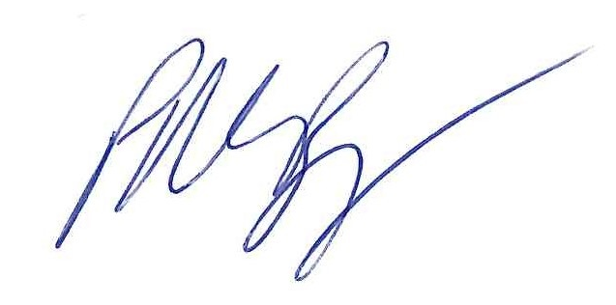
Mr P M Burgess & all the staff at CHPA
