Monday 25th November 2024

Dear Parent/carer,

I write to you with increasing concern in relation to the use of profanity and inappropriate racist language that we are beginning to hear more of from pupils.

This type of language is not accepted in any form at CHPA!

Unfortunately, we are getting increasing reports of this language being used within CHPA, on the playground and outside of CHPA, within the community. Only last week, there were number of occasions where we had to liaise with families due to profanity or the use of language that is racially driven in its content

This week in age appropriate assemblies with Mr Burgess and Mrs Fotheringham and within class sessions with teachers, pupils will be been spoken and more education given about use of appropriate language and how we speak to and treat other people, be that whilst at CHPA or in general life. It is imperative that we teach pupils to be well mannered, articulate and respectful of others and their use of language is an essential part of this.

As a parent myself, I understand that TV, social media, the news, attending some sports events, sociary in general at times, and other things children have access to can be difficult to manage, in order to protect them from hearing such language, however, it is imperative that we are all clear on what is and is not acceptable. I would appreciate it if you could also speak with your child/ren about this on a personal level to reinforce this message and that profanity and inappropriate language is not acceptable.

Such language is not taught or tolerated at CHPA, or any school and moving forward, if this is to continue, on a case-by-case basis,I will take the steps necessary disciplinary steps within my power as Headteacher to eradicate it.

Thnak you for your support and understanding in this matter.

Regards

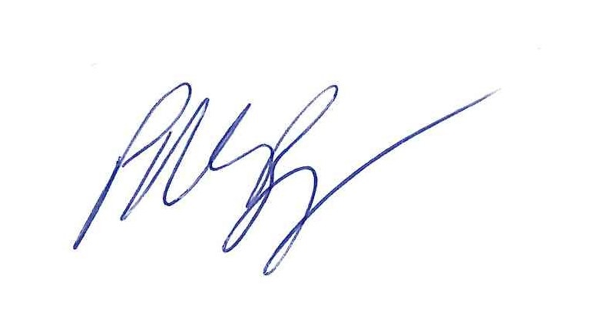

Mr P M Burgess

Headteacher