Monday 21st October 2024

Dear Parent/Carer

Disappointingly, I write this letter with sadness but out of necessity, in light of the recent conduct of a small number of parents and their actions towards CHPA staff.

As you are aware, it is the firm belief of all staff and I, that it is in the best interest of every pupil, for CHPA, home and pupilsto work together as a team. At times, CHPA and home may differ in our approaches to this, but the common goal remains the same.

Unfortunately, it has become apparent that some parents feel it is acceptable to be rude and at times aggressive to members of CHPA staff. I can categorically state that this **NOT ACCEPTABLE** in any circumstance. I am sure you would agree that all staff (no matter what profession they are in) have the right to come to work, to do a professional job (that they are good at) and in doing so feel safe, secure and respected. Something I am sure you would also expect in your own working environments.

As a result of this, I have instructed staff, if they feel they are in a situation in which they feel vulnerable or threatened, be this in person or via telephone, to remove themselves from that situation in order to keep themselves and their physical and mental health and well-being in order.

If your child tells you something about their day that you feel requires further clarification, then please speak to their class teacher in the first instance, if appropriate then a member of the Leadership team may also become involved. We are only too happy to help address any questions or clarification you may need as soon as practicably possible, in order that working relationships are positive and focused upon what is best for pupils. As we all know, pupils see things through their eyes, and as children between 4-11, they do not always interpret circumstances with full accuracy.

Unfortunately, staff have now spoken to me on on a number of occasions about how they have felt intimidated due to language and/or physical action by adults. You may be unaware, but parents do not have an automatic right to enter onto CHPA premises. The Governing Board give implied licence to parents to enter the CHPA premises to drop off and collect their children, to be invited in to CHPA to discuss matters relating to their children and their education in a calm and reasonable manner and to enjoy events organised by us, peacefully with other members of the CHPA community. However, as Headteacher and in conjunction with the Governing Board, we have the authority to withdraw that licence if it is felt that it is necessary for health and safety, or to ensure the efficient running of the academy.

This kind of decision is never taken lightly and any removal of licence is always the very last option, but as Headteacher and a Governing Board, we must always ensure the safety and well-being of everyone through a duty of care. This is something your employer should, and would, do for you in similar circumstance as part of this duty of care.

I look forward to long and positive future relationships with all parents and families and I am sure that for 99.99% of you, this news will come as something of a shock, and, as stated, this is a significant minority, but it cannot and will not be tolerated.

Yours sincerely

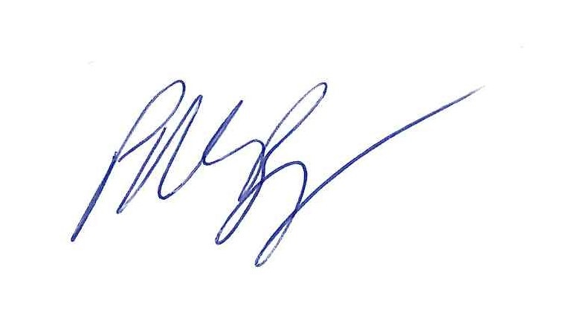

Luan Roper

P M Burgess L Roper

Headteacher Chair of Governing Board