**SEND**

**Information**

**Report**

Charnock Hall Primary Academy – Autumn 2024

Review frequency: Annual.

Approval: Full governing body or a committee of the governing body.

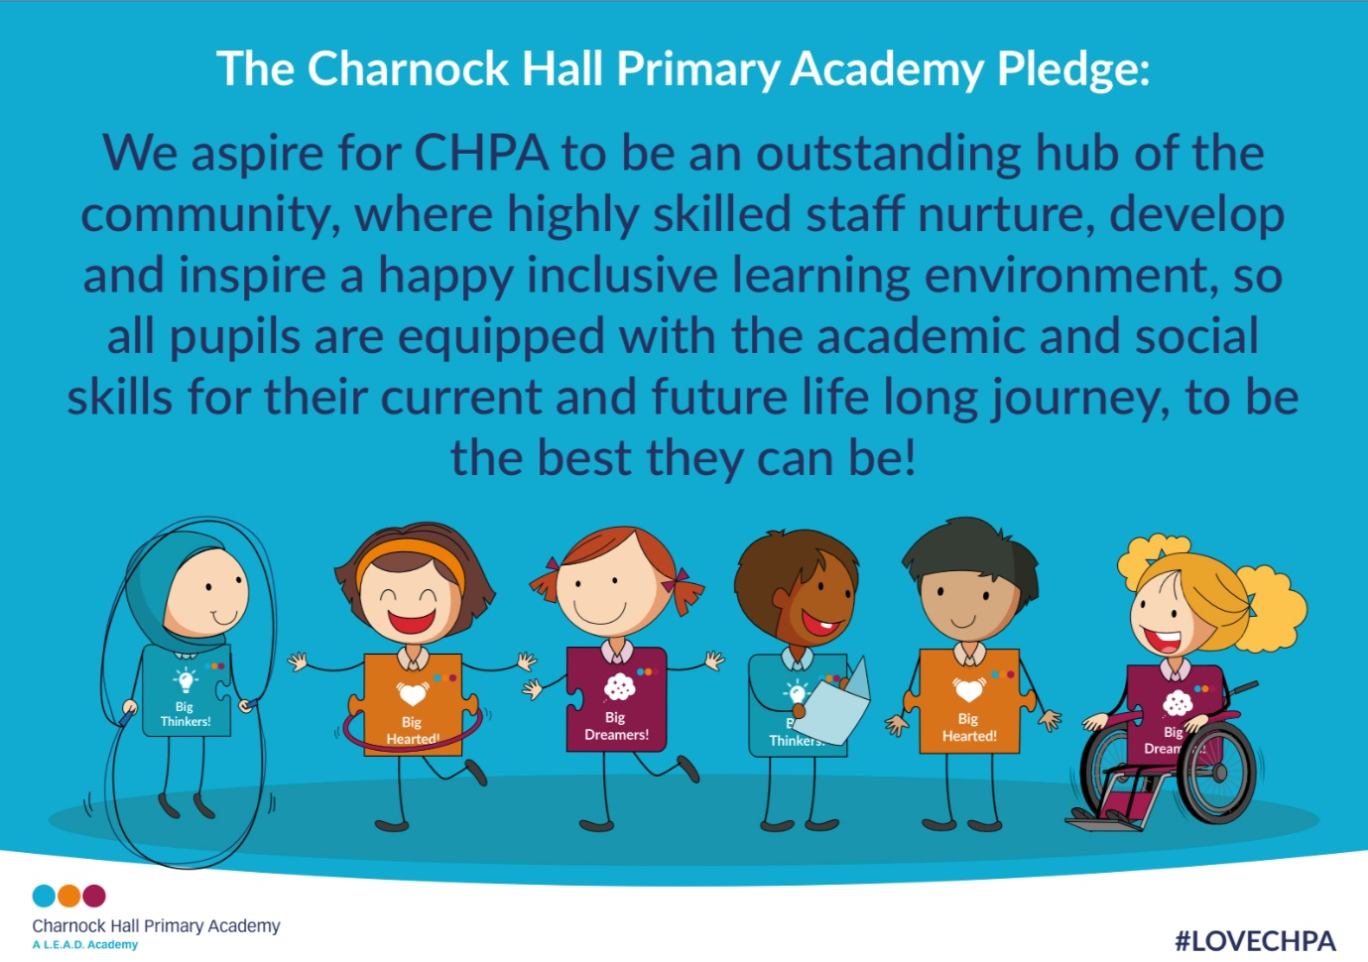

We maintain a strong ethos of inclusion at CHPA, which aims to provide fully for children across a range of special educational needs;

· Communication Difficulties

· Cognition and Learning

· Social, Emotional and Mental health difficulties

· Sensory and/or physical needs

The Special Educational Needs Code of Practice gives guidance to education settings that help to identify, assess and provide help for children with special educational needs. It sets out the processes and procedures organisations must or should follow to meet the needs of children.

Principles underlying the Code

The SEND Code of Practice describes the principles that should be observed by all professionals working with children and young people who have SEN or disabilities.

These include:

~ taking into account the view of children, young people and their families

~ enabling children, young people and their parents to participate in decision-making

~ collaborating with partners in education, health and social care to provide support

~ identifying the needs of children and young people

~ making high quality provision to meet the needs of children and young people

~ focusing on inclusive practices and removing barriers to learning

~ helping children and young people to prepare for adulthood

How will my child be welcomed into school?

We believe that every child is an individual and should be valued. At CHPA, we strive for all children to have their needs met and be given equal access to the curriculum. Our aim is to provide support to all children with Special Education Needs and/or Disability, whether this is through individual and/or small group provision, so they can reach their full potential and become the best they can be! We feel that their contribution to school life should be valued and we seek to build their self-esteem.

Who is involved?

**SENDCo & Assistant SENDCo**: Mrs Louise Fotheringham & Miss Laura Bingham

Responsible for:

• Coordinating all the support for children with special educational needs or disabilities (SEND) and developing the school’s SEND Policy to make sure all children get a consistent, high quality response to meeting their needs in school.

• Ensuring that you are:

~ Involved in supporting your child’s learning

~ Kept informed about the support your child is getting

~ Involved in reviewing how they are doing

• Liaising with all the other people who may be coming into school to help support your child’s learning e.g. Speech and Language Therapist, Educational Psychologist, etc.

• Updating the school’s SEND register (a system for ensuring all the SEND needs of pupils in this school are known) and making sure that there are detailed records of your child’s progress and needs.

• Providing specialist support for teachers and support staff in the school so they can help children with SEND in the school achieve the best progress possible.

• Monitoring the impact of policies and the effectiveness of provision in the school.

• Working with the Local Authority and External Consultants to implement and monitor our provision.

**Class Teacher**

Responsible for:

• The progress of your child and identifying, planning and delivering any additional help your child may need (this could be things like targeted work, additional support) and informing the SENDCo as necessary.

• Conducting 3 reviews per school year.

• Ensuring that all staff working with your child in school is helped to deliver the planned work/programme for your child, so they can achieve the best possible progress. This may involve the use of additional adults, outside specialist help and specially planned work and resources.

• Ensuring that the school’s SEND Policy is followed in their classroom and for all the pupils they teach with any SEND.

How we identify Special Educational Needs

All staff have a responsibility to ensure all pupils at CHPA are achieving their potential, are secure and happy. Any concerns a staff member may have regarding barriers to learning are discussed with the SENDCo. Early intervention and continual tracking of progress are key to identifying SEND and ensuring children are supported at the first opportunity to ensure the best possible progress. We do this through the following systems:

* Baseline data on entry to Foundation Stage 2 (Reception) is discussed by the head teacher, class teachers and SENDCo to identify any pupils with potential SEND.
* Half termly pupil progress meetings to identify children with a potential barrier to learning.
* Termly SEND reviews.
* SENDCo tracks data half termly of all children.

Once a child is identified as having a potential SEN it is the SENDCo’s responsibility to observe, advise class teachers, discuss with parents or refer to external agencies if necessary.

What will happen if my child does have SEND?

The school will follow a graduated approach to your child’s learning. It will follow the sequence of -Assess, Plan, Do, Review. This way we can ensure that the school is meeting your child’s needs.

Children with specific barriers to learning, that cannot be overcome through whole class good and outstanding teaching (Quality First Teaching) and intervention groups, will be supported through the following:

• Assessments can be carried out in school. We have range of assessments for maths, reading, phonics, speech and language and mental health. If necessary, referrals will be made to outside agencies to advise and support the school in enabling your child to make progress.

• Before referrals are made you will be asked to come to a meeting to discuss your child’s progress and help plan possible ways forward. You may also be asked to complete an Extended Support Plan (ESP) document with the SENDCo and class teacher which will outline your child’s strengths, needs and outline the provision we can provide in school.

• If your child is not making expected progress it may be necessary to assess using a small steps tracker to identify and monitor small steps of progress (Birmingham Toolkit). If it is agreed that the support of an outside agency is a way forward, you will be asked to give your permission for the school to refer your child to a specialist professional e.g. a Speech and Language Therapist or Educational Psychologist. This will help the school and yourself understand your child’s particular needs better.

How will teaching be adapted to meet the needs of my child?

All children receive class teacher input via good and outstanding classroom teaching:

• The teacher will have the highest possible expectations for your child and all pupils in their class.

• All teaching is based on building on what your child already knows, can do and understands.

• Putting in place different ways of teaching so that your child is fully involved in learning in class. This may involve things like using more practical learning or providing different resources adapted for your child.

• All lessons are planned to meet the needs of your child and the class.

• Grouping of ability, mixed and independent work is used to support all pupils.

• Specific strategies (which may be suggested by the SENDCo or staff from outside agencies) to enable your child to access the learning task.

How do we know provision is effective?

We use robust monitoring systems to ensure we are adapting provision to enable pupils with SEND to make good progress. The progress of pupils with SEND is tracked half termly and discussed by the class teacher and Senior Leadership team, including the SENDCo at Pupil Progress Meetings. Pupils and parents have the opportunity to discuss progress at the termly SEND reviews. Where concerns about progress are raised, adaptations to provision will be made, sometimes involving external agencies. Progress during extra interventions is discussed weekly by Teachers and Teaching Assistants and records of progress is kept in files in the classroom. The SENDCo analyses assessment data at the start and end of interventions to ensure they are effective in boosting children’s attainment.

What skills do the staff have to meet the needs of my child?

• The SENCO’s job is to support the class teacher in planning for children with SEND.

• The Academy has an Academy Improvement Plan, including identified training needs for all staff to improve the teaching and learning of children, including those with SEND. This may include whole school training on SEND issues or to support identified groups of learners in school, such as Attention Deficit Hyperactivity Disorder (ADHD), Speech & Language and dyslexia.

• We have whole staff training to disseminate knowledge, strategies and experience, to ensure consistency of the school’s approach for children with an SEND.

• Individual teachers and Teaching Assistants attend training courses run by outside agencies that are relevant to the needs of specific children in their class.

How will I know how my child is getting on?

At CHPA your child’s progress is continually monitored by their class teacher, SENDCo and the Leadership Team.

• Each half term class teachers submit data about their children to the Senior Leadership Team which is tracked. This is then discussed in Pupil Progress Meetings.

• If your child is in Year 1 and above, but is not yet at National Curriculum levels, a more sensitive assessment tool is used which shows their level in more detail and will also show smaller but significant steps of progress.

At the end of each Key Stage (Year 2 and Year 6) all children are required to be assessed, Year 6 using Standard Assessment Tests (SATS) and Year 2 through Teacher Assessment. This is something the government requires all schools to do and the results are published nationally.

• Children on the School SEND register will have 3 reviews per year. In these reviews targets will be reviewed and set for your child.

• The progress of children with an Educational Health Care Plan (EHCP) is formally reviewed at an Annual Review with all adults involved with the child’s education.

• The Leadership Team and SENDCo will also check that your child is making at least good progress with any individual learning and in any group that they take part in.

• A range of ways will be used to keep you informed, which may include:

~ Home Learning Journals

~ Parents evenings

~ Additional meetings as required

~ Termly reports

~ Positive books- link between school and home

Accessibility for pupils with a disability

Access arrangements for pupils with a physical or sensory disability are made as and when needed. Disabled access toilets and changing facilities are available in school.

What extracurricular activities can my child access?

• We make sure activities outside the classroom and school trips are available to all.

• Risk assessments are carried out for each trip and suitable numbers of adults are made available to accompany the pupils, with 1:1 support if necessary.

• Parents and carers are invited to accompany their child on a school trip if this ensures access.

• After school clubs are available to all pupils. Adjustments will be made to support their participation.

• Health and safety audits will be conducted as and when appropriate.

What if I think my child needs more help than the school can provide?

If you or the school believe that your child needs more support than the current provision set in place either you or the School can request that the Local Authority carry out a statutory assessment of your child’s needs. This is a legal process and you can find more details about this in the Local Authority (LA) based Local Offer (<https://www.sheffielddirectory.org.uk/localoffer>)

After the school have sent in the request to the Local Authority (with a lot of information about your child, including some from you), they will decide whether they think your child’s needs (as described in the paperwork provided), seem complex enough to need a statutory assessment. If this is the case they will ask you and all professionals involved with your child to write a report outlining your child’s needs. If they do not think your child needs this, they will ask the school to continue with the support they are providing.

After the reports have all been sent, the Local Authority will decide if your child’s needs are severe, complex and lifelong and that they need more support in school to make good progress. If this is the case they will write an Educational Health Care Plan (EHCP). The EHCP will outline support your child will receive from the LA and how the support should be used and what strategies must be put in place. It will also have long and short term goals/outcomes for your child.

This may be used to support your child with whole class learning, individual programmes or small groups. Each child’s plan will vary depending on the needs of the child and the targets set in the EHCP. We may be able to offer in-house programs like: Speech and Language Therapy, Lego therapy etc through the Inclusion team. We will always use the advice of external agencies e.g. an Educational Psychologist to help develop and review each child’s needs.

How will school help manage transitions into school, into a new class or into a new school?

We recognise that transitions can be difficult for a child with SEND and take steps to ensure that any transition is as smooth as possible.

If your child is moving to another school:

~ We will contact the school SENDCo and ensure that they know about any special arrangements or support that need to be made for your child.

~ We will make sure that all records about your child are passed on as soon as possible.

When moving classes in school (usually to the next year group):

~ Information will be passed on to the new class teacher in advance and in most cases, a planning meeting will take place with the new teacher.

~ All SEND Support plans will be shared with the new teacher.

~ Depending on the needs of the child, a visit to their new classroom can be arranged to help them to get to know their new environment.

~ Relationship building work with their new teacher can be organised before the summer holidays

~ Books can be made containing photographs of the child’s new teachers, classroom, etc for your child to take home with them over the summer holidays so that they can become familiar with everything whilst they are not in school.

~ Provision maps and SEND registers will be given and additional meetings with the SENDCo will be had before the summer holidays.

• When moving into CHPA during the academic year:

~ We will meet with you and your child to discuss their needs and decide how to best transition into our school.

~ We will liaise with previous school SENDCo to discuss the provision and obtain records from external agencies.

• In Year 6:

We fully support parents and carers in making decisions about the secondary school they choose for their children and work with them to ensure the smooth transition from KS2 to KS3 is smooth.

~ The SENDCo will meet or speak over the phone to the SENDCo of their secondary school, and arrange additional meetings with parents if necessary.

~ Your child will have opportunities to learn about aspects of transition to support their understanding of the changes ahead.

~ Where possible your child will visit their new school on several occasions and in some cases staff from the new school will visit your child in this school.

If you have any further queries please contact: Mrs Louise Fotheringham or Miss Laura Bingham

Telephone: 0114 2396083

Email: louisefotheringham@charnockhallacademy.co.uk

laurabingham@charnockhallacademy.co.uk

Link to the local offer: <https://www.sheffielddirectory.org.uk/localoffer>