Geography (strand: practical) Essential Skills and Knowledge EYFS to Y6
Aspect |  | KS1 |  | Lower KS2 |  | Upper KS2
 | YR | Y1 | Y2 | Y3 | Y4 | Y5 | Y6
Locational Knowledge:  Positioning  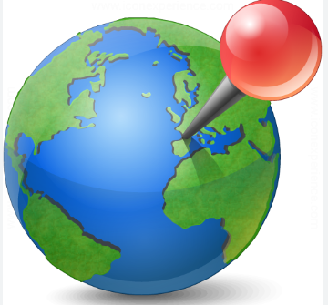 | Can find the UK. | Name and locate and identify the characteristics of the four countries of the UK including the capital city London. | Name and locate the world’s seven continents and five oceans.  Name, locate and identify characteristics of the four countries and capital cities of the  United Kingdom and its surrounding seas. | Locate the world’s countries, using maps to focus on Europe (including the location of Russia) concentrating on their environmental regions, key physical and human characteristics, countries, and major cities.  Name and locate and describe counties and cities in the United Kingdom. | Locate the world’s countries, using maps to focus on North and South America, concentrating on their environmental regions,  key physical and human characteristics, countries, and major cities.  Name and locate counties and cities of the United Kingdom, geographical regions and key topographical features (including hills, mountains, coasts and rivers). | Identify the position and significance of the Prime/Greenwich Meridian and time zones (including day and night).  Name and locate counties and cities of the United Kingdom, geographical regions and their identifying human and physical characteristics. | Identify the position and significance of latitude, longitude, Equator, Northern  Hemisphere, Southern Hemisphere, the Tropics of Cancer and Capricorn, Arctic and  Antarctic Circle, the Prime/Greenwich Meridian and time zones (including day and night).  Name and locate counties and cities of the United Kingdom, geographical regions and  their identifying human and physical characteristics,  and understand  how some of these aspects have changed over time
Place Knowledge:  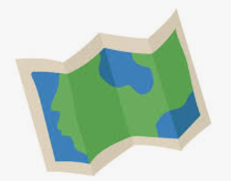 |  | Name the four countries of UK | Name the four countries and capital cities of the  United Kingdom and its surrounding seas. | Name counties and cities in the United Kingdom.  Name the world’s countries, using maps to focus on Europe (including the location of Russia) | Name the world’s countries, using maps to focus on North and South America, concentrating on their major cities.  Name counties and cities of the United Kingdom. | Name counties and cities of the United Kingdom. | .
Human and Physical Geography:  Vocabulary  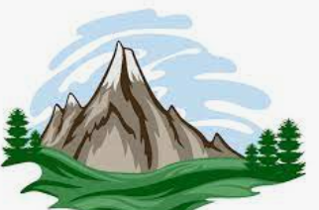 | Use simple geographical vocabulary. | Use basic geographical vocabulary to name physical and human features of familiar places. | Use geographical vocabulary to name features of familiar and unfamiliar places. | Use technical and geographical vocabulary to describe geographical processes. | Explain views on a geographical issue using appropriate vocabulary. | Ask and answer geographical questions using correct geographical vocabulary. | Present findings both graphically and in writing using appropriate vocabulary.
Human and Physical Features | Investigate the weather. | Identify seasonal and daily weather patterns in the United Kingdom. | Identify the location of hot and cold areas of the world in relation to the Equator and the North and South Poles. | Describe and understand key aspects of physical geography, including: climate zones, and vegetation belts, rivers, volcanoes and earthquakes, and the water cycle. Describe human geography, including types of settlement and land use. | Describe and understand key aspects of: physical geography, including:, rivers,  mountains, climate and the water cycle.  Describe human geography, including types of settlement and land use and water systems. | Describe and understand key aspects of: physical geography, including climate zones and biomes.  Describe human geography, including: land use, trade links, and the distribution of natural resources including energy,  food, minerals and water. | Describe and understand key aspects of: physical geography, including: climate zones and biomes. Describe human geography, including economic activity and the distribution of natural resources including energy, food, minerals and water.
Perspectives  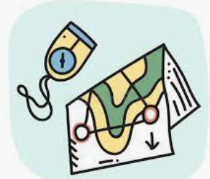 |  | Use aerial photographs and plan perspectives to recognise landmarks and basic human and physical features. | Study aerial photographs and plan perspectives to recognise landmarks and basic human and physical features.
Mapping | Draw simple maps | Draw a simple picture map labelling particular features. | Draw simple maps or plans using symbols for a key.
Using maps  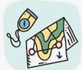 | Investigate globes and atlases. | To use world maps, atlases and globes to identify the United Kingdom and its countries. | Use world maps, atlases and globes to identify the United Kingdom and its countries, as well as the countries, continents and oceans studied at this key stage. | Analyse maps, atlases, globes and digital/computer mapping to locate countries and describe features studied. | Study and draw conclusions about places and geographical features using a range of geographical resources, including maps, atlases, globes and digital mapping. | Analyse and compare a place, or places, using aerial photographs. atlases and maps. | Use satellite imaging and maps of different scales to find out geographical information about a place.
Field work | Complete observations of their local environment. | Name, describe and group features of the home/school environment from first hand observation, responding to simple questions. | Name, describe and compare human and physical features of their own locality and another named place, asking and responding to questions. | Observe, n=measure and record the human and physical features in the local area responding to a range of geographical questions. | Propose geographical questions, collecting and recording specific evidence to answer them. | Choose the best method of recording observations and measurements, including sketch maps, plans, graphs and digital technologies. | Describe and explain geographical processes observed including taking accurate measurements and representing these in text, graphs and spreadsheets.
Research  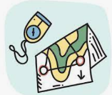 |  | Use maps, pictures and stories to find out about different places. | Use information texts and the web to gather information about the world’s human and physical geography. | Locate appropriate information needed for a task, from a source material. | Suggest which source material to use for a specific task, locating the information needed. | Use search engines, index, contents and other techniques to locate and interpret information. | Use search engines, index, contents and other research techniques to locate and interpret information identify gaps in information collated and suggest ways of finding it.
Direction | Use simple positional language. | Use simple locational language including in front, behind, next to, far away and near to, to describe the location of geographical features on a map and in fieldwork. | Use compass directions (North, South, East and West) to describe the location of geographical features and routes on a map. | Use the eight points of a compass to describe the location of a country or geographical feature. | Use the eight points of a compass, four grid references, symbols and key  (including the use of Ordnance Survey maps) to build their knowledge of the United  Kingdom and the wider world | Use the eight points of a compass, four and six-figure grid references, symbols and key  (including the use of Ordnance Survey maps) to build their knowledge of the United Kingdom and the wider world. | Use the eight points of a compass, four and six-figure grid references, symbols and key (including the use of Ordnance Survey maps) to build their knowledge of the United Kingdom and the wider world.
Data |  | Collect data during fieldwork such as the number of trees / houses. | Collect and organise simple data from fieldwork. | Analyse data which they have collected from first hand observations and experiences, identifying any patterns. | Collect and analyse data from first and second hand sources identifying and analysing patterns and suggesting reasons for them. |  | Analyse and present more complex data from different sources suggesting reasons why it may vary.

