May 2025

Dear new Parent/Carer,

We cannot wait until your child starts with us at CHPA and to ensure that transition is smooth, please see below information about uniform expectations and additional items pupils we recommend that pupils bring with them.

The aim of our approach to uniform CHPA is committed to –

* promoting equality
* ensuring value for money
* ensuring that no pupil is discriminated against due to their religion or belief, economic circumstances, or social and cultural background.
* committed to developing our pupils’ sense of belonging to our academy.

We believe that wearing a smart and practical uniform allows all children, regardless of their backgrounds, to feel equal to their peers and confident in their appearance. It is important for pupils to wear clothing that is conducive to a successful learning environment, including activity-appropriate clothing, such as sports attire.

CHPA has a duty to make sure that the uniform we require is affordable, in line with statutory [guidance](https://www.gov.uk/government/publications/cost-of-school-uniforms/cost-of-school-uniforms) from the Department for Education on the cost of school uniform.

We understand that items with distinctive characteristics (such as branded items, or items that have to have a school logo or a unique fabric/colour/design) cannot be purchased from a wide range of retailers and that requiring many such items limits parents’ ability to ‘shop around’ for a low price.

We will make sure our uniform:

* Is available at a reasonable cost
* Provides the best value for money for parents/carers

We will do this by:

* Carefully considering whether any items with distinctive characteristics are necessary
* Limiting any items with distinctive characteristics where possible
* Considering cheaper alternatives to school-branded items, such as logos that can be ironed on, as long as this doesn’t compromise quality and durability
* Avoiding specific requirements for items pupils could wear on non-school days, such as coats, bags and shoes
* Keeping the number of optional branded items to a minimum, so that the academy’s uniform can act as a social leveler
* Avoiding different uniform requirements for different year/class/house groups
* Avoiding different uniform requirements for extra-curricular activities
* Considering alternative methods for signaling differences in groups for interschool competitions, such as creating posters or labels
* Making sure that arrangements are in place for parents to acquire second-hand uniform items
* Avoiding frequent changes to uniform specifications and thereby minimising the financial impact on parents of any changes
* Consulting with parents and pupils on any proposed significant changes to the uniform policy and carefully considering any complaints about the policy

|  |  |  |
| --- | --- | --- |
| **Item** | **Purchased From** | **Other Notes** |
| Blue sweatshirt/jumper/cardigan | Available from We Do Workwear with a school logo, or **plain** from any high street shop | Orders can be made directly to We Do Workwear - |
| Plain white or sky blue polo shirt | Available from We Do Workwear with a school logo, or **plain** from any high street shop | Orders can be made directly to We Do Workwear |
| Grey/Black trousers or skirt | Available from any high street shop | Tracksuit bottoms, joggers or jeans are not acceptable |
| Grey/Black tailored shorts | Available from any high street shop | Leggings, Sports shorts are not acceptable |
| Gingham style dress/playsuit (blue & white checked) | Available from any high street shop |  |
| Black smart shoes/trainers | Available from any high street shop | No brand logos or coloured shoes.  Fitted sandals can be work in the summer months. No Crocs, Ugg style footwear or flip-flops. |
|  |  |  |
| PE Kit | We have a set (T-shirt/shorts/PE bag) available to buy from We Do Workwear, or available from any high street shop | Orders can be made directly to We Do Workwear - |
| Black plain shorts | Available from any high street shop | No brand logos |
| Plain t-shirt | Available from to buy from We Do Workwear or any high street shop | These are in one of the CHPA colour teams –  Red – Don  Blue - Sheaf  Green - Rother  Yellow – Loxley  No brand logos. |
| Plain PE Hoodie | Available from to buy from We Do Workwear or any high street shop | These are in one of the CHPA colour teams –  Red – Don  Blue - Sheaf  Green - Rother  Yellow – Loxley  No brand logos.  For when weather is colder |
| Black plain tracksuit bottoms | Available from to buy from We Do Workwear or any high street shop. | No brand logos.  For when weather is colder |
| Trainers/plimsolls | Available from any high street shop |  |
| Book Bag | Available from to buy from We Do Workwear or any high street shop | This is not a requirement to have, and parents may choose to only use a school bag/rucksack. |
| Extra pair of old shoes / Wellies |  | During the winter, we try to utilise the field as much as possible. If parents’ wish to send a pair of old shoes for the pupils to keep at school, and don’t mind them getting dirty, then they may. |
| Swimming (Y5) | Swimming costume – one piece  Trunks – no shorts allowed | Pupils go swimming in Y5. |
| All in one suit / wellies | Any colour | If possible, we like Early Years pupils to have an all-weather suit and wellies, so they can access the outdoor learning environment throughout the year. |
| Earrings- small stud earrings |  | Earrings are not permitted to be worn at any time.  In the event that they are worn, tape is used to cover them. |
| Jewellery |  | No other jewelry is permitted other than a wrist watch. |
| Make-up & false nails |  | No false nails, make-up (including nail varnish) is permitted |
| Hairstyle |  | No extreme haircuts or colours are permitted. |

## We recommend that pupils have a water bottle (with their name on). We have a water fountyain at CHPA that pupils can use to refill their bottle during the day.

## **Jewellery**

On health and safety grounds, we do not allow children to wear jewellery at CHPA. The exceptions to this rule is a wrist watch/fit bit as this supports the development of life skills. All other types of jewellery are not permitted to be worn by pupils.

## **Make-up**

Make-up of any kind/type is not permitted to be worn by pupils. (Where there is a need based upon medical grounds, this should be discussed with the Headteacher).

Perfume/Aftershave/Cologne or any similar product is not permitted to be worn as it can cause distraction to other pupils and these scents can cause issues for individuals who may be allergic to them and this could also affect pupils with SEND sensory needs.

As appropriate to their individual physical development, some pupils may need to wear deodorant. This is acceptable for hygiene reasons, but should, where possible, be fragrance free.

Lip balm is permitted in the event that it is needed. However, these should be scent and colour free.

Where pupils do attend CHPA wearing make-up, we reserve the right to require the pupil to remove this. Where they are not able to do this independently, you will be contacted to attend immediately, to support your child in removing this.

**The role of parents and carers**

We ask all parents and carers who send their children to CHPA to support this uniform approach. We believe that parents and carers have a duty to send their children correctly dressed and ready for their daily learning. Parents and carers should ensure that their child has the correct uniform, and that it is clean and in good repair.

If any parent would like CHPA to modify the uniform policy, they should make representation, in the first instance, to the Headteacher. CHPA welcomes children from all backgrounds and faith communities. If there are serious reasons, e.g. religious objections, why parents and carers want their child to wear clothes that differ from the CHPA uniform, we will look at such requests on an individual basis. Similarly, should an item of CHPA uniform prove problematic for a pupil with disabilities, then parents and carers are invited to draw this to the attention of the Headteacher.

In addition to this, during the warmer periods, it would be beneficial that pupils have the following items with them –

* Sun cream (they must be able to apply this themselves)
* Hat
* Some pupils bring sun glasses and/or a mini fan. Both of these are fine, but are the responsibility of pupils.

We understand that due to the cost of living, uniform can become expensive and with this in mind, the amazing CHPA_PTA has set up outr very own Uniform Swap Shop, where branded uniform can be taken for a small donation, or swapped for uniform in good condition that may have been grown out of.

Finally, PLEASE ensure that all items of uniform have names clearly written in them. This will make it much easier, in the event of a pupil losing an item, that it can be quickly returned.

I look forward to your support in this matter.

Regards

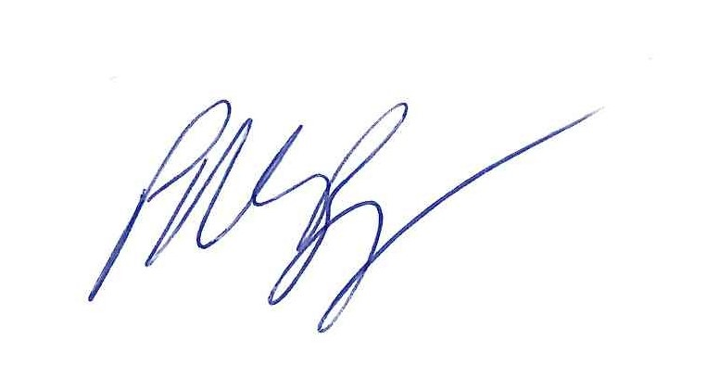

Mr P M Burgess

Headteacher