

L.E.A.D. ACADEMY TRUST
Attendance Policy

Policy/Procedure management log
Document name | Attendance Policy
Date approved | Trust approval – September 2025  CHPA AGB Approval – 3.12.25
Date issued | September 2025
Date of review | September 2026

Introduction

This statement sets out the legal framework, the definitions and our policy expectations.

The L.E.A.D. Academy Trust requires this policy to be implemented by all its member academies.

The policy makes the expectations for attendance management explicit in order to ensure consistency of practice across the network of academies. The L.E.A.D. Academy Trust’s aim is for all of its academies to be calm, orderly, safe, and supportive environments where all pupils want to be in school and are keen and ready to learn.

The L.E.A.D. Academy Trust defines the policy expectation, but the responsibility for implementation of the policy rests with the Headteacher of each academy.

Cross Reference: Safeguarding Policy, Behaviour Policy, SEND policy

Legislative Framework

This policy meets the requirements of the working together to improve school attendance from the Department for Education 2024 (DfE), and refers to the DfE’s statutory guidance on school attendance parental responsibility measures. These documents are drawn from the following legislation setting out the legal powers and duties that govern school attendance:

Part 6 of The Education Act 1996
Part 3 of The Education Act 2002
Part 7 of The Education and Inspections Act 2006
The School Attendance (Pupil Registration) 9England) Regulations 2024
The Education (parenting contracts and Parenting Orders) Regulations 2007
The Education (Penalty Notices) (England) (Amendment) Regulations 2007 (and 2013 amendments)
The Crime and Disorder Act 1998
The Anti-Social Behaviour Act 2003
The Sentencing Act 2020
The Children’s and Young Persons Acts 1933 and 1963
The Equality Act 2010

Procedures for attendance management implemented by individual academies will be operated in a positive way, reflecting the high expectations of all within the academy community.

All staff are responsible for promoting and establishing good attendance in Trust academies. It is important that all staff are consistent and proactive in rewarding good attendance, and in dealing with poor attendance.

Trust Expectations of Academies

To manage and improve attendance effectively, the Trust expects every academy to:
- Have a clear attendance policy which all staff, pupils and parents understand. The policy must include:

- Attendance and punctuality expectations of pupils and parents, including:
  - start and close of the day
  - register closing times
  - processes for requesting leaves of absence
  - processes for informing the school of the reason for an unexpected absence.

- The name and contact details of the Senior Attendance Champion responsible for the strategic approach to attendance.
- Information and contact details of staff who pupils and parents should contact about attendance on a day to day basis (such as a form tutor, attendance officer etc) and for more detailed support on attendance (such as a head of year, pastoral lead or family liaison officer etc).
- Information regarding day to day processes for managing attendance, for example first day calling and processes to follow up on unexplained absence.
- How the academy is promoting and incentivising good attendance.
- The strategy for using data to target attendance improvement efforts to the pupils or pupil cohorts who need it most.
- The strategy for reducing persistent and severe absence, including how access to wider support services will be provided to remove the barriers to attendance and when support will be formalised in conjunction with the local authority.
- Details of the National Framework for Penalty Notices and when Notices to Improve, penalty notices or other legal interventions will be sought if support is not appropriate (e.g. for a holiday in term time), not successful, or not engaged with. Details regarding how attendance expectations are set for all pupils, the attendance policy should account for the specific needs of certain pupils and pupil cohorts. The policy should be applied fairly and consistently but in doing so schools should always consider the individual needs of pupils and their families who have specific barriers to attendance.

- Develop and maintain a whole academy culture that promotes the benefits of high attendance.
- Accurately complete admission and attendance registers, and have effective day to day processes in place to follow-up absence.
- Regularly monitor and analyse attendance and absence data to identify pupils or cohorts that require support with their attendance and put effective strategies in place.
- Build strong relationships with families, listen to and understand barriers to attendance and work with families to remove them.
- Share information and work collaboratively with other schools and academies in the area, local authorities, and other partners when absence is at risk of becoming persistent or severe.

Improving attendance requires constant focus, and effective whole academy approaches require regular ongoing support, guidance, and challenge. The Trust expects each Academy Governing Body (AGB) to:
  - Recognise the importance of attendance and promote it across the academies ethos and policies.
  - Ensure leaders fulfil expectations and statutory duties.
  - Regularly review attendance data, discuss, and challenge trends, and help academy leaders focus improvement efforts on the individual pupils or cohorts who need it most.
  - Ensure staff receive adequate training on attendance.

Day to Day Processes

Alongside accurate recording of attendance and absence, the Trust expects each academy to have robust day to day processes to track and follow up absence and poor punctuality and to develop processes that meet the needs of their pupils and contexts. As a minimum, each academy must:
- Proactively manage lateness and set out the length of time the register will be open, after which a pupil will be marked as absent. This should be the same for every session, and depending on the structure of the school day, not longer than either 30 minutes after the session begins, or the length of the form time or first lesson in which registration takes place.
- Identify any absences that are not explained for each session and contact parents (and where appropriate foster carers and/or social workers) to understand why and when the pupil will return. Where absence is recorded as unexplained in the attendance register, the correct code should be inputted as soon as the reason is ascertained, but no later than 5 working days after the session.
- Conduct home visits where required to ensure good attendance of pupils.
- Where reasonably possible, hold more than one emergency contact number for each pupil.
- Regularly inform parents about their child’s attendance and absence levels.
- Hold regular meetings with the parents of pupils whom the academy (and/or local authority) considers to be vulnerable or are persistently or severely absent to discuss attendance and engagement at school.
- Identify pupils who need support from wider partners as quickly as possible and make the necessary referrals to the Local Authority and Secretary of State.
- Make the necessary statutory data returns.
- Support pupils on return following a lengthy or unavoidable period of absence to build confidence and bridge gaps.

Each academy, in order to instil good attendance, should therefore:

- Work closely with their Local Authority School Attendance Support Team.
- Organise regular targeted meetings with families.
- Take a multi-disciplinary approach with the School Attendance Team to overcome barriers.
- Undertake legal intervention, where all voluntary support options are unsuccessful (Attendance Prosecution).
- Use parenting contracts as a formal written agreement with the academy.
- Implement an Education Supervision Order (ESO) where a formal parenting contract has been unsuccessful. An ESO is a useful alternative to provide formal legal intervention without criminal prosecution.
- Initiate fixed penalty notices by working with the Local Authority.
- Make use of Parenting Orders following non-attendance alongside a fine and or a community order. These can be imposed by the Court.

Equality Statement
The L.E.A.D. Academy Trust is committed to applying the equality duty in all academies across all phases. It is the responsibility of all staff, leaders, trustees and governors to have due regard to the need to eliminate unlawful discrimination, to advance equality of opportunity, and to foster good relations between people.

Safeguarding

L.E.A.D. Academy Trust recognises that attendance may be an indicator that a pupil is in need of help or protection. As a result, we expect each academy to consider whether a pupil’s attendance may be linked to them suffering, or being likely to suffer, significant harm.
Where this may be the case, the academy is expected to follow our child protection and safeguarding policy, and consider whether pastoral support, an early help intervention or a referral to children’s social care is appropriate.

Monitoring, Evaluation and Review

In order to determine the effectiveness of a policy, the Trust will monitor and evaluate its impact. This will be achieved by:

- Regular analysis of data.
- The AGB reviewing progress made and the effectiveness of the policy on an annual basis.
- The Trust Board scrutinising the attendance data and any issues reported in the Quality Assurance (QA) visits made by Directors of Schools.

CHARNOCK HALL PRIMARY ACADEMY
Attendance Policy

Policy/Procedure management log
Document name | Attendance Policy
Date approved | Trust approval  *Please add the date of the AGB approval
Date issued | September 2025
Date of review | September 2026

1. Aims
At Charnock Hall Primary Academy we are committed to meeting our obligation with regards to school attendance through our culture and ethos that values good attendance. Through the use of the Inclusive Attendance model, our unwavering commitment to attendance centres around child-centric actions, evidence-informed practices, and a shared understanding of everyone's roles and collective responsibilities to promote exceptional attendance. This is done through:
- Promoting good attendance
- Reducing absence, including persistent and severe absence
- Ensuring every pupil has access to the full-time education to which they are entitled
- Acting early to address patterns of absence
- Building strong relationships with families to ensure pupils have the support in place to attend
- Promoting and supporting punctuality in attending lessons

2. Legislation and Guidance
This policy meets the requirements of the working together to improve school attendance from the Department for Education 2022 (DfE) updated September 2024, and refers to the DfE’s statutory guidance on school attendance parental responsibility measures. These documents are drawn from the following legislation setting out the legal powers and duties that govern school attendance:

Part 6 of The Education Act 1996
Part 3 of The Education Act 2002
Part 7 of The Education and Inspections Act 2006
The School Attendance (Pupil Registration) 9England) Regulations 2024
The Education (parenting contracts and Parenting Orders) Regulations 2007
The Education (Penalty Notices) (England) (Amendment) Regulations 2007 (and 2013 amendments)
The Crime and Disorder Act 1998
The Anti-Social Behaviour Act 2003
The Sentencing Act 2020
The Children’s and Young Persons Acts 1933 and 1963
The Equality Act 2010

3. Roles and Responsibilities
*Full details of roles and responsibilities can be found in appendix 4.

3.1 Academy Trustees
Trustees are responsible for:

- Ensuring that there is a Trust wide strategy to improve attendance and as part of this strategy share effective practice on attendance management and improvement across academies.

Academy Governing Bodies (AGBs) are responsible for:

- Take an active role in attendance improvement, support the academy to prioritise attendance and work together to set a whole school culture
- Making sure academy leaders fulfil expectations and statutory duties
- Regularly reviewing and challenging patterns of attendance, compare with other local academies, identify areas of progress and where greater focus is needed
- Making sure staff receive adequate training on attendance
- Holding the Headteacher to account for the implementation of this policy

The Attendance Link Governor is Mark Grimshaw.

3.2 The Headteacher
The Headteacher is responsible for:

- Implementation of this policy at the academy
- Develop and maintain a whole school culture that promotes the benefits of good attendance
- Ensure that admissions and attendance registers are accurately completed
- Have robust daily procedures in place to follow up absence
- Monitoring absence data to identify patterns and trends and have a clear strategy in place to identify which pupils and pupil cohorts to focus on and measure impact of any intervention, including PA/SA and vulnerable groups
- Supporting staff with monitoring the attendance of individual pupils
- Ensure that there is a dedicated senior leader with overall responsibility for championing and improving attendance.
- Arranging and conducting term time leave request meetings with Parents/Carers.
- Authorising the Local Authority issuing of fixed-penalty notices where necessary

3.3 The Senior Attendance Champion:
The designated senior leader is responsible for:

- Leading attendance across the academy
- Ensuring all academy-based staff complete their attendance responsibilities in line with statutory procedures and academy policy and procedures
- Set a clear vision for improving and maintaining good attendance and ensuring a whole school approach to attendance
- Evaluating and monitoring expectations and processes
- Having an oversight of data analysis and use strategic tools, such as the DfE data to inform practice
- Devising specific strategies to address areas of poor attendance identified through data
- Arranging calls and meetings with parents to discuss attendance issues
- Lead formal conversations with parents
- Establish targeted intervention and support to pupils and families and measure the impact of such interventions

The designated senior leader responsible for attendance is Louise Fotheringham and can be contacted via attendance@charnockhallacademy.co.uk

3.4 The Attendance Officer/Attendance Lead
The academy attendance officer is responsible for:

- Monitoring and analysing attendance data (see section 7)
- Benchmarking attendance data to identify areas of focus for improvement
- Providing regular attendance reports to the Senior Attendance champion and academy staff and reporting concerns about attendance to the designated senior leader responsible for attendance and the Headteacher
- Working with the the Local Authority and other partners to tackle persistent and severe absence

The attendance officer is Rachel Bolton and can be contacted via attendance@charnockhallacademy.co.uk

3.5 Class Teachers

Class teachers are responsible for recording attendance on a daily basis, using the correct codes, and submitting this information to the office by 8:50 (AM) and 1:15 (PM).

3.6 Academy Office Staff
Academy office staff will:
- In the absence of The Attendance Officer, record all absence details received on a day-to-day basis and log it on the academy MIS system
- Transfer calls from parents to the Attendance Officer in order to provide them with more detailed support on attendance
- Welcome all children in to school when arriving late.
- Communicate with Parent/Carer when bringing a child in late to establish the reason.

3.7 Parents/Carers
Parents/carers are expected to:

- Make sure their child attends every day on time
- Report their child’s absence on The School Gateway App before 8:00 am (on the day of the absence and each subsequent day of absence), and advise when their child is expected to return
- Speak to Mrs Bolton to discuss a return to school if sickness is a reason for absence and is believed to be a reason other than a sickness bug.
- Provide the academy with more than 1 emergency contact number for their child and update accordingly
- Ensure that, if their child is late, they accompany them to the main entrance to sign in their child on the iPad.
- Ensure that, where possible, appointments for their child are made outside of the academy day and appointment letters are provided to the Attendance Officer via attendance@charnockhallacademy.co.uk
- Only request a leave of absence in exceptional circumstances by completing a Notification of Term Time Leave form. This must be completed with a minimum of 20 schools days’ notice where possible to allow for a meeting with the Headteacher to take place.
- Attend meetings where attendance falls below national expectations

3.8 Pupils
Pupils are expected to:

- Attend CHPA every day and be punctual
- Share concerns with a trusted adult in School.
- Engage actively in classroom activities

3.9 The Local Authority
The Local Authority is legally obliged to:

- Rigorously track local attendance data.
- Provide a strategic approach to improving attendance and ensure that it is a key focus of all frontline services
- Provide access to the School Attendance Support Team which provides the following core functions:
- Communication and advice
- Targeted support Meetings
- Multi-disciplinary support for families
- Provide each school with a named point of contact in the School Attendance Team who can support with queries and advice
- Enable opportunities to share effective practice
- Work with academies to issue legal interventions
- Monitor and improve attendance of children with a social worker through their virtual school

4. Recording Attendance
4.1 Attendance Register
At Charnock Hall Primary Academy, we keep an attendance register of all pupils on the academy roll.
We will take our attendance register at the start of the first session of each day and once during the second session. It will mark whether every pupil is:
- Present
- Attending an approved off-site educational activity
- Absent
- Unable to attend due to exceptional circumstances

Any amendment to the attendance register will include:

- The original entry
- The amended entry
- The reason for the amendment
- The date on which the amendment was made
- The name and position of the person who made the amendment

DfE attendance codes can be found in appendix 1.
We will also record:
- Whether the absence is authorised or not
- The nature of the activity if a pupil is attending an approved educational activity
- The nature of circumstances where a pupil is unable to attend due to exceptional circumstances

We will keep every entry on the attendance register for 6 years after the date on which the entry was made.

The school day at Charnock Hall Primary Academy starts at 8:35 for EYFS/KS1 and 8:40 for KS2 and children should be ready to learn and in their classroom by this time. The gates are open 8:25 – 8:35 for EYFS/KS1 and 8:30 – 8:40 for KS2. Pupils must arrive on time every day.
The register for the first session will be taken at 8:35 (EYFS/KS1) and 8:40 KS2 and will be kept open until 8:45 (EYFS/KS1) and 8:50 (KS2). However, registers will remain open for use by the office (children arriving late) until 9:00am. The register for the second session will be taken at 13:10.
4.2 Unplanned Absence
The pupil’s parent/carer must notify the academy of the reason for the absence on the first day of an unplanned absence by 8:00 am. Absences must be notified via The School Gateway App with a clear reason of absence, for example stating the illness or symptoms.
We will mark absence due to illness as authorised unless Charnock Hall Primary Academy has a genuine concern about the authenticity of the illness. If the authenticity of the illness is in doubt, Charnock Hall Primary Academy may ask the pupil’s parent/carer to provide medical evidence, such as, prescription, appointment card or other appropriate form of evidence. We will not ask for medical evidence unnecessarily.

If a child’s attendance drops below 90%, absences will not be authorised unless there is medical evidence. If a child has had historic low attendance, absences will not be authorised without medical evidence when dropping below our school target of 96.5%

If the academy is not satisfied about the authenticity of the illness, the absence will be recorded as unauthorised and parents/carers will be notified of this.

Where sickness is reported as a reason for absence, a minimum of a 24 hour absence period must be adhered to. This usually will be in cases where a child has been sick for reasons other than a sickness bug. To return after 24 hours, a conversation needs to be had with a member of the Attendance Team.

4.3 Planned Absence
Attending a medical or dental appointment will be counted as authorised as long as the pupil’s parent/carer notifies the academy in advance of the appointment. Evidence needs to be sent to attendance@charnockhallacademy.co.uk
If a medical or dental appointment is booked in school hours, parents/carers must inform the School Office and bring a copy of the appointment letter or text message. Where possible this should be provided at least 48 hours prior to the appointment.
However, we encourage parents/carers to make medical and dental appointments out of school hours where possible. Where this is not possible, the pupil should be out of the academy for the minimum amount of time necessary.
The pupil’s parent/carer must also apply for any other type of term-time absence as far in advance as possible of the date or dates of the requested absence.

4.4 Lateness and Punctuality
A pupil who arrives late:
- Before the register has closed, will be marked as late, using the appropriate code ‘L’
- After the register has closed, no longer than 30 minutes after the start of the session, a pupil will be marked as absent, using the appropriate code ‘U’ which signifies that the pupil arrived after the official closing of the register and denotes an unauthorised absence.

L and U codes will be allocated by Rachel Bolton or CHPA’s Attendance team in the absence of Rachel.

When children are late, a text message will be sent to the parent/carer explaining the importance of being at School on time. If a child is regularly late, parents/carers will be contacted via letter to raise awareness of their child’s punctuality concerns. If punctuality then continues to be of concern, parents/carers will be invited in for a School Attendance Meeting with The Attendance Officer. At this meeting, an informal Attendance Support plan will be created with the parent/carer. A period of monitoring will follow. If there is no improvement the process will become more formal and a member of The Local Authority will be invited to attend a further meeting.

4.5 Following up Unexplained Absence
Where any pupil we expect to attend does not attend, or stops attending without reason, the academy will:

- Call the pupil’s parent/carer on the morning of the first day of unexplained absence to ascertain the reason. If the academy cannot reach any of the pupil’s emergency contacts, the academy may conduct a home visit. Where no contact is made, a letter containing a code will be posted at the property. Where other agencies are involved, for example Social Care, a phone call will also be made to them.
- Identify whether the absence is approved or not
- Identify the correct absence code to use and input it as soon as the reason for absence is ascertained – this will be no later than 5 working days after the session
- Call the parent/carer on each day that the absence continues without explanation to ensure proper safeguarding action is taken where necessary. If absence continues, the academy will consider involving the School Attendance Support Team and other partner agencies
- Where there are Safeguarding concerns, a police safe and well check may be requested by School.

4.6 Reporting to Parents/Carers
The academy will regularly inform parents about their child’s attendance and absence levels. Children with 100% attendance for the week are celebrated in the weekly newsletter and are displayed on the screens around School. Letters will be sent termly to parents/carers informing them of their child’s attendance to date. Attendance will also be discussed at parents evening. Letters resulting from monitoring will also inform parents/carers of improvements or falling attendance.

5. Authorised and Unauthorised Absence
5.1 Approval for Term-time Absence
Only exceptional circumstances warrant a leave of absence. XXXX academy will consider each application individually taking into account the specific facts and circumstances and relevant background context behind the request. If a leave of absence is granted, it is for the Headteacher to determine the length of the time the pupil can be away from school. As Headteachers should only grant leaves of absence in exceptional circumstances, it is unlikely a leave of absence will be granted for the purposes of a family holiday.

Any request should be submitted as soon as it is anticipated and, where possible, at least 4 weeks before the absence, and in accordance with any leave of absence request form (Appendix 3), accessible via the School Office. The Headteacher may require evidence to support any request for leave of absence. The School will only respond, in the form of a letter, if the term time leave request has been authorised.
Valid reasons for authorised absence may include:
- Illness and medical/dental appointments (see sections 4.2 and 4.3 for more detail)
- Religious observance – where the day is exclusively set apart for religious observance by the religious body to which the pupil’s parents belong. If necessary, the academy will seek advice from the parents’ religious body to confirm whether the day is set apart
- The pupil is a mobile child and their parent(s) is travelling in the course of their trade or business and the pupil is travelling with them. A mobile child is a child of compulsory school age who has no fixed abode and whose parent(s) is engaged in a trade or business of such a nature as to require them to travel from place to place.

Where a request has not been made but school have received information with reason to believe that a family are on holiday, this will be investigated. A home visit will be carried out and a letter will be sent to the parent/carer requesting evidence of the reasons for absence. Failure to do so will result in school referring the information to the Local Authority for a penalty notice to be issued for unauthorised leave in term time.

5.2 Pupils with Medical Conditions or Special Educational Needs and Disabilities
In line with Section 19 of the Education Act 1996 the Local Authority (LA) have a duty to: “make arrangements for the provision of suitable education at school or otherwise than at school for those children of compulsory school age who, by reason of illness, or otherwise, may not for any period receive suitable education unless such arrangements are made for them.”
This applies to children and young people:
- who are of statutory school age and who
- are permanently resident in the local authority and
- who are not in school for 15 days or more, whether consecutive or cumulative due to ill health and
- where the health need and necessity for absence has been validated as necessary by a medical doctor
- will not receive a suitable full-time education unless the local authority makes arrangements for this

Health problems include: disabilities, physical illnesses, injuries and clinically defined mental health problems. Suitable medical evidence will be required, including details of the health problem, how long the condition is expected to last, the likely outcome, and a treatment plan. This must be provided by a suitable medical professional, normally a hospital consultant. However, where specific medical evidence is not available quickly, the local authority will liaise with other medical professionals (e.g. the child's GP), so that provision of education is not delayed.
5.3 Children Missing Education (CME)
The academy recognises that early intervention is necessary to identify the existence of any underlying safeguarding risk, and to help prevent the risks of a child going missing in education. The academy will:

- Follow absence procedures
- Make a referral to CME if information is obtained that the family have moved out of area, with no forwarding school/academy
- Make a referral to CME if a pupil has not returned after 10 days and there has been no contact with the family, despite efforts made by the academy
- Work closely with the Children Missing Education (CME) Officer to identify a pupil’s current whereabouts/destination
- Agree with CME an appropriate time and category to remove the child from the academy roll. This includes those children and young people who are expected to move swiftly into appropriate provision; this is in line with The Education (Pupil Registration) (England) (Amendment) Regulations 2016
- Contact the Local Authority via CME after 20 school days of absence, to discuss whether to remove a pupil from the academy roll. The final decision about removal from the academy roll remains with the Headteacher.
- The academy will create a ‘lost pupil’ record on the national Lost Pupil’s Database School to School (s2s) to assist future schools and Children Missing from Education Officers to identify and locate children
See Children missing in education guidance

5.4 Legal Sanctions - National Threshold for issuing penalty notice
The academy can refer parents to the local authority where they do not ensure that children attend school. Parents can be fined for the unauthorised absence of their child from school, where the child is of compulsory school age.

The national threshold is 10 sessions of unauthorised absence in a rolling period of 10 school weeks. A school week means any week in which there is at least one school session. This can be met with any combination of unauthorised absence (e.g. 4 sessions of holiday taken in term time plus 6 sessions of arriving late after the register closes all within 10 school weeks). These sessions can be consecutive (e.g. 10 sessions of holiday in one week) or not (e.g. 6 sessions of unauthorised absence taken in 1 week and 1 per week for the next 4 weeks). The period of 10 school weeks can also span different terms or school years (e.g. 2 sessions of unauthorised absence in the Summer Term and a further 8 within the Autumn Term).

A penalty notice is an out of court settlement which is intended to change behaviour without the need for criminal prosecution. If repeated penalty notices are being issued and they are not working to change behaviour they are unlikely to be most appropriate tool. Therefore, from autumn term 2024, only 2 penalty notices can be issued to the same parent in respect of the same child within a 3 year rolling period and any second notice within that period is charged at a higher rate:
• The first penalty notice issued to a parent in respect of a particular pupil will be charged at £160 if paid within 28 days. This will be reduced to £80 if paid within 21 days.
• A second penalty notice issued to the same parent in respect of the same pupil is charged at a flat rate of £160 if paid within 28 days.
• A third penalty notice cannot be issued to the same parent in respect of the same child within 3 years of the date of issue of the first. In a case where the national threshold is met for a third time (or subsequent times) within those 3 years, alternative action should be taken instead. This will often include considering prosecution, but may include other tools such as one of the other attendance legal interventions.

6. Strategies for Promoting Attendance
In addition to Appendix 2 flowchart of promoting good attendance, CHPA have the following strategies in place:
- 100% club – this is an opportunity for all children to be a part of on a weekly basis. All children with 100% attendance for the week are celebrated by sharing with parents/carers in the newsletter and on screens displayed around the school.
- Attendance Ambassadors – all children who achieved 100% attendance in the previous academic year are recognised for their achievement by having the new role of Attendance Ambassadors. The role of the Ambassadors is to not only help to improve attendance throughout CHPA but to role model outstanding school attendance.
- Attend-opoly – a weekly incentive used as part of our weekly Learner of the Week Assembly where the class/classes with the highest attendance for the week roll the dice and move around the Attend-opoly board on display in the hall. This provides classes with a varied and fun choice, which recognises good attendance e.g. extra playtime, treat snacks,
- Incentives – Attendance Ambassadors are part of the decision making in regards to incentives used for positive attendance. Half termly, termly and end of year rewards and certificates are shared with children for 100% attendance, most improved attendance and children at and above our school target.
- Parent’s evenings – registration certificates are given out by teachers and attendance is discussed with each parent/carer.

7. Attendance Monitoring
Attendance is monitored closely by Rachel Bolton and Louise Fotheringham. This enables attendance concerns to be identified at an early stage. Monitoring is also done within the Inclusion team to ensure that cohorts that require support can be identified and given the appropriate targeted support. Attendance is also discussed at Attendance Support Meetings with a member of the Inclusion and Attendance Team from The Local Authority.
A table summarising our graduated, partnership approach can be found in appendix 4
- We will use DfE data tools to inform intervention, such as attendance bandings and comparison reports to bench mark against similar schools
- Use PowerBi to analyse current attendance

7.1 Monitoring Attendance
The academy will:
- Monitor attendance and absence data trends on a weekly, half-termly, termly and yearly basis in relation to whole cohorts and distinct pupil groups
- Monitor individual pupil attendance, absence and punctuality on a daily and weekly basis
- Identify whether or not there are particular groups of children whose absences may be a cause for concern
- Pupil-level absence data will be collected daily and published at national and local authority level through the DfE's school absence national statistics releases. The underlying academy-level absence data is published alongside the national statistics. The academy will compare attendance data to the national average, and share this with the governing board

7.2 Analysing Attendance
The academy will:

- Analyse attendance and absence data using SIMS/PowerBi regularly to identify pupils or cohorts that need additional support with their attendance, and use this analysis to provide targeted support to these pupils and their families
- Look at historic and emerging patterns of attendance and absence, and then develop strategies to address these patterns

7.3 Using Data to Improve Attendance
The academy will as a minimum

- Monitor and analyse weekly attendance patterns and trends and deliver intervention and support in a targeted way to pupils and families. This should go beyond headline attendance percentages and should look at individual pupils, cohorts and year groups (including their punctuality) across the school to help schools achieve their responsibilities under the Public Sector Equality Duty. When analysing patterns, some schools, especially secondary schools, may wish to look further into patterns of attendance within a session to ensure all pupils are attending all timetabled lessons
- Use this analysis to provide regular attendance reports to class teachers or tutors to facilitate discussions with pupils and to leaders (including any special educational needs coordinators, designated safeguarding leads and pupil premium leads)
- Undertake frequent individual level analysis to identify the pupils who need support and focus staff efforts on developing targeted actions for those cases (see paragraphs 45-47). This should not just focus on persistent and severe absence, but look at all severities of absence to identify pupils who can be supported earlier before patterns become entrenched
- Conduct thorough analysis of half-termly, termly, and full year data to identify patterns and trends. This should include analysis of pupils and cohorts and identifying patterns in uses of certain codes, days of poor attendance and where appropriate, subjects which have low lesson attendance
- Benchmark their attendance data against local, regional, and national levels to identify areas of focus for improvement
- Devise specific strategies to address areas of poor attendance identified through data. This may, for example, include pupils in a year group with higher than average absence or for pupils eligible for free school meals if their attendance falls behind that of their more advantaged peers
- Monitor in the data the impact of school wide attendance efforts, including any specific strategies implemented. The findings should then be used to evaluate approaches or inform future strategies
- Provide data and reports to support the work of the board or governing body
- Academies should decide which cohorts of pupils should be included in their data analysis based on their context and school population. This may include: boys and girls, year groups, pupils with special educational needs or disabilities, pupils with a social worker or who are looked-after by the local authority, pupils eligible for free school meals, and any pupils from backgrounds (including ethnicities, religions or beliefs, or sexual orientations where applicable) in the school community that have, or have historically had, lower attendance than their peers
- Academies may wish to make use of the View Your Education Data tool to compare attendance outcomes of different cohorts of pupils at a local and national level to identify where intervention is most needed

7.4 Reducing Persistent and Severe Absence
Persistent absence is where a pupil misses 10% or more of school, and severe absence is where a pupil misses 50% or more of school.

The academy will:
- Use attendance data to find patterns and trends of persistent and severe absence
- Hold regular meetings with the parents of pupils who the academy (and/or local authority) considers to be vulnerable, or are persistently or severely absent, to discuss attendance and engagement
- Provide access to wider support services to remove the barriers to attendance
- Use all available legal means at the academies disposal to challenge situations where there is severe and persistent absence
- Our processes ensure that we identify attendance concerns at an early stage and communicate with parents via letters and meetings, ensuring that the child’s voice is also captured.

Attendance is closely monitored across academic years. If a child was persistently or severely absent in the previous academic year, they will be closely monitored from the start of the current academic year.

8. Policy Review
This policy will be reviewed as guidance from the local authority or DfE is updated, and as a minimum once per year by Louise Fotheringham, Inclusion Lead. At every review, the policy will be approved by the AGB.

9. Links with Other Policies
This policy links to the following policies:
- Child protection and safeguarding policy
- Behaviour policy
- Equality policy

Appendix 1: attendance codes
The following codes are taken from the DfE’s guidance on school attendance.

Attending the school
Code | Definition | Scenario
/ | Present (am) | Pupil is present at morning registration
\ | Present (pm) | Pupil is present at afternoon registration
L | Late arrival | Pupil arrives late before register has closed

Attending a place other than school
Code | Definition | Scenario
K | Attending a place other than at school | Attending education provision arranged by the local authority
B | Attending any other approved educational activity | Pupil is attending a place for an approved educational activity that is not a sporting activity or work experience
D | Dual registered at another school | Pupil is attending a session at another setting where they are also registered
P | Sporting activity | Pupil is participating in a supervised sporting activity approved by the school
V | Educational trip or visit | Pupil is on an educational visit/trip organised, or approved, by the school and supervised by a member of school staff
W | Work experience | Pupil is on a work experience placement

Code | Definition | Scenario

Absent - Leave of Absence
C | Leave of absence for exceptional circumstances | A leave of absence must not be granted unless there are exceptional circumstances
C1 | Regulated performance or employment abroad | Leave of absence for the purpose of participating in a regulated performance or undertaking regulated employment abroad
C2 | Part-time | Leave of absence for compulsory school age pupil subject to a part-time timetable
H | Authorised holiday | Pupil has been allowed to go on holiday due to exceptional circumstances
J1 | Interview | Leave of absence for the purpose of attending an interview for employment or for admission to another educational institution
M | Medical/dental appointment | Pupil is at a medical or dental appointment
S | Study leave | Leave of absence for the purpose of studying for a public examination
X | Not required to be in school | Pupil of non-compulsory school age is not required to attend
Absent – other authorised reasons
Code | Definition | Scenario
I | Illness (not medical or dental appointment) | The pupil is unable to attend due to illness (both physical and mental health related). Schools should advise parents to notify them on the first day the child is unable to attend due to illness.
E | Excluded | Suspended or permanently excluded and no alternative provision made
T | Pupil is a mobile child | Parent travelling for occupational purposes
R | Religious observance | A day exclusively set apart for religious observance
Absent – unable to attend school due to unavoidable cause
Code | Definition | Scenario
Q | Unable to attend the school because of a lack of access arrangements | Unable to attend because the local authority has failed to make access arrangements
Y1 | Unable to attend due to transport normally provided not being available | The pupil is unable to attend because the school is not within walking distance of their home and the transport to and from the school that is normally provided for the pupil by the school or local authority is not available.
Y2 | Unable to attend due to widespread disruption to travel | The pupil is unable to attend the school because of widespread disruption to travel caused by a local, national, or international emergency
Y3 | Unable to attend due to part of the school premises being closed | Part of the school premises is unavoidably out of use and the pupil is one of those that the school considers cannot practicably be accommodated in those part of the premises that remain in use
Y4 | Unable to attend due to the whole school site being unexpectedly closed | In response to adverse weather
Y5 | Unable to attend as pupil is in criminal justice detention | See statutory guidance for correct usage
Y6 | Unable to attend in accordance with public health guidance or law | See statutory guidance for correct usage
Y7 | Unable to attend because of any other unavoidable cause | See statutory guidance for correct usage
Absent – unauthorised absence
Code | Definition | Scenario
U | Arrived in school after registration closed | Where a pupil has arrived late after the register has closed but before the end of session.
O | Absent in other or unknown circumstances | Where no reason for absence is established or the school is not satisfied that the reason given is one that would be recorded using one of the codes statistically classified as authorised.
G | Holiday not granted by the school | The school has not granted a leave of absence and the pupil is absent for the purpose of a holiday.
N | Reason for absence not yet established | Where absence is recorded as code N in the attendance register, the correct absence code should be entered as soon as the reason is ascertained, but no more than 5 school days after the session. If a reason for absence cannot be established within 5 school days, schools must amend the pupil’s record to Code O.

Administrative codes
Code | Definition | Scenario
# | Planned whole school closure | Whole school closures that are known and planned in advance
Z | Prospective pupil not on admission register | To enable schools to set up registers in advance of pupils joining the school to ease administration burdens.
Appendix 3:
Flow chart of promoting good attendance
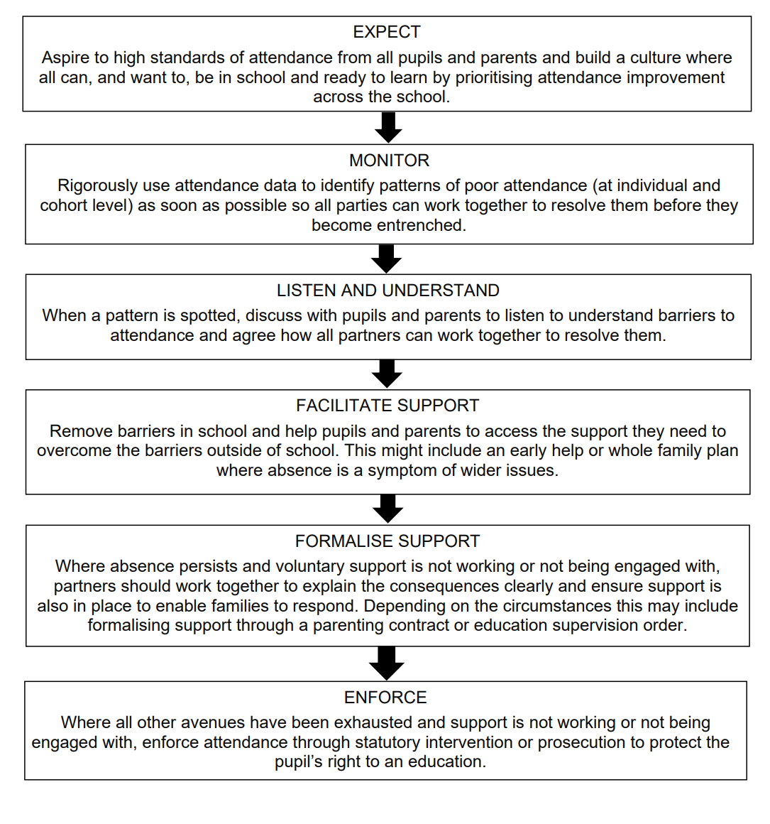

Appendix 4 - A Graduated, Partnership Approach to Improving Attendance
0 – 2  DAYS OFF | - School shall share positively framed messages in assemblies and newsletters  - School shall develop whole school approach  - School shall maintain accurate attendance recording systems  - School shall contact parent/carer on the first morning of a child’s absence, if parent has not informed the school on the first day of absence  - Schools shall ensure their attendance policies are accessible to all
4 – 7 DAYS OFF | - Communication with parents and with pupils about the importance of attendance and tackling non-attendance  - School shall issue attendance letter 1 and monitor attendance for a further 2 weeks  - School shall complete a home visit if there has been no parent engagement
7-9.5 DAYS  Off | - School shall regularly review attendance data  - School shall issue attendance letter 2, inviting the parent to a meeting within 10 calendar days. At the meeting, an attendance plan and parent contract shall be completed. It is expected that a plan is agreed and signed by the parent/carer and pupil (where appropriate) at the meeting. School shall provide parent/carer a copy of the minutes from the meeting  - School to monitor attendance and conduct a review meeting with parent in 2 weeks.  - School to complete home visit if there has been no parent engagement
9.5 – 17  DAYS OFF | - School may consider Early Help assessment if consent is given by parent  - If a child’s attendance meets 10 unauthorised sessions in 10 weeks, school shall request a remote case review with their AIO.  - School shall identify a maximum of 5 cases they wish to review with their EWO.  - School shall issue Notice to improve (NTI letter 3) if agreed by their linked EWO  - In line with the NTI, the School shall monitor the child’s attendance for a further 4 weeks  - A date to review cases where an NTI has been issued, shall be arranged by the EWO
19 – 25 DAYS OFF | - EWO and school shall complete case review and identify outcomes  - Outcomes: 10/10 Penalty Notice, UA Request for Service, Advisory Notice or further actions shall be requested by the EWO  - A 10/10 Penalty Notice may only be processed when there has been no previous legal intervention in the case  - The EWO shall request that school issue Letter 4 to parent/carer informing that a referral has been submitted to EWS  - EWO shall arrange a Parent Panel meeting with the school and the EWO shall issue letter to parent/carer inviting them to attend the meeting  - If parent does not attend their Parent Panel Meeting, the EWO shall conduct a home visit and attempt to engage parent/carer  - EWO shall issue a Formal Warning Notice to parent/carer either during the Parent Panel Meeting, home visit or by post  - School shall maintain contact with the family and continue with their attendance procedures  - EWO shall review attendance after 10 days from when the FWN was issued
27 +  DAYS OFF | - Outcomes are consideration for legal intervention, an Advisory Notice or further actions shall be requested by the EWO  - It remains Schools/Academies responsibility to address the child’s absence, and follow the Graduated, Partnership Approach to Improving attendance from the beginning.

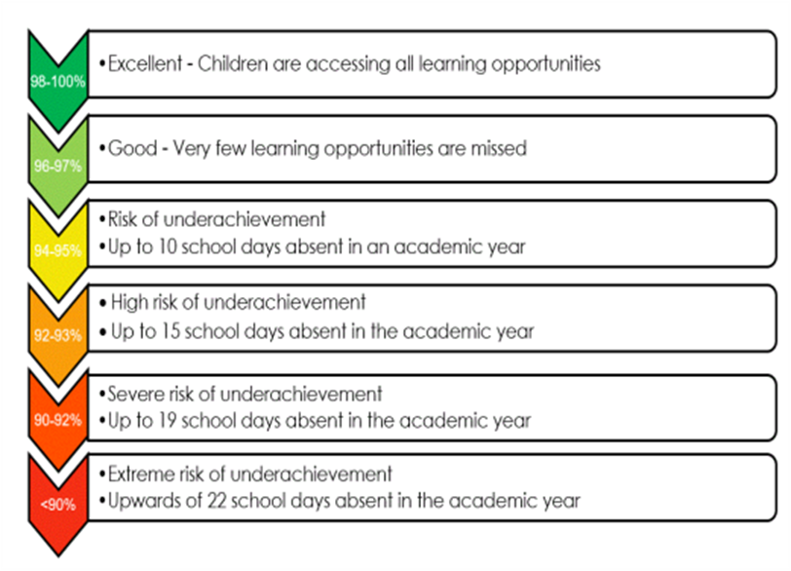

Appendix 2: Notification of Term Time Leave (one form per family)
Name of Pupils at this school:  Sibling in other schools:  (name, dob, name of school)  Current address: | (please ensure school have correct details for all parents/carers)  Name of Parent/Carer 1:  D.o.b:  Name of Parent/Carer 2:  D.o.b:  Address of parent 2 if different to that on the left:
Dates of leave: From To Returning to school
What is the notification for?

Exceptional leave during term time: yes/no
(if yes please attach additional information/evidence to support your circumstances)

Holiday in term time: yes /no
Where will you be staying/visiting during the leave period?
If staying with friends/relatives, please provide the full address and Emergency Contact Details (UK and Abroad). If taking a holiday, please provide the region and country of travel.

UK:
Abroad:
- I confirm that the information on this form is true
- I agree to keep the school informed of any changes to my travel arrangements or if my child is unable to return to school on to due date
- I am aware that if my child does not return to school by the date provided that he/she is at risk of losing their place at this school
- I am aware that I will be fined and/or prosecuted for any time which my child is absent from school that has not been authorised by the headteacher.
Signed by parent/carer: |  | Print name & relationship to child: | Date:
For school use only |  | Date request received / /
Has the notification been considered by the headteacher? Y/N
Has the notification been discussed with the parent/carer? Y/N Date: …………….

No of days Authorised ……… No of days Unauthorised ………….

Date of decision letter sent to parent/carer (only if leave is to be granted):
Is If unauthorised leave is taken this case complies with Penalty Notice criteria, please forward to Attendance Legal Team via Anycomm’s along with HTC, Pupil/student attendance register.
Name of school:  Charnock Hall Primary Academy |  | Headteacher’s signature: | Date:
Before completing this form, please ensure you have understood school’s policy for term time leave

Appendix 5 – Roles and responsibilities document (working together to improve attendance 2024)
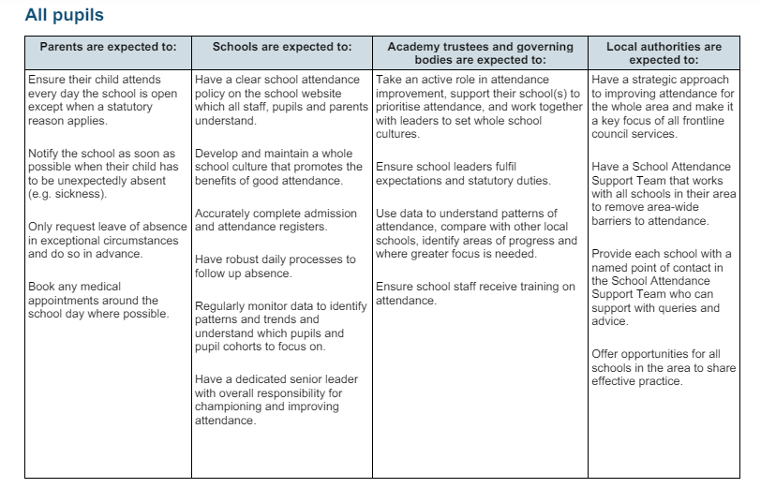
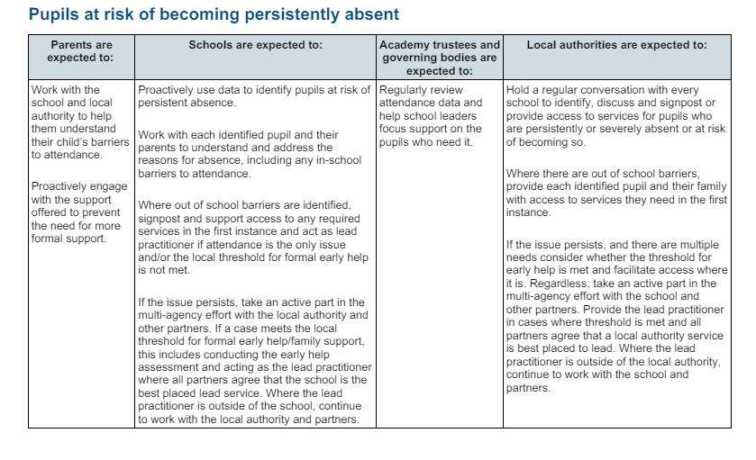
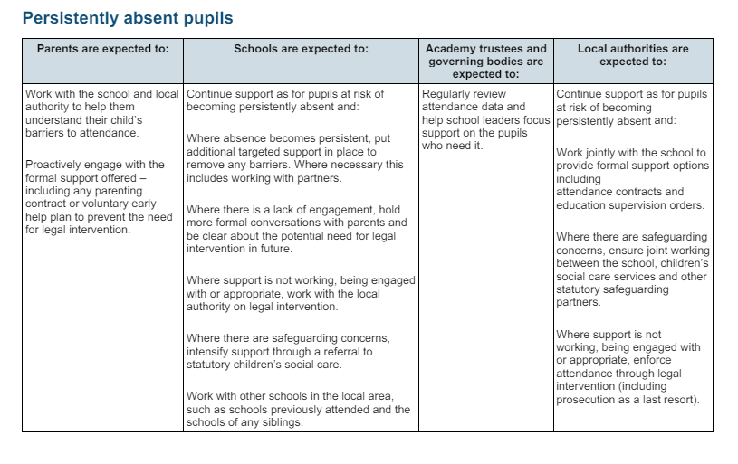
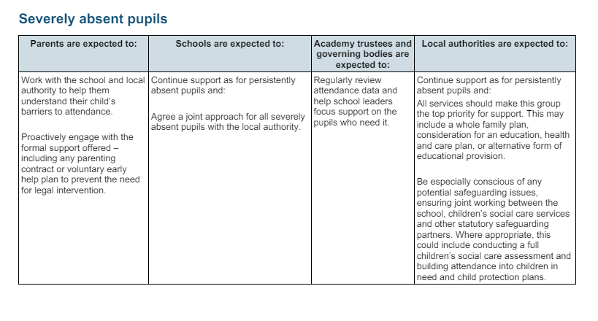
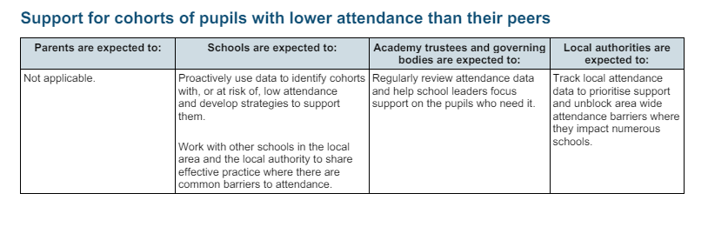
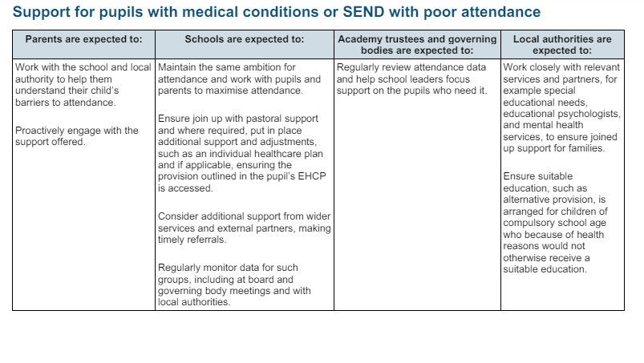
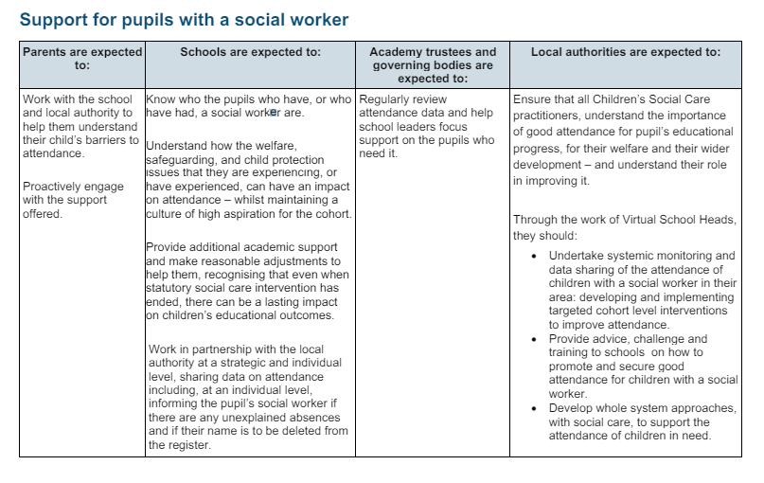

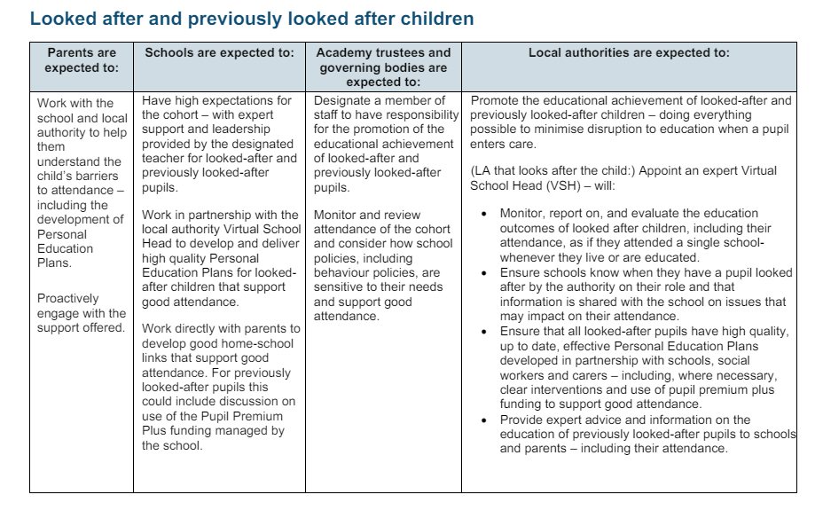
Appendix 6 - Multi-Tiered System of Support
To guarantee a comprehensive approach to attendance, we implement a Multi-Tiered System of Support. A Multi-Tiered System of Support (MTSS) for school attendance involves three tiers of intervention, with roles for teachers, the school, children, parents, and external agencies – including the Local Authority. Data-driven decision-making and training requirements are pivotal to the implementation of the system. The system aligns with the Department for Education's (DFE) "Working Together to Improve School Attendance" guidelines.

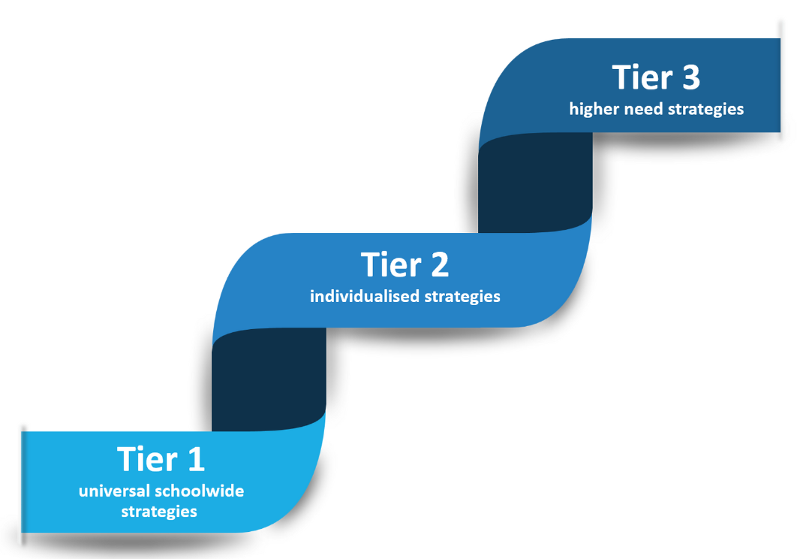

Tier 1 - Universal Approach: Establishing a baseline universal attendance approach that benefits all children.

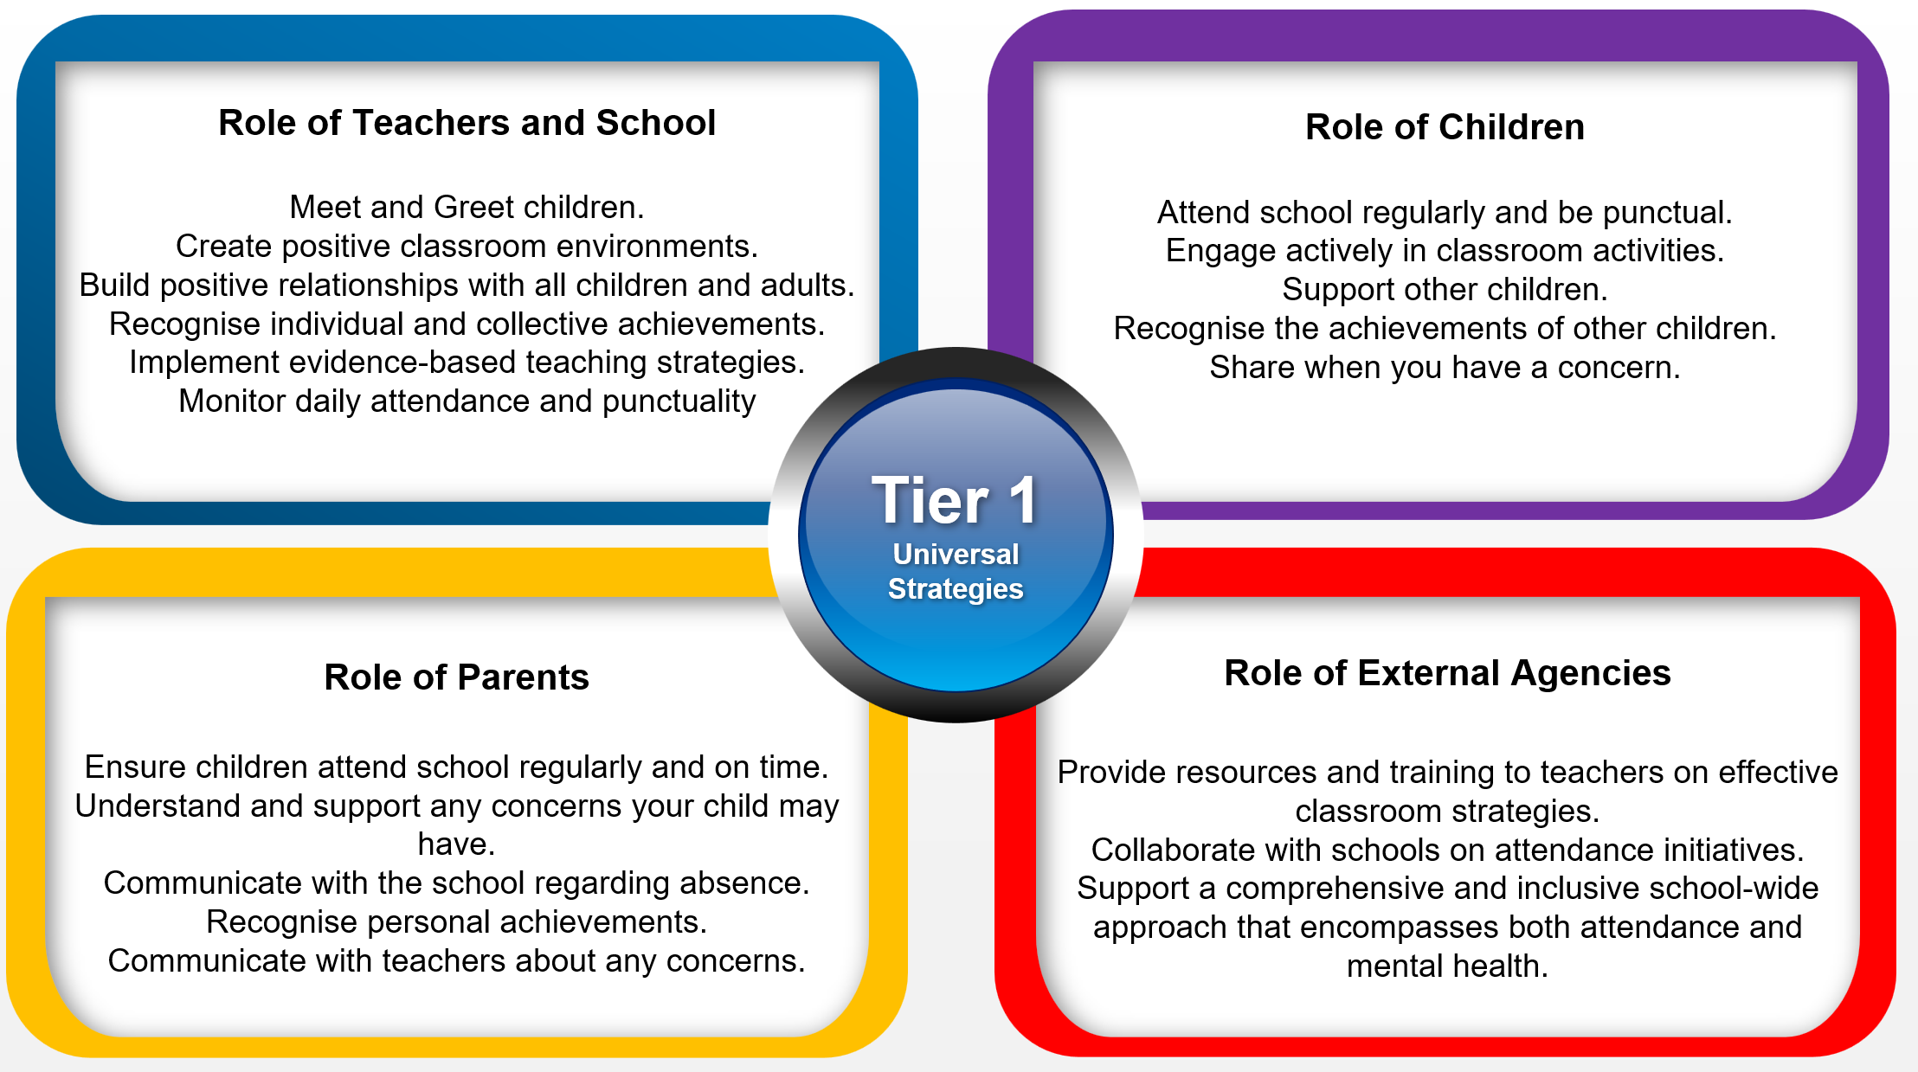

Tier 2 - Individualised Strategies and Early Help Support: Tailoring strategies to individual needs and providing early help support for persistent attendance challenges.

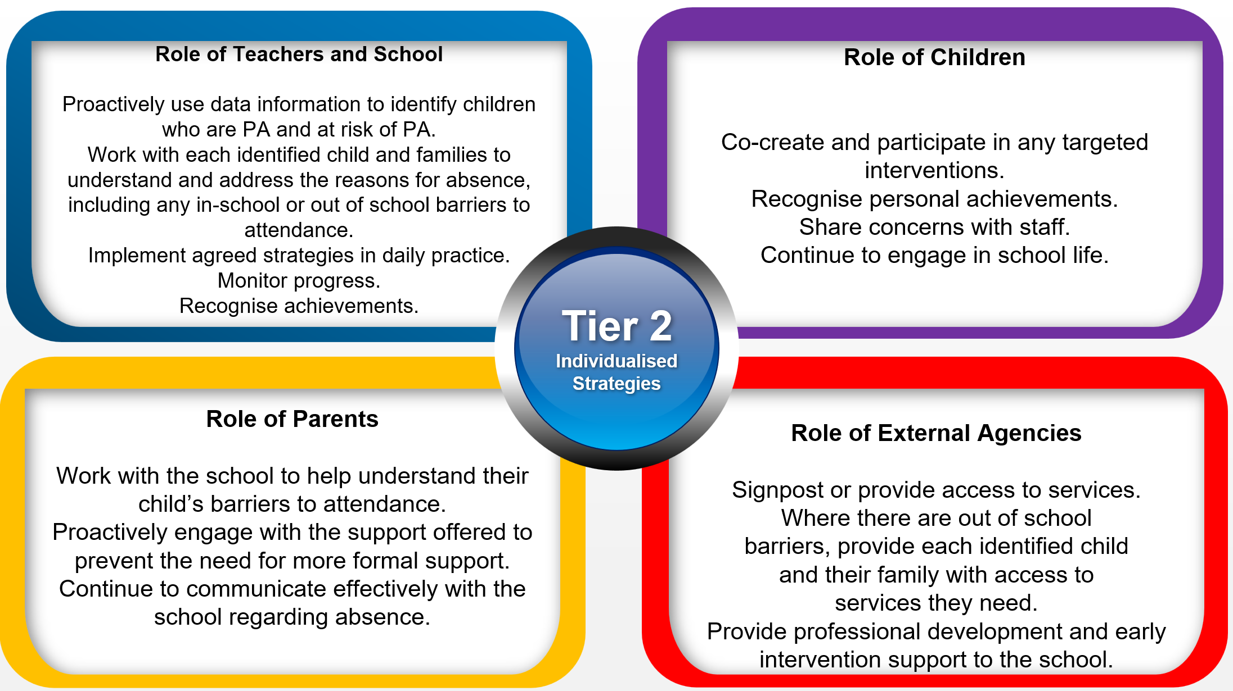

Tier 3 - Higher Needs Strategies Support: Furnishing specialised support for children, young people, and families with complex attendance requirements, including access to external agency support when necessary.

