 | Term 1 | Term 2 | Term 3
Topic title | Dinosaur Planet  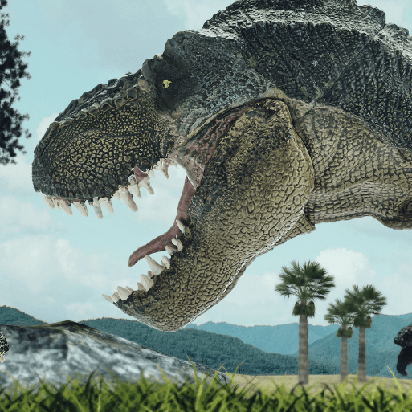  HISTORY | Bright Lights Big City  GEOGRAPHY | School Days  HISTORY
Memorable experience | Dino hunt ‘to find examples of hidden ‘dinosaur treasures’. | Great Fire of London Day | Exploring street views.  Looking at Victorian artefacts  Victorian Day in School
First Hand Experiences | Visit to St Peters Church | Trip into Sheffield on a tram.  Great Fire of London Day | History Van – Victorian School Day
English | 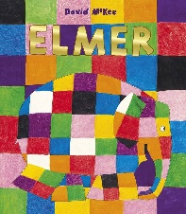  F -Elmer – David McKee  F -Harry and the Bucketful of Dinosaurs – Ian Whybrow  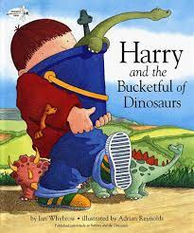  F -Funny Bones  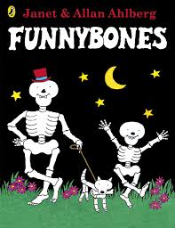  F -Little Red Riding Hood  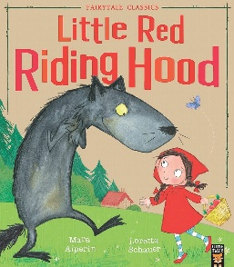  Letters to Santa | F - Paddington- Michael Bond  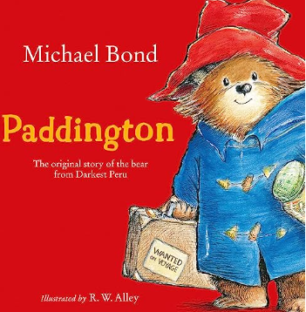    F/ NF -Katie in London –James Mayhew  F -Jack and the Beanstalk  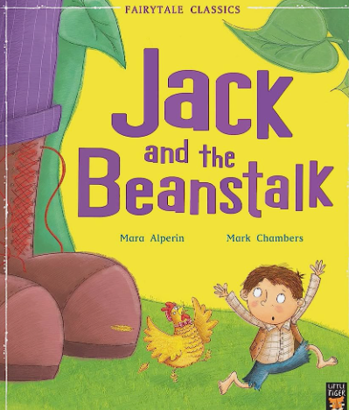 | F -The 3 Billy Goats Gruff  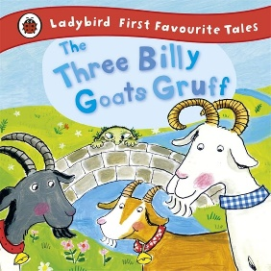  F- The Gruffalo – Julia Donaldson  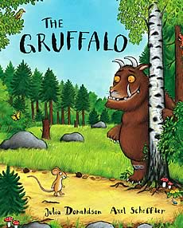  F -The Tiger Who Came To Tea –Judith Ferr    F -The Queen’s Knickers
English | Character descriptions;  Setting descriptions;  Letter writing  Retelling of a story  Labelling  Non-chronological report on Dinosaurs | Instructional writing – how to make a marmalade sandwiches.  Persuasive writing – Come to London leaflet  Recount on the Great Fire of London Day  Retelling of a story | Retelling of a story  Letter writing  Character descriptions;  Setting descriptions;
Daily Reads | 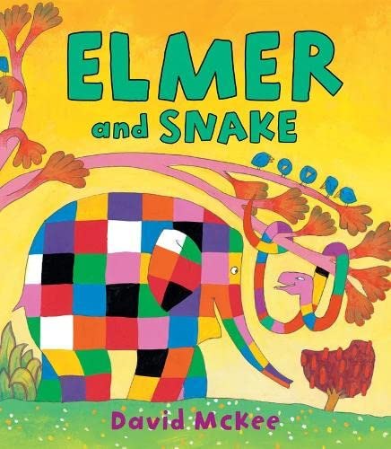  F - Elmer and Snake  F - Oi Frog!  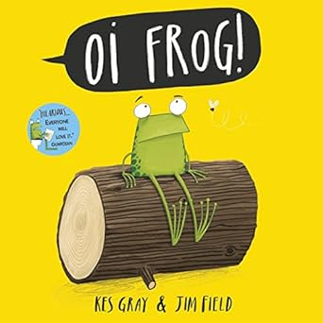 | 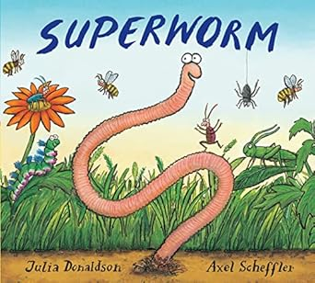  F -Superworm  F - The Koala Who Could  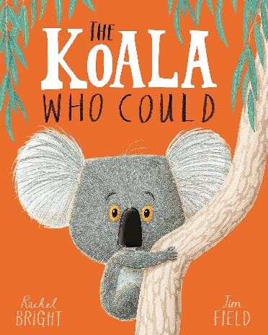 | F - Zog  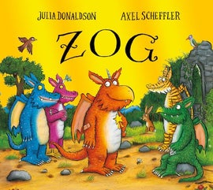  F - Giraffes Can’t Dance  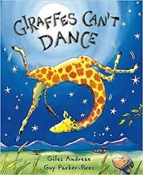
Poetry Reads | Dinosaurs - An action poem by Nancy Klein | London calls by Gabby Dawnay  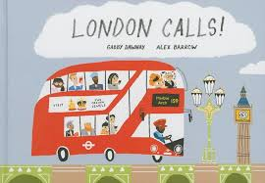 | Excuses by Allan Ahlberg  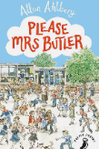
Reading | Guided reading sessions including fluency and comprehension sessions weekly.
Maths | Unit 1: Numbers to 10  (12 lessons) Strengthening & Deepening (3 lessons)  Unit 2 – Part-whole within 10  (5 lessons) Strengthening & Deepening (2 lessons)  Unit 3 – Addition & Subtraction within 10 (1)  (6 lessons) Strengthening & Deepening (2 lessons)  Unit 4 – Addition & Subtraction within 10 (2)  (12 lessons) Strengthening & Deepening (3 lessons)  Unit 5 – 2D & 3D Shapes  (5 lessons) Strengthening & Deepening (2 lessons)  Unit 6 – Numbers to 20  (7 lessons) Strengthening & Deepening (3 lessons) | Unit 7 – Addition within 20  (6 lessons) Strengthening & Deepening (3 lessons)  Unit 8 – Subtraction within 20  (8 lessons) Strengthening & Deepening (3 lessons)  Unit 9 – Numbers to 50  (11 lessons) Strengthening & Deepening (3 lessons)  Unit 10 – Introducing Length & Height  (5 lessons) Strengthening & Deepening (2 lessons)  Unit 11 – Introducing Weight & Volume  (7 lessons) Strengthening & Deepening (2 lessons) | Unit 12 – Multiplication  (6 lessons)  End of Unit Check  Strengthening & Deepening (2 lessons)  Unit 13 – Division  (5 lessons) Strengthening & Deepening (2 lessons)  Unit 14 – Halves & Quarters  (5 lessons)  Unit 15 – Position & Direction  (3 lessons)  Strengthening & Deepening (1 lessons)  Unit 16 – Numbers to 100  (9 lessons)  Strengthening & Deepening (3 lessons)  Unit 17 – Time  (7 lessons)  Strengthening & Deepening (2 lessons)  Unit 18 – Money (3 lessons)  Strengthening & Deepening (2 lessons)
Science |   Seasonal Changes  Focus Scientist Jim Cantore (Meterologist)  Pupils will be taught to observe the changes across the four seasons. They will observe and describe the weather associated with the seasons and how day length varies.  NB: This unit will be re-visited across the academic year in all three terms.    Human Senses  Focus Scientist Louis Braille (Inventor of Braille)  Pupils will be taught to identify, name, draw and label the basic parts of the human body and say which parts of the body are associated with each sense. | 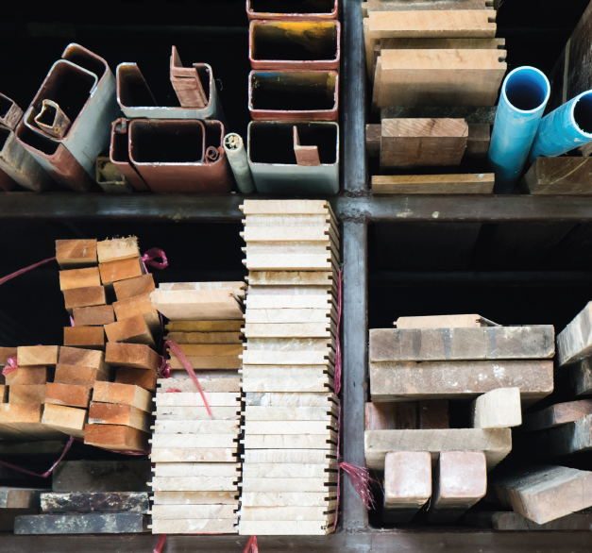  Everyday materials  Focus Scientist Chester Greenwood (Engineer/Inventor)  Pupils will be taught to distinguish between an object and the material from which it is made. They will identify and name a variety of everyday materials, including wood, plastic, glass, water and rock. They will describe the simple physical properties of a variety of everyday materials. They will also compare and group together a variety of these everyday materials on the basis of their physical properties.    Animals including Humans: Animal Parts  Focus Scientist Bill Oddie (TV Presenter on Wildlife)  Pupils will be taught to identify and name a variety of common animals that are birds, fish, amphibians, reptiles and mammals. They will be taught to identify and name a variety of common animals that are carnivores, herbivres and omnivores. They will describe and compare the structure of a variety of common animals (birds, fish, amphibians, reptiles and mammals, including pets). |   Plant Parts  Focus Scientist George Forest (Biologist)  Pupils will be taught to identify and name a variety of common plants, including garden plants, wild plants and trees, and those classified as deciduous and evergreen. They will be taught to identify and describe the basic structure of a variety of common plants, including roots, stem/trunk, leaves and flowers
Computing | Unit 1: Technology around us  Unit 2: Creating Media - Digital Painting    . | Unit 3: Programming A - Moving a Robot  Unit 4: Data and Information - Grouping Data   | Unit 5: Creating Media – Digital Writing  Unit 6: Programming B – Programming Animations
Art and Design | Unit 1: Spirals   | Unit 4: Exploring Watercolour | Unit 6: Inspired by Flora & Fauna
Design and Technology |   Chop, Slice and Mash  Food - Preparation techniques; Hygiene rules; Designing and making salads and sandwiches. This project teaches children about sources of food and the preparatory skills of peeling, tearing, slicing, chopping, mashing and grating. They use this knowledge and techniques to design and make a supermarket sandwich according to specific design criteria. |   Taxi!  Mechanisms – wheels, axles and chassis. This project teaches children about wheels, axles and chassis and how they work together to make a vehicle move. | 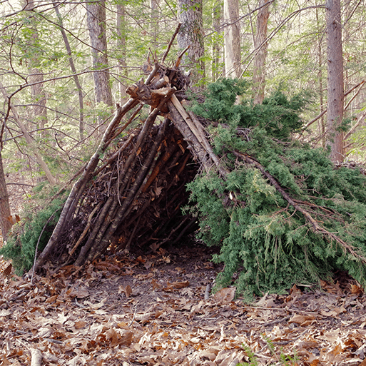  Shade and Shelter  Investigating existing products; Designing and making shelters and dens; Prototypes; Safety rules; Materials. This project teaches children about the purpose of shelters and their materials. They name and describe shelters and design and make shelter prototypes. Children then design and build a play den as a group and evaluate their completed product.
Geography |   Our Wonderful World  Physical and human features; Picture maps; Cardinal compass points; Equator and hemispheres; Continents; Oceans; Countries and capital cities of the UK; Protecting natural environments; Fieldwork  This essential skills and knowledge project teaches children about physical and human features, maps, cardinal compass points, and positional and directional language. They learn about the equator, hemispheres and continents and are introduced to the countries, capital cities and settlements of the United Kingdom. The children carry out simple fieldwork to find out about local physical and human features.  Name and locate the world’s seven continents and five oceans.  Use world maps, atlases and globes to identify the UK and its countries, as well as the countries, continents and oceans studied at this key stage. | Countries and capital cities of the UK; Physical features of the UK; Settlements; Human features;  Weather and seasons; Landmarks; Aerial images; Locational language; Maps; Compass directions;  Geographical similarities. This project teaches children about the physical and human characteristics of the United Kingdom, including a detailed exploration of the characteristics and features of the capital city, London. | Fieldwork; Human and physical features; Maps; Local environment; Changes over time
History | Dinosaur Planet  Historical vocabulary; Investigate what happened to the dinosaurs using a range of age-appropriate non-fiction books. Talk about what they discover and make drawings and labelled diagrams to represent some of their ideas.  Learn about the lives of significant individuals, including Mary Anning, in the past who have contributed to national and international achievements. Compare aspects of life in different periods. | 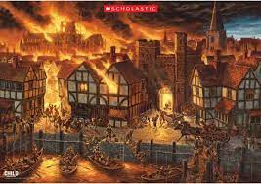  Significant event – Great Fire of London | School Days  Historical vocabulary; Historical artefacts; Timelines; Present day schools; Our school; Victorian era; Victorian schools; Significant people – Samuel Wilderspin
Music |   Hey You! To compose your own rap or words to the existing rap, that could link to any topic in school, graffiti art, literacy, breakdancing or 80s Hip Hop culture in general. Historical context of musical styles.  KS1 Production of Bethlehem Bake-Off  With simple songs, as well as a choice between dramatised or narrated versions, ‘Bethlehem Bake-Off’ is a delightful Christmas musical for ages 5-7.  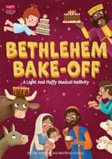 |   In the groove Six different styles of music used here - Blues, Latin, Folk, Funk, Baroque and Bhangra that link to history, geography, countries and cultures. Ourselves. Historical context of musical styles.    Round And Round Latin American style of music -  Countries from around the world. Film music. Historical context of musical styles. |   Your Imagination Think about the history of music in context, listen to some Western Classical music and place the music from the units you have worked through, in their correct time and space. Consolidate the foundations of the language of music.    Reflect, Rewind and Replay This Unit of Work consolidates the learning that has occurred during the year. All the learning is focused around revisiting songs and musical activities, a context for the History of Music and the beginnings of the Language of Music
PSHE | What is the same and different about us?  Who is special to us? | What helps us stay healthy?  What can we do with money? | Who helps to keep us safe?  How can we look after each other and the world?
Physical Education | Real PE Social (Autumn 1)  Real Dance (Autumn 1)      Real PE Physical (Autumn 2)  Real Gym (Autumn 2)  Personal – Coordination (Autumn 1) | Real PE Creative (Sprong 1)  Real Gym (Spring 1)    Real PE (Spring 2)  Real Dance (Spring 2) | Real PE Cognitive (Summer 1)    Premier Education: Games  Tchoukball (Summer 1)  Real PE Healthy and Fitness (Summer 2)  Athletics (Summer 2)
RE  Sheffield Agreed Syllabus | Unit 11: What does it mean to belong to a faith community?  Unit 8: Why does Christmas matter to Christians? | Unit 9: Who is Jewish and how do they live?  Unit 10: What do Christians believe God is like? | Unit 7: Who do Christians say made the world?  Unit 12: How should we care for the world and for others, and why does it matter?  (THEMATIC)

