 | Term 1 | Term 2 | Term 3
Topic title | Magnificent Monarchs  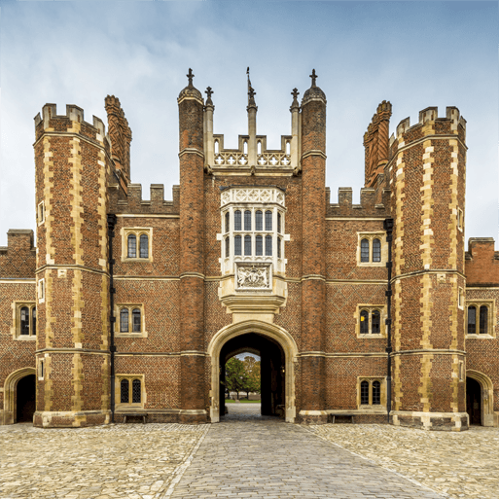  HISTORY | COASTLINE  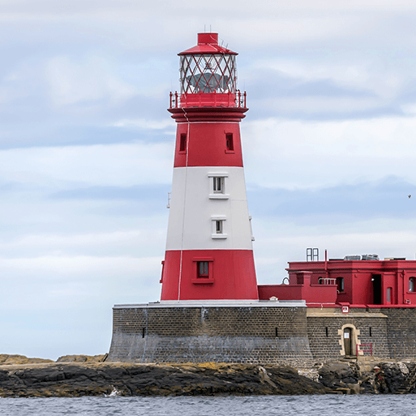  GEOGRAPHY | Movers and Shakers  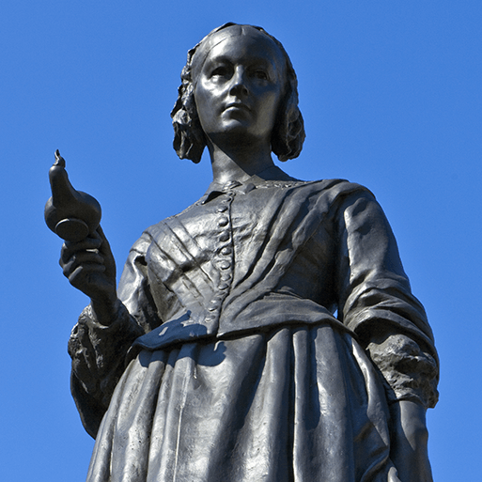  HISTORY
Memorable experience | Making crowns and dressing up as kings and queens.  Magnificent Monarch Fabulous Finish | Coastal Visit to Whitby. | Studying a local significant person.  Movers and Shakers Fabulous Finish
First Hand Experiences | Day trip to Manor Castle in Sheffield | 2 Day Residential to Whitby | Dressing up as Significant People.
English | F – Rapunzel  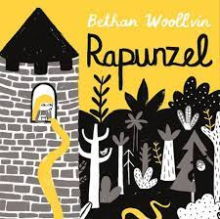  NF – Firework Videos    F– The Very Smart Pea and the Princess to Be  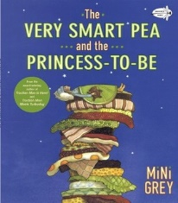  NF – Local History Trip  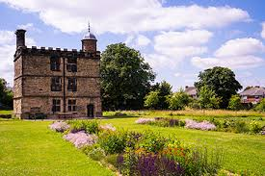  Diary Entry  Wanted Poster  Poetry  Recount on trip to Manor Castle  Narrative Traditional Tale | F - Storm Whale  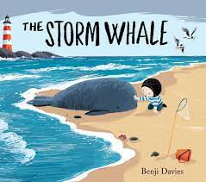  F – Grandads Island  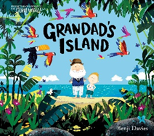  P – Spring Walk    NF – Thank you letter to YHA.    Non – Chronological Report  Setting Description  Spring Poetry  Letter | F – Lost and Found  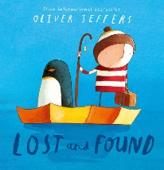  P- The Owl and the Pussycat  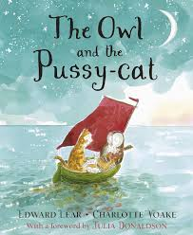  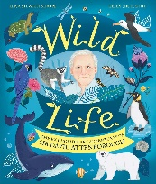  NF – The Extraordinary Adventures of Sir David Attenborough.  NF – DT Practical Experience  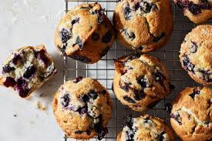  Narrative  Poetry  Non – Chronological Report  Instructions - DT
Daily Reads | F – The Queen’s Hat  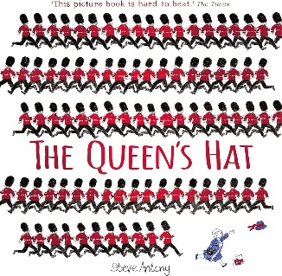  NF - Henry VIII (Popcorn: People in History)  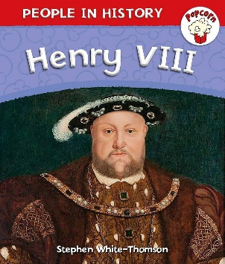  NF - Castles (DKfindout!)  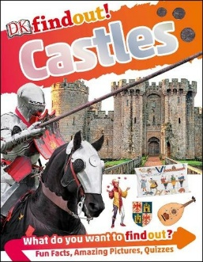 | F – Captain Cat  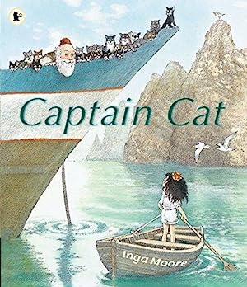  F – Grandad’s Island  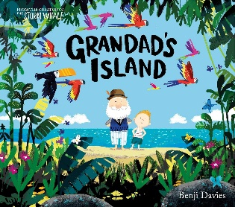  F - Wave  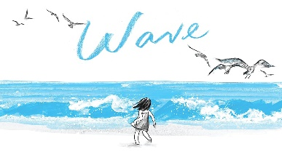 | NF – Great Women Who Changed the World.  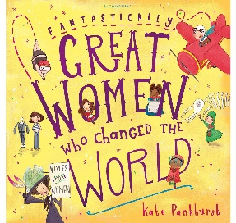  F – The Great Explorer  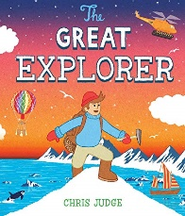  F- Man on the Moon (The day in the life of Bob)  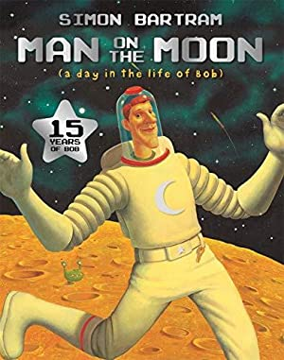
Poetry Reads | P – Smile out Loud  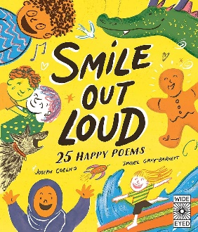  P – People Poems  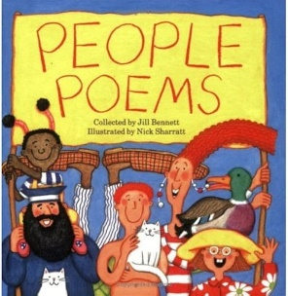 | P – Machine Poems  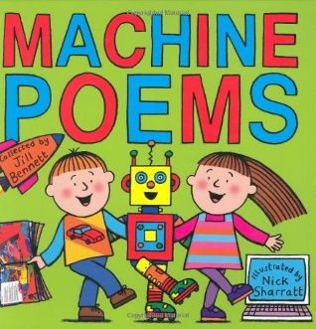  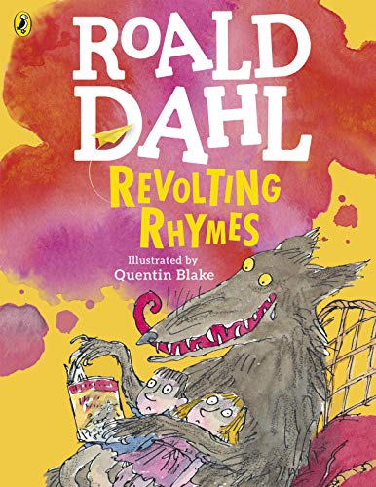  P- Revolting Rhymes | P – Poems Aloud  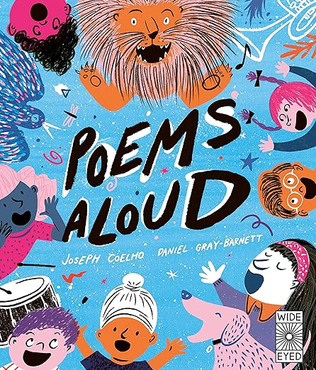  P – The Owl and the Pussycat  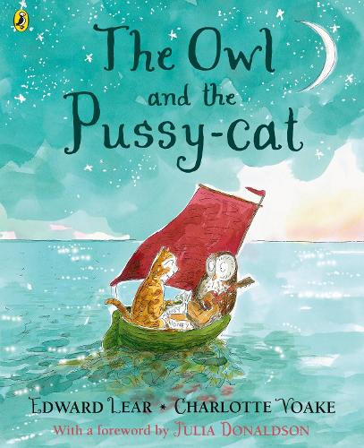
Reading | Fiction and Non Fiction Texts  5 Content domains.  Vocabulary,  Retrieval,  Sequencing,  Inferencing,  Prediction | Fiction and Non Fiction Texts  5 Content domains.  Vocabulary,  Retrieval,  Sequencing,  Inferencing,  Prediction | Fiction and Non Fiction Texts  5 Content domains.  Vocabulary,  Retrieval,  Sequencing,  Inferencing,  Prediction
Maths | Unit 1: Number – Numbers to 100 (18 lessons)  Unit 2: Number – Addition and subtraction 1 Addition methods, Subtraction methods, Problems (addition and subtraction); (13 lessons)  Unit 3: Number – Addition and subtraction 2; (12 lessons)  Unit 4: Properties of Shapes (12 lessons) | Unit 5: Measurement - Money (10 lessons)  Unit 6: Number – Multiplication and Division (1) (8 lessons)  Unit 7: Multiplication and Division (2) (10 lessons)  Unit 10: Fractions - Recognising, finding and making fractions, Equivalence, Counting and calculating fractions; (13 lessons)  Unit 8: Measurement – Length and height, Problems (measurement); (5 lessons)  Unit 9: Mass, capacity and temperature (8 lessons) | Revisit Unit 2 and Unit 5 2 Step Problem Lessons*  Unit 11: Measurement – Time (6 lessons)  Unit 12: Problem Solving and Efficient Methods (12 lessons)  Unit 13: Geometry – Position, direction and coordinates; (5 lessons)  Number – Addition and subtraction, Problem solving and efficient methods; (12 lessons)  Unit 14: Statistics (7 lessons)
Science | 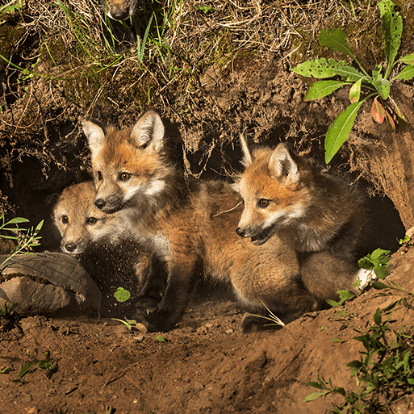  Living Things and Habitats (7 Lessons)  Pupils are taught to explore and compare the differences between things that are living, dead, and things that have never been alive Identify that most living things live in habitats to which they are suited and describe how different habitats provide for the basic needs of different kinds of animals and plants, and how they depend on each other. Identify and name a variety of plants and animals in their habitats, including microhabitats. Describe how animals obtain their food from plants and other animals, using the idea of a simple food chain, and identify and name different sources of food.  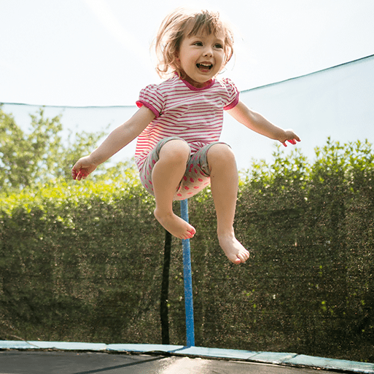  Humans (5 Lessons)  Pupils are taught to:  Notice that animals, including humans, have offspring which grow into adults Find out about and describe the basic needs of animals, including humans, for survival (water, food and air). Describe the importance for humans of exercise, eating the right amounts of different types of food, and hygiene. | Humans (2 Lesson)    Everyday Materials (6 Lessons)  Pupils are taught to identify and compare the suitability of a variety of everyday materials, including wood, metal, plastic, glass, brick, rock, paper and cardboard for particular uses  Find out how the shapes of solid objects made from some materials can be changed by squashing, bending, twisting and stretching. | 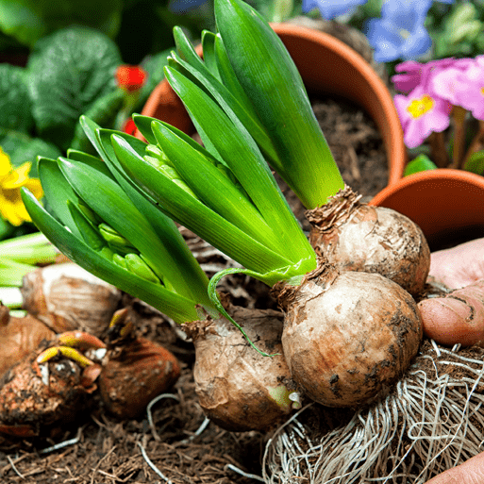  Plant Survival (6 Lessons)  Pupils are taught to observe and describe how seeds and bulbs grow into mature plants  Find out and describe how plants need water, light and a suitable temperature to grow and stay healthy.  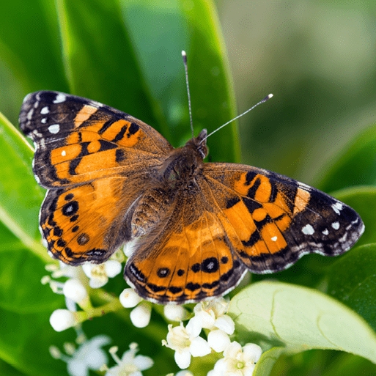  Animal Survival (7 Lessons)  Pupils are taught to: Notice that animals, including humans, have offspring which grow into adults.Find out about and describe the basic needs of animals, including humans, for survival (water, food and air)
Computing | Unit 1: Computing systems and networks. IT is around us (connecting computers).  Unit 2 Creating media (digital photography).   | Unit 4: Data and information (pictograms).    Unit 5: Creating media (digital music) | Unit 3: Programming (Robot Algorithm).  Unit 6: Programming B (programming quizzes)
Art and Design | Unit 1: Explore & Draw   | Unit 2: Exploring the World Through Mono Print | Unit 6: Music & Art
Design and Technology |   Push and Pull - This project teaches children about three types of mechanism: sliders, levers and linkages. They make models of each mechanism before designing and making a greetings card with a moving part. |   Beach Hut - Structures – strengthening and joining. This project teaches children about making and strengthening structures, including different ways of joining materials. | 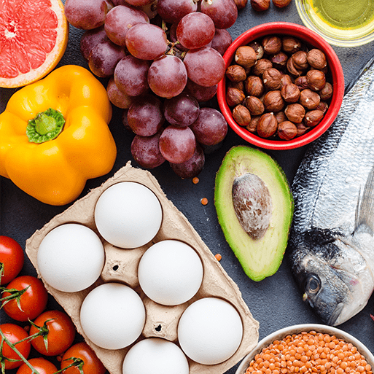  Remarkable Recipes - Sources of food; Kitchen tools; Reading recipes; Hygiene rules; Making a school meal. This project teaches children about sources of food and tools used for food preparation. They also discover why some foods are cooked and learn to read a simple recipe. The children choose and make a new school meal that fulfils specific design criteria.
Geography | Significant Places – royal residences | Coastline - Maps, globes and atlases; World seas and oceans; Human and physical features; Locational language; Compass directions; Physical processes – erosion; Changes over time; Tourism. This project teaches children about the physical and human features of coastal regions across the United Kingdom, including a detailed exploration of the coastal town of Whitby, in Yorkshire. | Historical landmarks - Significant Places    Let's Explore the World - Using an atlas; Using a compass; Using map keys; Locating the equator, Northern and Southern Hemispheres and North and South Poles; Hot, temperate and cold places; Comparing England to Somalia; Fieldwork. This essential skills and knowledge project teaches children about atlases, maps and cardinal compass points. They learn about the characteristics of the four countries of the United Kingdom and find out why there are hot, temperate and cold places around the world. They also compare England to Somalia. Children carry out fieldwork, collecting primary data in their locality to answer geographical questions.
History | Magnificent Monarchs - Historical vocabulary; Historical periods; Timelines; Power and rule; Historical artefacts; Significant people – Henry VIII, Queen Victoria, Queen Elizabeth II, King Charles Iii. Actions and impact; Historical models. This project teaches children about the English and British monarchy from AD 871 to the present day. Using timelines, information about royal palaces, portraits and other historical sources, they build up an understanding of the monarchs and then research six of the most significant sovereigns. |  | Movers and Shakers - Historical models; Exploring significance; Local historically significant person; Historical vocabulary; Chronology and timelines; Historically significant artists, activists, explorers, monarchs and scientists; Facts and opinions; Memorials; Significant people – Emmeline Pankhurst, Christopher Columbus, Neil Armstrong, Rosa Parks, Vincent van Gogh.  This project teaches children about historically significant people who have had a major impact on the world. They will learn to use timelines, stories and historical sources to find out about the people featured and use historical models to explore their significance.
Music | 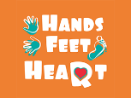  Hands, Feet, Heart - This is a six-week Unit of Work. All the learning is focused around one song: Hands, Feet, Heart. The material presents an integrated approach to music where games, the dimensions of music (pulse, rhythm, pitch etc.), singing and playing instruments are all linked. As well as learning to sing, play, improvise and compose with this song, children will listen and appraise different styles of South African music.  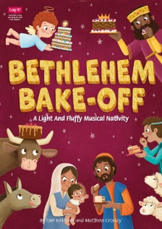  KS1 Production of Bethlehem Bake-Off  With simple songs, as well as a choice between dramatised or narrated versions, ‘Bethlehem Bake-Off’ is a delightful Christmas musical for ages 5-7. |   I Wanna Play In a Band - They will learn to sing, play, improvise and compose with this song, children will listen and appraise classic Rock songs.  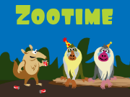  Zootime - This is a six-week Unit of Work. All the learning is focused around one song: Zootime. The material presents an integrated approach to music where games, the interrelated dimensions of music (pulse, rhythm, pitch etc), singing and playing instruments are all linked |   Friendship Song - They will learn that music has a steady pulse. We will learn that rhythms are different to pulses. We will learn that we add high and low sounds, pitch, when we sing and play instruments    Reflect, Rewind and Replay - This Unit of Work consolidates the learning that has occurred during the year. All the learning is focused around revisiting songs and musical activities, a context for the History of Music and the beginnings of the Language of Music.
PSHE | What makes a good friend?  What is bullying? | What jobs do people do?  What helps us to stay safe? | What helps us grow and stay healthy?  How do we recognise our feelings?
Physical Education |   Personal – Coordination (Autumn 1)  Personal – Static Balance (Autumn 1)  Premier Education: Games: Boccia (Autumn 1)  Social – Dynamic Balance to Agility (Autumn 2)  Social – Static Balance (Autumn 2)  Personal - Floor Work, Apparatus and Sequence Development (Autumn 2) | Cognitive – Dynamic Balance (Spring 1)  Cognitive – Static Balance (Spring 1)  Creative – Coordination (Ball Skills) (Spring 2)  Creative – Counter Balance (Spring 2)  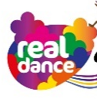 Personal – Develop Shapes & Circles (Spring 1) | Physical – Coordination (Sending and Receiving) (Summer 1)  Physical – Agility (Reaction and Response_ (Summer 1)  Health and Fitness – Agility (Ball Chasing) (Summer 2)  Health and Fitness – Static Balance (Floor Work) (Summer 2)  Orienteering  Athletics
RE  Sheffield Agreed Syllabus | Unit 15  Who is a Muslim and how do they live? Part 1  Unit 13  What is the good news Christians believe Jesus brings?  Part 1 | Unit 14  What is the good news Christians believe Jesus brings?  Part 2  Unit 16  Why does Easter matter to Christians? | Unit 17  Who is a Muslim and how do they live? Part 2  Unit 18  What makes some places sacred to believers?  (THEMATIC)

