 | Term 1 |  | Term 2 |  |  | Term 3
Topic title | Through the Ages  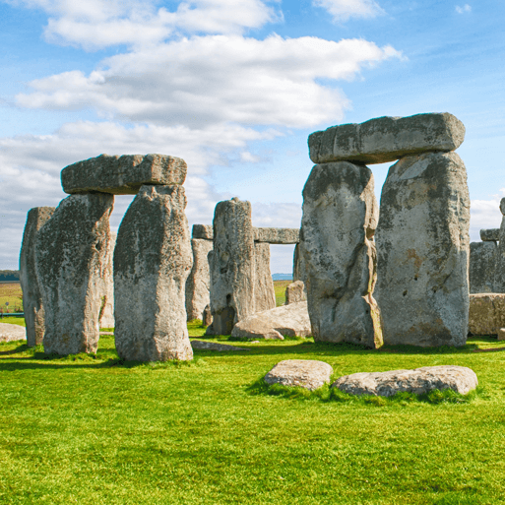  HISTORY |  | Rocks, Relics and Rumbles    GEOGRAPHY |  |  | Emperors and Empires  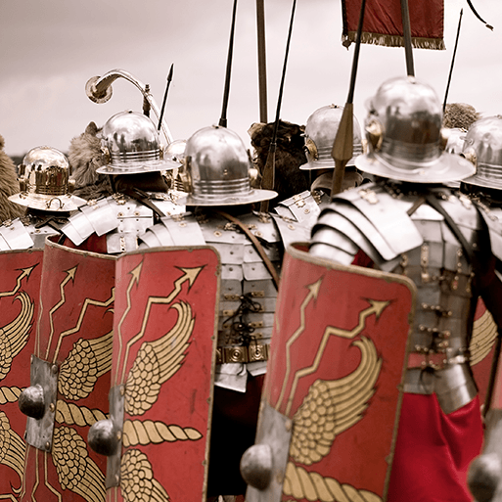  HISTORY
Memorable experience | Prehistoric visit. |  | Let's rock! |  |  | Living museum.
First Hand Experiences | Manor Lodge Trip – Stone Age workshop |  | Magna Centre - workshop |  |  | Roman Workshop in school
English | F- Descriptive setting  The Ice Age – Video clip  F- Recount narrative  Stone Age Boy – Satoshi Kitamura  Non-linear  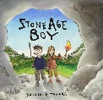  Letter (informal)  The Iron Man- Ted Hughes  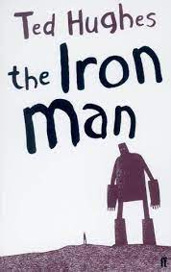 |  | F- Character description  Letter of complaint (formal)  Matilda  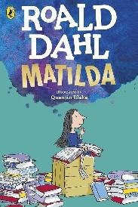  NF- Biography  Stone Girl, Bone Girl– the story of Mary Anning  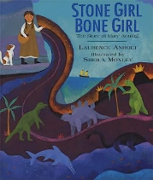 |  |  | F- Mystery narrative  Juius Zebra: Rumble with the Romans  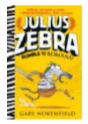  NF- non-chronological repot  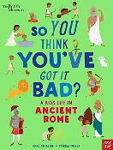  So you think you’ve got it bad? A kid’s life in Ancient Rome.
Daily Reads | Archaic  F- Charlotte’s Web  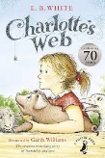  F- The Lion the Witch and the Wardrobe  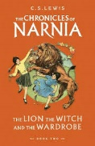 | Non-Linear  F- Fortunately the Milk  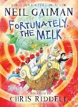 |  | Narratively Complex  F- The Witches  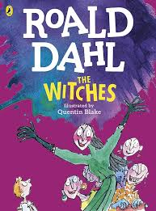  F- The Five Realms – The Legend of Podkin One-Ear  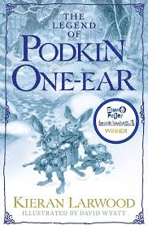 | Figurative/Symbolic  F- The Tunnel  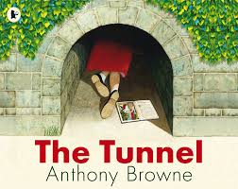 |  | Resistant  F- The Mysteries of Harris Burdick  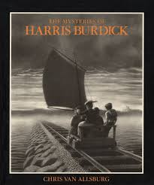  F- Cloud Busting  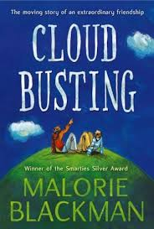
Poetry Reads | P - An Emotional Menagerie  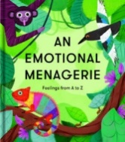  P -Apes to Zebras  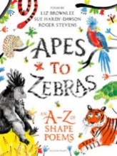 |  | P - Selfies with Komodos  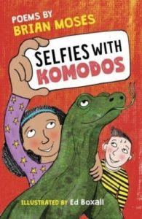  P - Earth Verse  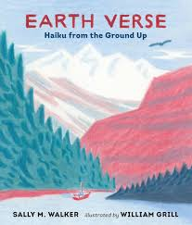 |  |  | P - 101 poems for children  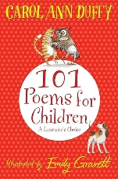  P - Little Lemur Laughing  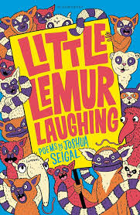
Reading | Ug: Boy Genius of the Stone Age- Raymond Briggs  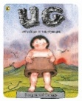  The Iron Man- Ted Hughes |  | Matilda – Roald Dahl  Stone Girl Bone Girl - the story of Mary Anning |  |  | Escape from Pompeii- Christina Balit  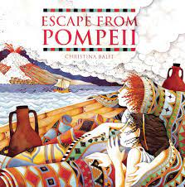  Diary of a Killer - Anne Fine  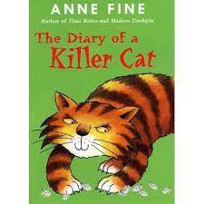  Juius Zebra: Rumble with the Romans
Maths | Unit 1: Place Value within 1000 (13 lessons)  Unit 2: Addition and Subtraction 1 (10 lessons)  Unit 3: Addition and Subtraction 2 (13 lessons)  Unit 4: Multiplication and Division 1 (5 lessons)  Unit 5: Multiplication and Division 2 (13 lessons) |  | Unit 6: Multiplication and Division 2 (13 lessons)  Unit 7: Length and Perimeter (11 lessons)  Unit 8: Fractions 1 (10 lessons)  Unit 9: Mass (7 lessons)  Unit 10: Capacity (6 lessons) |  |  | Unit 11: Fraction 2 (8 lessons)  Unit 12: Money (5 lessons)  Unit 13: Time (12 lessons)  Unit 14: Angles and Properties of Shapes (9 lessons)  Unit 15: Statistics (7 lessons)  Revisit and consolidate
Science | 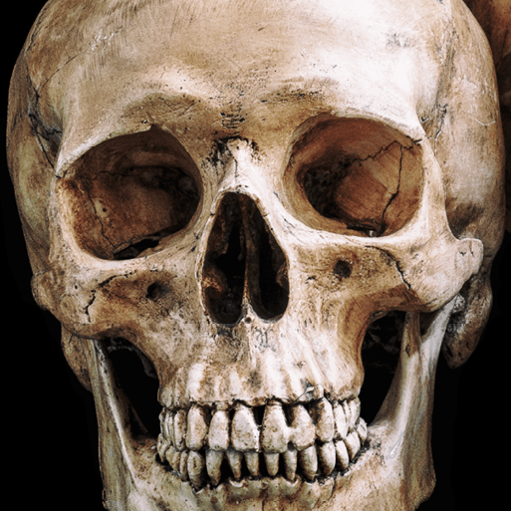  Animals including Humans  This project teaches children about the importance of nutrition for humans and other animals. They learn about the role of a skeleton and muscles and identify animals with different types of skeleton. |  | Rocks; Fossils; Soils  This teaches children about different rock formations. They learn how fossils are made.  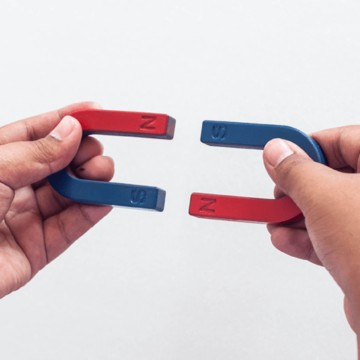  Forces and Magnets  This project teaches children about contact and non-contact forces, including friction and magnetism. They investigate magnets and magnetic materials, exploring how they behave in relation to their poles. |  |  |   Plants  This project teaches children about the requirements of plants for growth and survival. They describe the parts of flowering plants and relate structure to function, including the roots and stem for transporting water and the flower for reproduction.  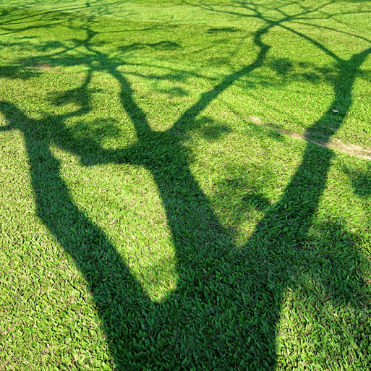  Light  This project teaches children about light and dark. They investigate the phenomena of reflections and shadows, looking for patterns in collected data. The risks associated with looking at the Sun are also explored.
Computing | Unit 1: Computing systems and networks (connecting computers)    Unit 2 Creating media (Stop-frame animation) |  | Unit 3: Programming A (sequencing sounds)    Unit 4: Data and information (branching databases) |  |  | Unit 5: Creating media (desktop publishing)  Unit 6: Programming B (events and actions in programs)
Art and Design | Unit 1: Gestural Drawing with Charcoal   |  | Unit 2: Working with Shape and Colour |  |  | Unit 4: storytelling through drawing
Design and Technology |   Cook Well, Eatwell - This project teaches children about food groups and the Eatwell guide. They learn about methods of cooking and explore these by cooking potatoes and ratatouille. The children choose and make a taco filling according to specific design criteria. |  | 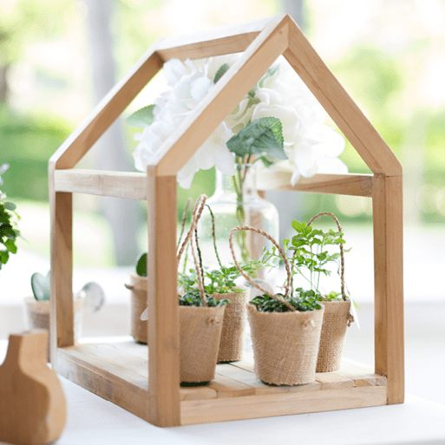  Greenhouse - This project teaches children about structures and frameworks. They make mini-greenhouse prototypes using strengthening, finishing and joining techniques |  |  | 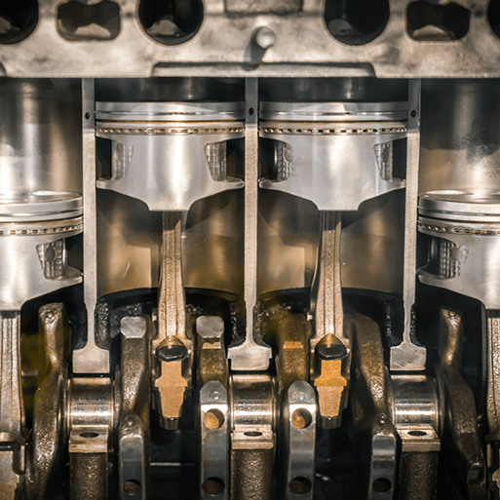  Making It Move - This project teaches children about cam mechanisms. They experiment with different shaped cams before designing, making and evaluating a child's automaton toy.
Geography | Human features; Stone Age monuments.  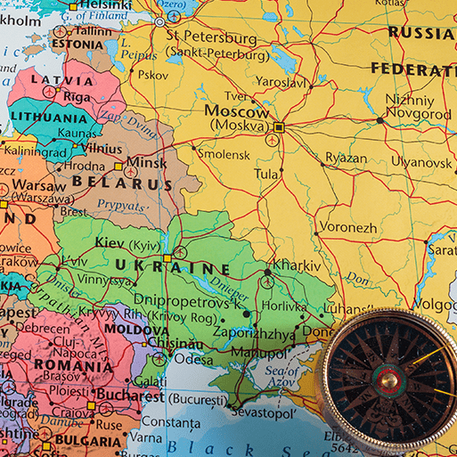  One Planet, Our World  Maps; Locating countries; Human and physical features; Four-figure grid references; Primary data; Compass points; Earth's layers; Plate tectonics; Latitude and longitude; European countries and cities; UK counties and cities; Carbon footprints; Weather and the local environment; Land use; Fieldwork; Local enquiry. This essential skills and knowledge project teaches children to locate countries and cities, and use grid references, compass points and latitude and longitude. They learn about the layers of the Earth and plate tectonics and discover the five major climate zones. They learn about significant places in the United Kingdom and carry out fieldwork to discover how land is used in the locality. |  | Rocks, Relics and Rumbles`  Layers of the Earth; Rocks; Plate tectonics; Ring of Fire; Features of volcanoes; Lines of latitude and longitude; Volcanic eruptions; Earthquakes and tsunamis; Compass points; Maps. |  |  | Maps Four-figure grid references; Compass points;
History | Through the Ages  This project teaches children about British prehistory from the Stone Age to the Iron Age, including changes to people and lifestyle caused by ingenuity, invention and technological advancement. |  | Significant people – Mary Anning; Pompeii |  |  | Emperors and Empires  Chronology; Everyday life in ancient Rome; Founding of Rome; Power and rule; Roman Empire; Significant emperors; Social hierarchy; Roman army; Roman invasion of Britain; Significant people – Boudicca; Everyday life in Roman Britain; Romanisation of Britain; Roman withdrawal; Roman legacy. This project teaches children about the history and structure of ancient Rome and the Roman Empire, including a detailed exploration of the Romanisation of Britain.
MFL  (Spanish) | I’m learning Spanish    Phonetics Lesson (1-4) |  | Animals  Fruits |  |  | I can  Ancient Britain or Little Red Riding Hood
Music |   Let Your Spirit Fly This is a six-week Unit of Work. All the learning is focused around one song: Let Your Spirit Fly. The material presents an integrated approach to music where games, the dimensions of music (pulse, rhythm, pitch etc.), singing and playing instruments are all linked.  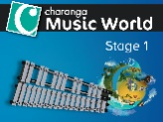  Glockenspiel Level 1 This is a six-week Unit of Work that introduces the children to learning about the language of music through playing the glockenspiel. The learning is focused around exploring and developing playing skills through the glockenspiel or if you have previous knowledge, the recorder. |  | 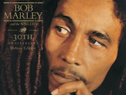  Three Little Birds This is a six-week Unit of Work. All the learning is focused around one song: Three Little Birds. The material presents an integrated approach to music where games, elements of music (pulse, rhythm, pitch etc.), singing and playing instruments are all linked. As well as learning to sing, play, improvise and compose with this song, children will listen and appraise other Reggae songs.    The Dragon Song This is a six-week Unit of Work. All the learning in this unit is focused around one song: The Dragon Song. Using your imagination and working together as a class, create your own performance of this song. |  |  |   Bringing us together This is a six-week Unit of Work. All the learning in this unit is focused around one song: Bringing Us Together - a Disco song about friendship, peace, hope and unity  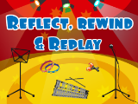  Reflect, Rewind and Replay This Unit of Work consolidates the learning that has occurred during the year. All the learning is focused around revisiting songs and musical activities, a context for the History of Music and the beginnings of the Language of Music.
PSHE | How can we be a good friend?  What keeps us safe? |  | What are families like?  What makes a community? |  |  | Why should we eat well and look after our teeth?  Why should we keep active and sleep well?
Physical Education |   Unit 1: Real PE Personal: Footwork (Autumn 1)  Unit 2: Real PE Social: Jumping and Landing (Autumn 1)  Unit 1: Real Gym (Autumn 2)   |  | Unit 3: Cognitive  Dynamic Balance: On a Line  Coordination: Ball Skills (Spring 1)  Premier Education: Handball (Spring 1)  Unit 4: Creative  Coordination: Sending and Receiving  Counter Balance: With a Partner (Spring 2)  Unit 2: Real Gym (Spring 2) |  |  | Unit 5: Physical  Agility: Reaction/ Response  Static Balance: Floor Work  Unit 6: Fitness  Agility: Ball Chasing  Static Balance: Stance    Unit 1: Real Dance  Athletics/Sports Day practice
RE  Sheffield Agreed Syllabus | Unit 23: What do Christians learn from the creation story?  Unit 19:  What is it like for someone to follow God? |  | Unit 21: How do festivals and worship show what matters to a Muslim?  Unit 22: How do festivals and family life show what matters to Jewish people? |  |  | Unit 25: What kind of world did Jesus want?  Unit 24: How and why do people try to make the world a better place?  (THEMATIC)

