 | Term 1 | Term 2 | Term 3
Topic title | Invasions  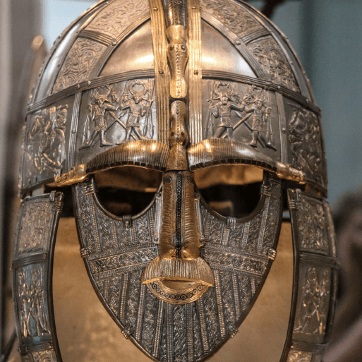  HISTORY | Misty Mountain, Winding River    GEOGRAPHY | Ancient Civilisations  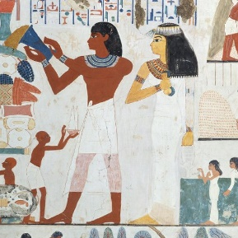  HISTORY
Memorable experience | Hatching a dragon egg linked to How to Train your Dragon  Visit a Anglo-Saxon/Viking village –VR Headsets. | River visit - What a view – Using VR Headsets | Visit Egyptian Tomb–VR Headsets.
First Hand Experiences | Vikings Day – History Van | The Deep Residential Trip | Egyptian Day
English | Beowulf  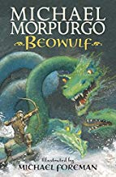  How to Train your Dragon  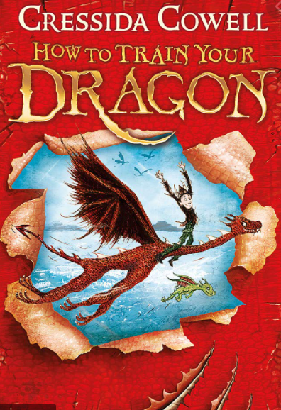  Instructions  Character Description  Non-Chronological report  Newspaper report  Problem Resolution Narrative | Where the River takes us  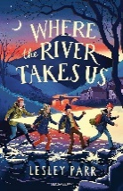    Oliver and the Seawigs  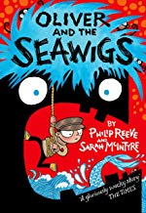  Poetry  Character descriptions  Letter of persuasion  Non-chronological report on Rivers and Mountains | Secrets of a Sun King  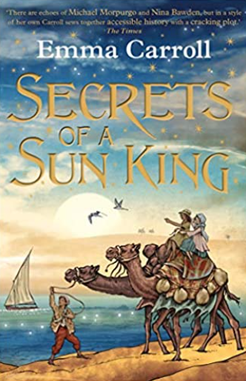  I was there: Tutankhamun’s Tomb  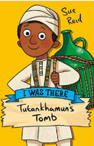  Newspaper report  Biography – Tutankhamun  Balanced Argument  Diary Entry
Daily Reads | The boy at the back of the class  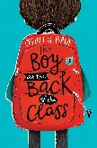  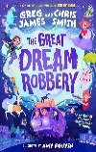  Great Dream Robbery | The book of stolen dreams  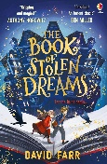  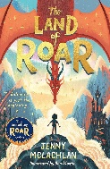  Land of Roar | Land of Roar  When the sky falls  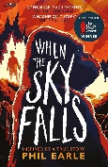
Poetry Reads | Poem for every day of the year  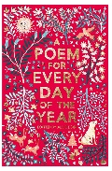 | Poem for every day of the year  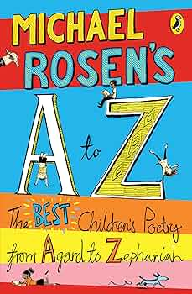 | Poem for every day of the year
Reading | Secrets of a Sun King and Non Fiction texts  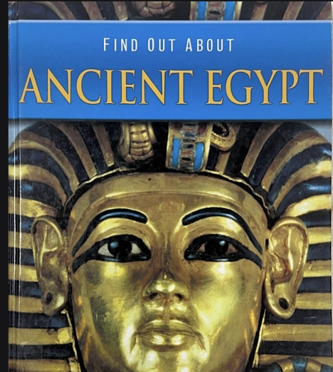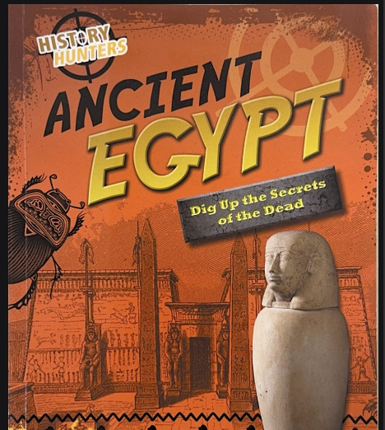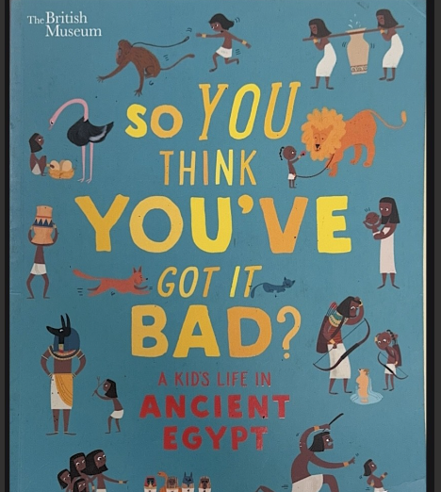  Vocabulary  Retrieval  Inference  Explain  Prediction | King of the Cloud Forests and Non Fiction texts  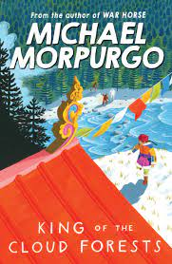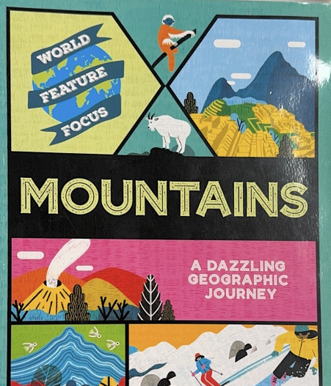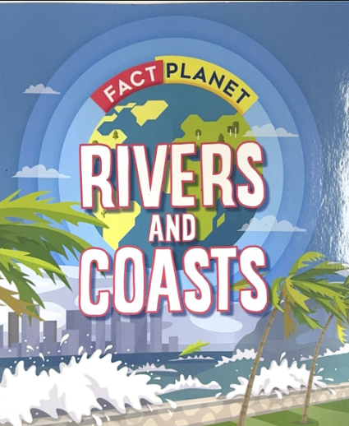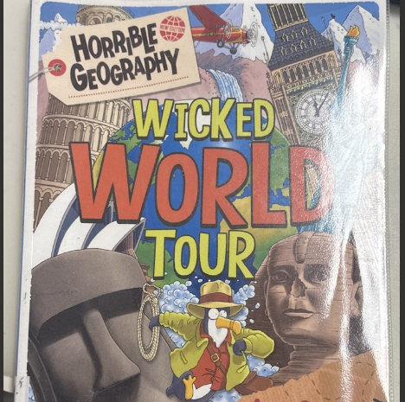  Vocabulary  Retrieval  Inference  Explain  Prediction | Secrets of a Sun King and Non Fiction texts  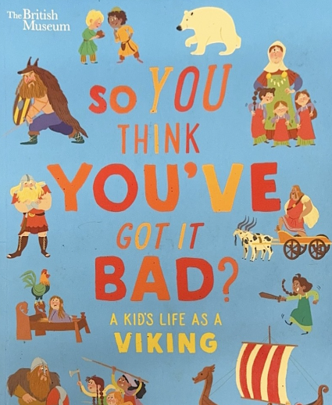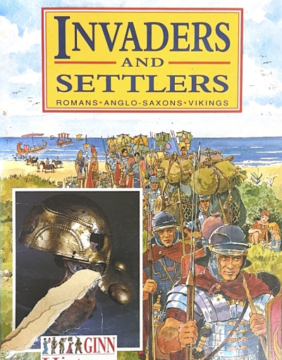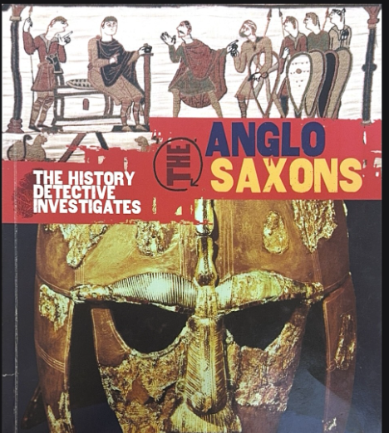  Vocabulary  Retrieval  Inference  Explain  Prediction
Maths | Power Maths  Unit 1: Place Value  Unit 2: Place value  Unit 3: Addition and Subtraction  Unit 4: Area  Unit 5 (Started): Multiplication and Division | Power Maths  Unit 5 (Continued) : Multiplication and Division  Unit 6: Multiplication and Divisions  Unit 7: Perimeter  Unit 8: Fractions  Unit 9: Fractions  Unit 10: Decimals | Power Maths  Unit 11: Decimals  Unit 12: Money  Unit 13: Time  Unit 14: Statistics  Unit 15: Geometry - angles and 2D shapes  Unit 16: Geometry - position and direction
Science | 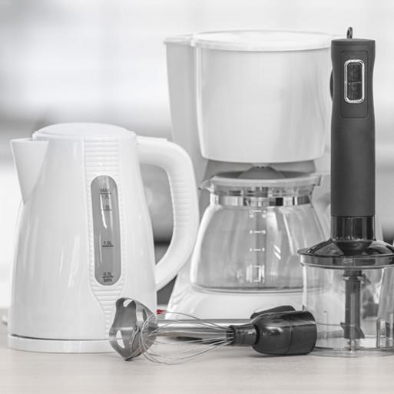  Electricity  This project teaches children about electrical appliances and safety. They construct simple series circuits and name their parts and functions, including switches, wires and cells. They investigate electrical conductors and insulators and identify common features of conductors.  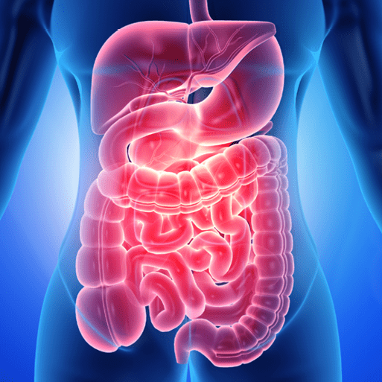  Animals, including humans  This project teaches children about the human digestive system. They explore the main parts, starting with the mouth and teeth, identifying teeth types and their functions. They link this learning to animals' diets and construct food chains to show the flow of energy. |   Sound  This project teaches children about sound and how sounds are made and travel as vibrations through a medium to the ear. They learn about pitch and volume and find out how both can be changed  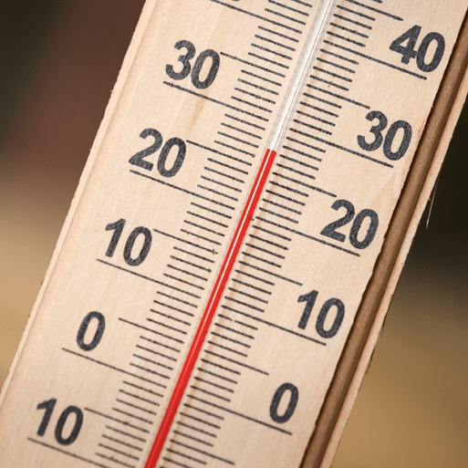  States of Matter  This project teaches children about solids, liquids and gases and their characteristic features. They observe how materials change state as they are heated and cooled, and learn key terminology associated with these processes. | 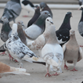  Living Things and their Habitat  This project teaches children about the grouping of living things, known as classification. They study local and wider habitats and use classification keys to identify living things. Children also learn about the impact of human influences on habitats and their living things.
Computing | Unit 1: Computing systems and networks – The Internet  Unit 2: Creating Media – Audio Production   | Unit 3: Programming A – Repetition in shapes  Unit 4: Data and information – Data logging | Unit 5: Creating media – Photo editing  Unit 6: Programming B – Repetition in games
Art and Design | Unit 1: Storytelling Through Drawing | Unit 4: Exploring Still Life | Unit 6: Festival Feasts
Design and Technology | 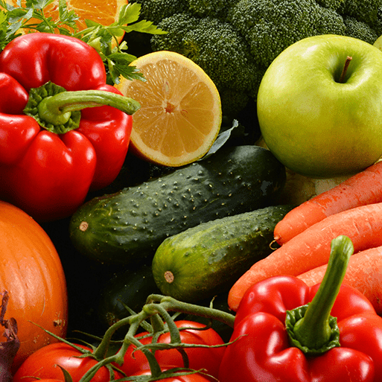  Fresh Food, Good Food - Food preservation techniques; Exploring food packaging; Prototypes; Designing, making and packaging healthy snacks. This project teaches children about food decay and preservation. They discover key inventions in food preservation and packaging, then make examples. The children prepare, package and evaluate a healthy snack. | 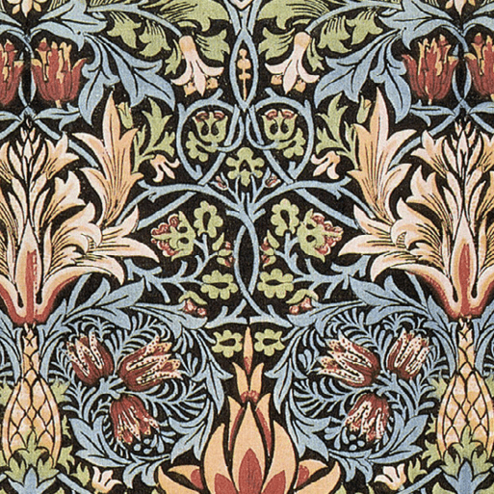  Functional and Fancy Fabrics - This project teaches children about home furnishings and the significant designer William Morris. They learn techniques for decorating fabric, including block printing, hemming and embroidery and use them to design and make a fabric sample. | 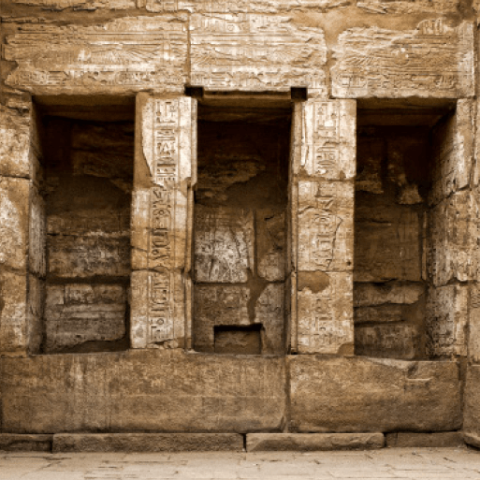  Tomb Builders - Simple and compound machines. This project teaches children about simple machines, including wheels, axles, inclined planes, pulleys and levers, exploring how they helped ancient builders to lift and move heavy loads.
Geography | 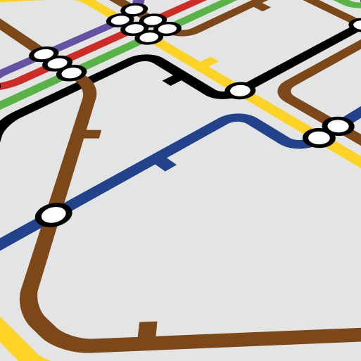  Interconnected World - Compass points; Four and six-figure grid references; Tropics of Cancer and Capricorn; Countries, climate and culture of North and South America; Significant physical features of the UK; Renewable and non-renewable energy; National Rail network; UK canal network; Fieldwork; Local enquiry.  This essential skills and knowledge project teaches children about compass points and four and six-figure grid references. They learn about the tropics and the countries, climates and culture of North and South America. Children identify physical features in the United Kingdom and learn about the National Rail and canal networks. They conduct an enquiry to prove a hypothesis, gathering data from maps and surveys before drawing conclusions. | Misty Mountain Windy River  Rivers; Maps; Grid references; Contour lines; Physical processes – erosion, transportation and deposition; World rivers; Aerial images; Mountains; UK mountains; World mountains; Compass points; Water cycle; Altitudinal zones; Data analysis.  This project teaches children about the characteristics and features of rivers and mountain ranges around the world, including a detailed exploration of the ecosystems and processes that shape them and the land around them. | 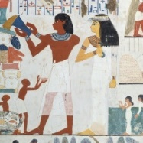  Geography revision and retrieval practice.  Ancient Civilisations - Locate countries using maps  Life in Ancient Sumer city states  City life in Egypt  prove a hypothesis, gathering data from maps and surveys before drawing conclusions.
History | Invasions - Roman withdrawal from Britain; Chronology of invasion; Anglo-Saxon invasion; Anglo-Saxon kingdoms, beliefs and customs; Religion; Everyday life in Anglo-Saxon Britain; Viking invasion; Everyday life in Viking Britain; Significant people – King Athelstan; Norman invasion; Legacy. This project teaches children about life in Britain after the Roman withdrawal. Children will learn about Anglo-Saxon and Viking invasions up to the Norman conquest. |  | 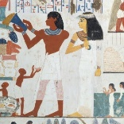  Ancient Civilisations - Features of civilisations; Ancient Sumer; Ancient Egypt; Indus Valley civilisation; Artefacts; Timelines; New inventions and technology; Everyday life; Social hierarchy; Significant leaders; End of ancient civilisations. This project teaches children about the history of three of the world’s first ancient civilisations: ancient Sumer, ancient Egypt and the Indus Valley civilisation. Children will learn about the rise, life, achievements and eventual end of each civilisation.
MFL  (Spanish) | Phonetics 2  Presenting Myself    Family | Goldilocks or Tudors  Habitats | Classroom  My Home
Music | Ukulele Lessons | Ukulele Lessons | Ukulele Lessons
PSHE | What strengths, skills and interests do we have?  How do we treat each other with respect? | How can we manage our feelings?  How will we grow and change? | How can our choices make a difference to others and the environment?  How can we manage risk in different places?
Physical Education |   Real PE Unit 1 Personal Skills Coordination - Footwork  Static Balance - One leg (Autumn 1)    Real Dance Unit 1 (Autumn 1)  Real PE Unit 2 Social Skills  Dynamic Balance to Agility - Jumping and landing  Static Balance – Seated (Autumn 2)    Real Gym Unit 1 (Autumn 2) | Real PE Unit 3 Cognitive Skills  Dynamic Balance - On a Line  Coordination - Ball skills (Spring 1)  Real Gym Unit 1 (Spring 1)  Real PE Unit 4: Creative Skills  Sending and receiving  Counter balance (Spring 2)  Premier Education: Games: Badminton (Spring 2) | Real PE Unit 5 Physical Skills  Agility - Reaction/response  Static balance - floor work (Summer 1)  Real PE Unit 6 Health and Fitness (Summer 1)  Agility - Ball Chasing  Static Balance – Stance  Orienteering (Summer 2)  Athletics/Sports Day practice (Summer 2)
RE  Sheffield Agreed Syllabus | Unit 20:  What is the trinity and why is it important for Christians?  Unit 27:  What do Hindus believe God is like? | Unit 29:  What does it mean to be a Hindu in Britain today?  Unit 28:  Why do Christians call the day Jesus died ‘Good Friday’? | Unit 26:  For Christians, when Jesus left what was the impact of Pentecost?  Unit 30:  How and why do people mark the significant events of life  (THEMATIC)

