 | Term 1 | Term 2 | Term 3
Topic title | Ground-breaking Greeks  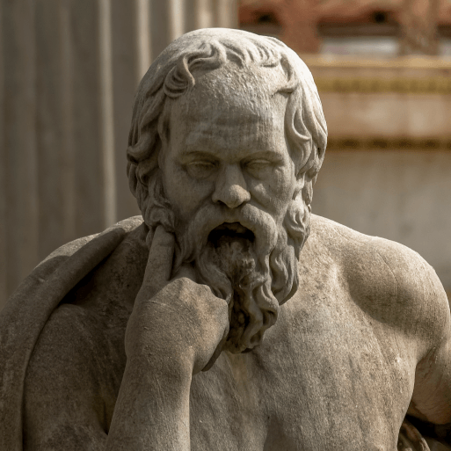  HISTORY | Sustainable World    GEOGRAPHY | Off with your head!  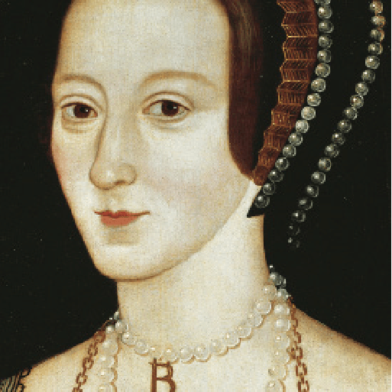  HISTORY
Memorable experience | Time team |  | Tudor Day
First Hand Experiences | Greek Day  Olympic Afternoon | Planetarium | Bishops House Visit
English | The Arrival – Shaun Tan  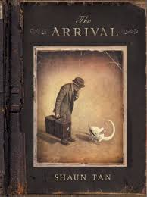  Flashback narrative  The Odyssey – Marcia Williams  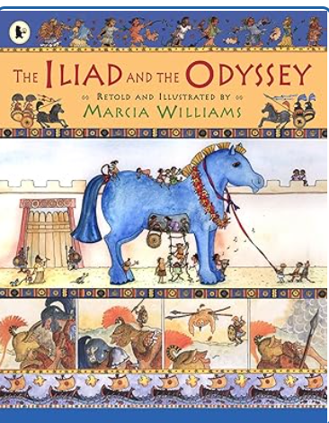  Non-chronological report  Character description | The Highwayman -Poem by Alfred Noyes  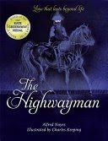  Pandora – Sci-Fi (Short Film)  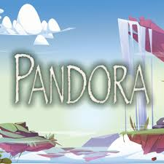  Poetry  Narrative  Explanation Text  Biographies | Treason – Berlie Doherty  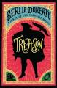    Alma – Rodrigo Blaas (Short Film)  Narrative  Non-chronological report  News Report
Reading | 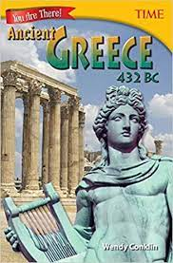  (Non Fiction) texts on Greeks.  Retrieval  Inference  Prediction  Vocabulary  Explain  Knowledge  Summary  Sequence | 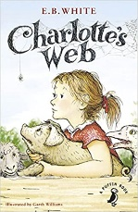  Charlotte’s Web – E B White  Retrieval  Inference  Prediction  Vocabulary  Explain  Knowledge  Summary  Sequence | Non Fiction – texts on Tudors  Retrieval  Inference  Prediction  Vocabulary  Explain  Knowledge  Summary  Sequence
Maths | Power Maths  Unit 1 – Place Value within 100,000 (8 lessons)  Unit 2 – Place Value within 1,000,000 (8 lessons)  Unit 3 – Addition & Subtraction (10 lessons)  Unit 4 – Graphs & Tables (5 lessons)  Unit 5 – Multiplication & Division (1) (10 lessons)  Unit 6 – Measure – Area & Perimeter (7 lessons) | Power Maths  Unit 7 – Multiplication & Division (11 lessons)  Unit 8 – Fractions (1) (8 lessons)  Unit 9 – Fractions (2) (12 lessons)  Unit 10 – Fractions (3) (7 lessons)  Unit 11 – Decimals & Percentages (12 lessons) | Power Maths  Unit 12 – Decimals (15 lessons)  Unit 13 – Geometry – Properties of Shapes (1) (7 lessons)  Unit 14 – Geometry – Properties of Shapes (2) (5 lessons)  Unit 15 – Geometry – Position & Direction (4 lessons)  Unit 16 – Measure – Converting Units (10 lessons)  Unit 17 – Measure – Volume & Capacity (4 lessons)  Revisit and Consolidation
Science |   Forces  This project teaches children about the forces of gravity, air resistance, water resistance and friction, with children exploring their effects. They learn about mechanisms, their uses and how they allow a smaller effort to have a greater effect.  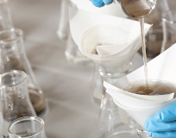  Properties and Changes in Materials  This project children to compare and group together everyday materials on the basis of their properties, including their hardness, solubility, transparency, conductivity (electrical and thermal), and response to magnets. They use their knowledge of solids, liquids and gases to decide how mixtures might be separated, including through filtering, sieving and evaporating. | 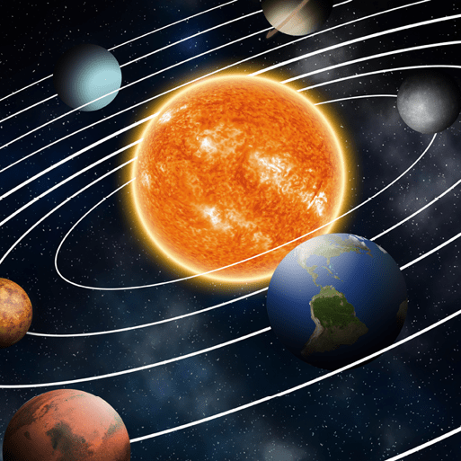  Earth and Space  This project teaches children about our Solar System and its spherical bodies. They describe the movements of Earth and other planets relative to the Sun, the Moon relative to Earth and the Earth's rotation to explain day and night. | 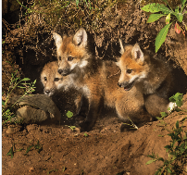  Living things and Habitats  This project teaches children about the differences in the life cycles of a mammal, an amphibian, an insect and a bird. We will also learn about the life processes of reproduction in some plants and animals.  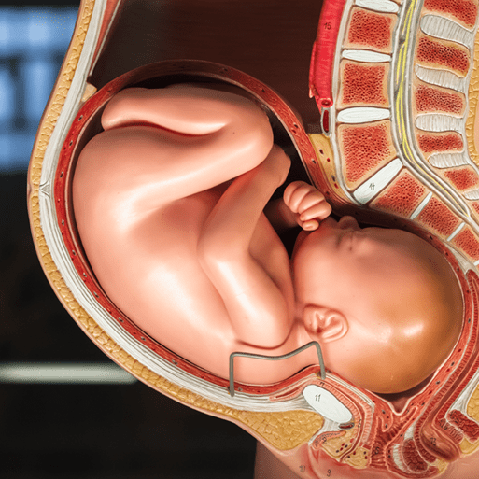  Animals, including humans  This project teaches children about the human life cycle. They explore growth and development to old age, including the changes experienced during puberty and human reproduction.  Food chains and webs; Life cycles; Plant reproduction; Growing plants; Modern farming
Computing | Unit 1: Computing systems and networks - Systems and searching    Unit 2: Creating media - Video production | Unit 3: Programming A – Selection in physical computing  Unit 4: Data and information – Flat-file databases | Unit 5: Creating media – Introduction to vector graphics  Unit 6: Programming B – Selection in quizzes
Art and Design | Unit 1: Typography and Maps  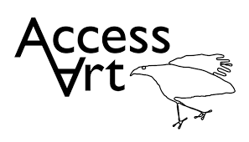 | Unit 2: Fashion Design | Unit 6: Architecture Dream Big or Small  
Design and Technology | 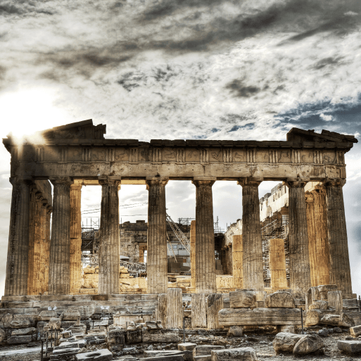  Architecture - Architecture over time; Greek architecture; Structural support, stiffness and stability; Building design. This project teaches children about how architectural style and technology has developed over time and then use this knowledge to design a building with specific features. | 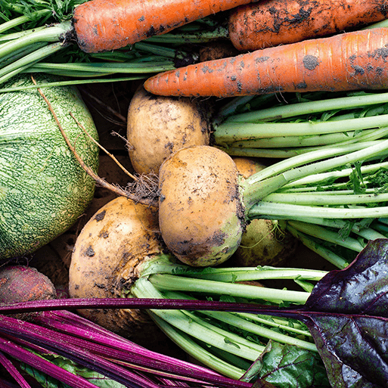  Eat the Seasons - Cooking; Nutrition. This project teaches children about the meaning and benefits of seasonal eating, including food preparation and cooking techniques. | 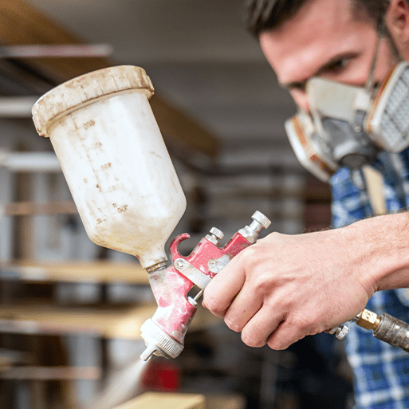  Moving Mechanisms - This project teaches children about pneumatic systems. They experiment with pneumatics before designing, making and evaluating a pneumatic machine that performs a useful function.
Geography | 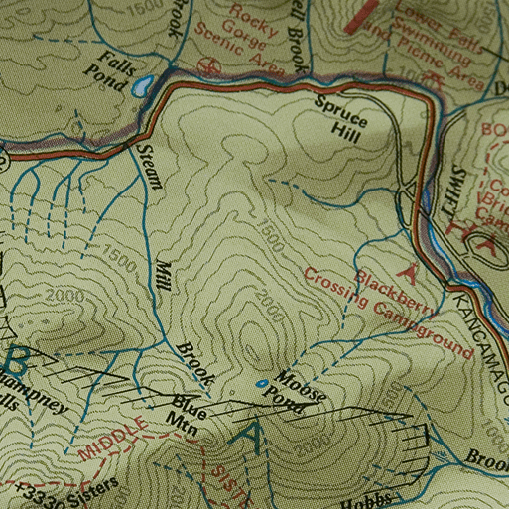  Investigating Our World - This essential skills and knowledge project teaches children about locating map features using a range of methods. They learn about the Prime Meridian, Greenwich Mean Time (GMT), and worldwide time zones and study interconnected climate zones, vegetation belts and biomes. Children learn about human geography and capital cities worldwide before looking at the UK motorway network and settlements. They carry out an enquiry to identify local settlement types. | Sustainable World  Natural Resources – renewable & non-renewable energy sources; global food production; minerals & their uses; water as a resource.  Sustainable World - Carbon footprints; Use of fossil fuels; tackling food waste; bio diversity & sustainability; Making cities more sustainable.
History | Ground-breaking Breaks - Minoan civilisation, Mycenaean civilisation, Dark Age, Archaic period, Classical period, Hellenistic period; Chronology and timelines; Primary and secondary sources; City states; Democracy; Role of men and women; Social hierarchy; Great Athenians; the Acropolis; Greek art, culture, architecture, philosophy, medicine and mathematics; Olympic Games; Alexander the Great; End of the Greek Empire; Legacy.  This project teaches children about developments and changes over six periods of ancient Greek history, focusing on the city state of Athens in the Classical age, and exploring the lasting legacy of ancient Greece. |  | Off With your Head – The Tudors  Study an aspect or theme in British history that extends pupils’ chronological knowledge beyond 1066. Gain historical perspective by placing their growing knowledge into different contexts: understanding the connections between local, regional, national and international history; between cultural, economic, military, political, religious and social history; and between short- and long-term timescales.  Gain and deploy a historically grounded understanding of abstract terms such as ‘empire’, ‘civilisation’, ‘parliament’ and ‘peasantry’.
MFL  (Spanish) | Do You Have A Pet? (Intermediate Language Unit)  What Is The Date? (Intermediate Language Unit)   | The Weather (Intermediate Language Unit)  Habitats or Romans (Intermediate Language Unit) | Olympics (Intermediate Language Unit)  Clothes (Intermediate Language Unit)
Music | 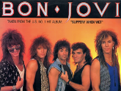  Livin’ on a prayer  This is a six-week Unit of Work. All the learning is focused around one song: Livin' On A Prayer. The material presents an integrated approach to music where games, the dimensions of music (pulse, rhythm, pitch etc), singing and playing instruments are all linked. As well as learning to sing, play, improvise and compose with this song, children will listen and appraise other classic rock songs.    Classroom Jazz  This is a six-week Unit of Work that builds on previous learning. All the learning is focused around two tunes: Three Note Bossa and The Five Note Swing. | 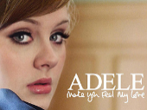  Make You Feel My Love  This is a six-week Unit of Work. All the learning is focused around one song: Make You Feel My Love. The material presents an integrated approach to music where games, elements of music (pulse, rhythm, pitch etc), singing and playing instruments are all linked. As well as learning to sing, play, improvise and compose with this song, children will listen and appraise other Pop Ballads.    Will Smith  This is a six-week Unit of Work. All the learning is focused around one song: The Fresh Prince Of Bel-Air. The material presents an integrated approach to music where games, the interrelated dimensions of music (pulse, rhythm, pitch etc.), singing and playing instruments are all linked. | 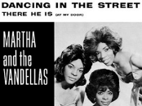  Dancing in the Streets  All the learning in this unit is focused around one song: Dancing In The Street by Martha And The Vandellas.  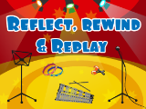  Reflect, Rewind and Replay  This Unit of Work consolidates the learning that has occurred during the year. All the learning is focused around revisiting songs and musical activities, a context for the History of Music and the beginnings of the Language of Music.
PSHE | What makes up a person’s identity?  What decisions can people make with money? | How can we help in an accident or emergency? – First Aid Course  How can friends communicate safely? | How can drugs common to everyday life affect health?  What jobs would we like?
Physical Education |   Real PE: Unit 1 Personal: Coordination Ball Skills (Autumn 1)    Real Gym Unit 1 (Autumn 2)  Swimming | Real PE Unit 2 Social: Dynamic Balances and Counter Balances (Spring 1)    Unit 1: Real Dance (Spring 2)  Swimming | Real PE Unit 4 Creative: Seated Balance Floor Work (Summer 1)  Premier Education: Fencing (Summer 2)  Athletics/Sports Day practice (Summer 2)
RE  Sheffield Agreed Syllabus | Unit 31: What does it mean if Christians believe God is Holy and loving?  Unit 32:What does it mean to be a Muslim in Britain today? | Unit 38: Why do Christians believe that Jesus was the Messiah?  Unit 33: Why is the Torah so important to Jewish people? | Unit 37: Christians and how to live: what would Jesus do?  Unit 36: What matters most to Humanists and Christians?  (THEMATIC)

