 | Term 1 | Term 2 | Term 3
Topic title | Britain at War  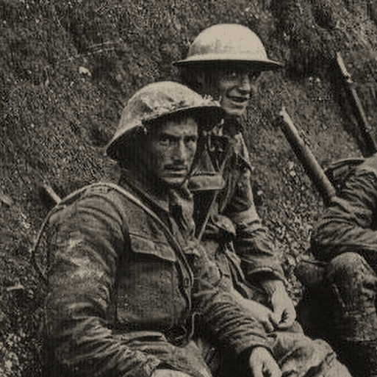  HISTORY | Frozen Kingdoms  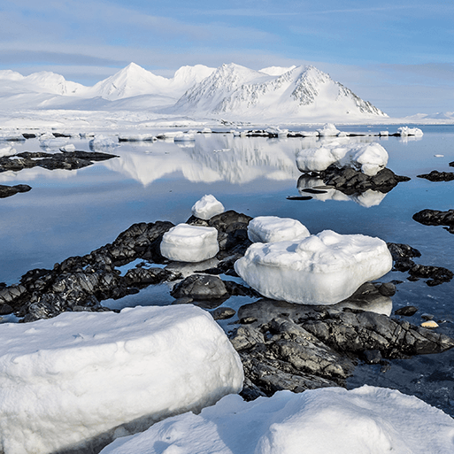  GEOGRAPHY | Benin  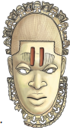  HISTORY
First Hand Experiences | PGL Residential  Britain at War Day (History Van) | Church visit  Frozen Kingdom Day | Crucial Crew  Holes Day
English | Letters from The Lighthouse / When the Sky Falls  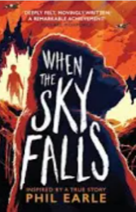  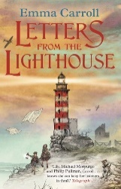  Diary entry (Letters from the Lighthouse)  Persuasive letter – (Letters from the Lighthouse)  Formal Letter of complaint writing – (Letters from the Lighthouse)  Narrative (Blitz) (When the Sky Falls) | Shackleton’s Journey /Holes  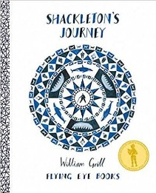  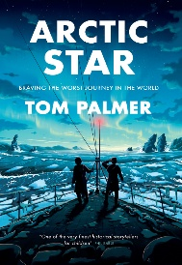  Biography (Shackleton)  Diary (Day in the life of a sailor)  Narrative – Survival (Arctic Star)  Non-chronological reports (Frozen Kingdom) | Holes / Freedom  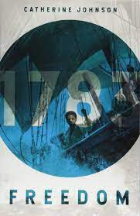  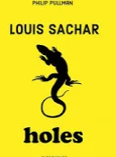  Non-chronological report – Leaflet (Holes)  Letter (informal) – (Holes)  Balanced Argument – (Freedom)  Poetry
Poetry Reads | 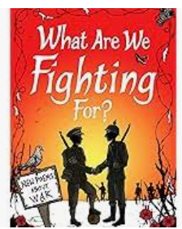  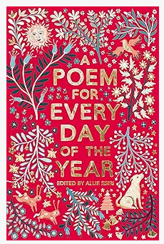 | 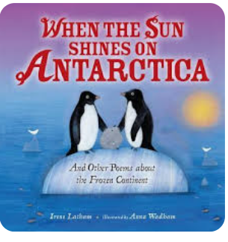  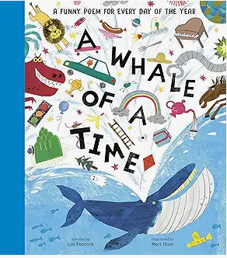 | 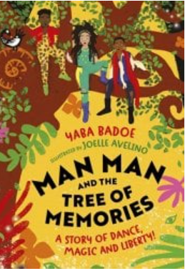  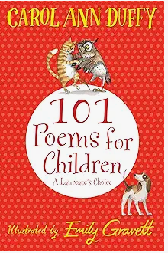
English - Reading | Retrieval  Inference  Prediction  Vocabulary  Explain  Knowledge  Summary  Sequence | Retrieval  Inference  Prediction  Vocabulary  Explain  Knowledge  Summary  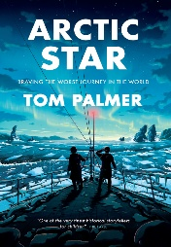  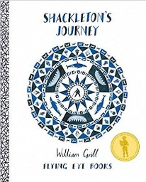  Sequence | Retrieval  Inference  Prediction  Vocabulary  Explain  Knowledge  Summary  Sequence
Maths | Power Maths  Unit 1 – Place value within 10,000,000 (7 lessons)  Unit 2 – Four operations (1) (10 lessons)  Unit 3 – Four operations (1) (11 lessons)  Unit 4 – Fractions (1) (11 lessons)  Unit 5 – Fractions (2) (9 lessons)  Unit 6 – Geometry - position and direction (4 lessons) | Power Maths  Unit 7 – Decimals (9 lessons)  Unit 8 – Percentages (9 lessons)  Unit 9 – Algebra (11 lessons)  Unit 10 – Measure - imperial and metric measures (5 lessons)  Unit 11 – Measure - perimeter, area and volume (11 lessons)  Unit 12 - Ratio and proportion (9 lessons) | Power Maths  Unit 13 – Geometry - properties of shapes (12 lessons)  Unit 14 – Problem Solving (14 lessons)  Unit 15 Statistics (10 lessons)  Revisit and Consolidation
Science | 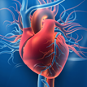  Animals, including humans  This project teaches children about the transport role of the human circulatory system, its main parts and their primary functions. They learn about healthy lifestyle choices and the effects of harmful substances on the body.  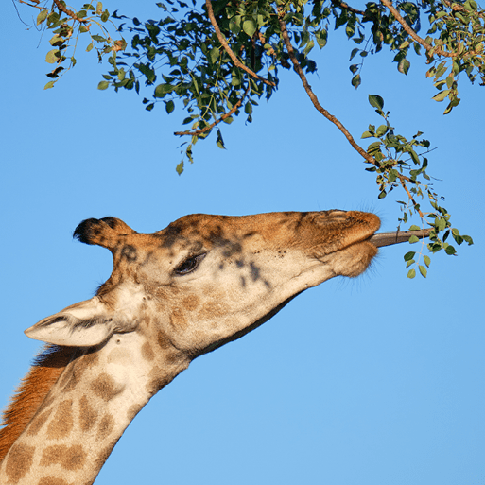  Evolution and inheritance  This project teaches children about how living things on Earth have changed over time, and how fossils provide evidence for this. They learn how characteristics are passed from parents to their offspring, and how variation in offspring can affect their survival, with changes (adaptations) possibly leading to evolution. | 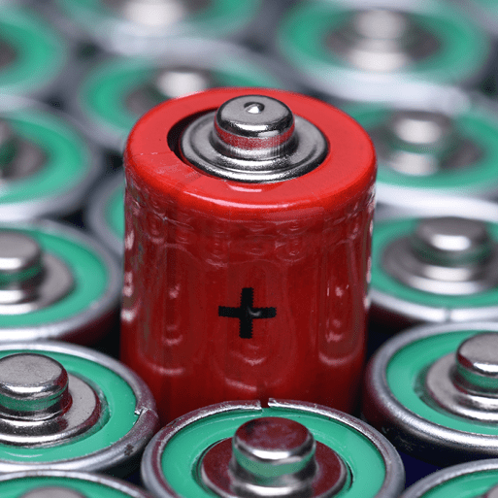  Electricity  This project teaches children about electrical circuits, their components and how they function. They recognise how voltage of cells affects the output of a circuit and record circuits using standard symbols. |   Light  This project teaches children about the way that light behaves, travelling in straight lines from a source or reflector, into the eye. They explore phenomena associated with light, including shadows, reflections, rainbows and diffraction.  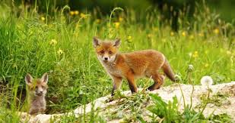  Living Things and Habitats  This project describes how living things are classified into broad groups according to common observable characteristics and based on similarities and differences, including microorganisms, plants and animals and to give reasons for classifying plants and animals based on specific characteristics.
Computing | Unit 1: Networks  Unit 2: Creating Media – Web Page Creation   | Unit 3: Programming- Variables in Games  Unit 4: Spreadsheets | Unit 5: 3D Modelling  Unit 6: Programming sensing movement  Y6 to Y7 transition – Microbits
Art and Design | 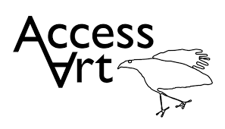  Unit 1: 2D Drawing to 3D Making | Unit 2: Activism | Unit 5: Take a Seat
Design and Technology | 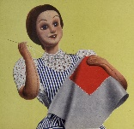  Make Do and Mend - Investigating clothing; Sewing – running stitch, whip stitch and blanket stitch; Repairing clothes; Making products from recycled materials. This project teaches children a range of simple sewing stitches, including ways of recycling and repurposing old clothes and materials. | 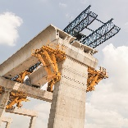  Bridges- Engineer - identify features of bridges before completing a bridge-building engineering challenge. This project teaches children about engineers and remarkable structures. They identify features of bridges before completing a bridge-building engineering challenge. | 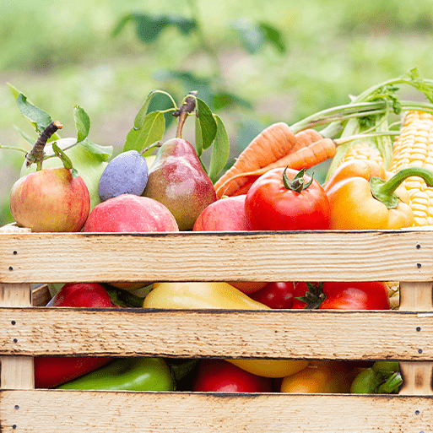  Food for Life- This project teaches children about processed food and healthy food choices. They make bread and pasta sauces and learn about the benefits of whole foods. They plan and make meals as part of a healthy daily menu and evaluate their completed products.
Geography | Place and interconnections; Maps | Frozen Kingdom  Arctic and Antarctic regions; Lines of latitude and longitude; Polar climates; Polar day and night; Polar oceans; Polar landscapes; Climate change; Natural resources; Indigenous people; Tourism.  This project teaches children about the characteristics and features of polar regions, including the North and South Poles, and includes a detailed exploration of the environmental factors that shape and influence them. | 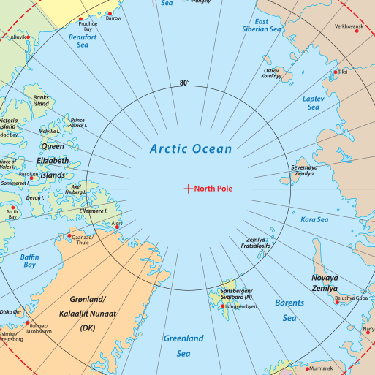  Benin and African slave trade  - Africa – countries, land use, natural resources, location, settlements, population, climate and physical features. .
History | Britain at War  First and Second World Wars; Causes; Warring nations; Weaponry, warfare and technology; Key events and battles; Impact on citizens and everyday life; Significant leaders; End of war; Local history study; Remembrance; Post-war Britain.  This project teaches children about the causes, events and consequences of the First and Second World Wars, the influence of new inventions on warfare, how life in Great Britain was affected and the legacy of the wars in the post-war period. | Frozen Kingdom  Polar exploration;  Significant people – Robert Falcon Scott; Ernest Shackleton;  Significant events – Titanic | 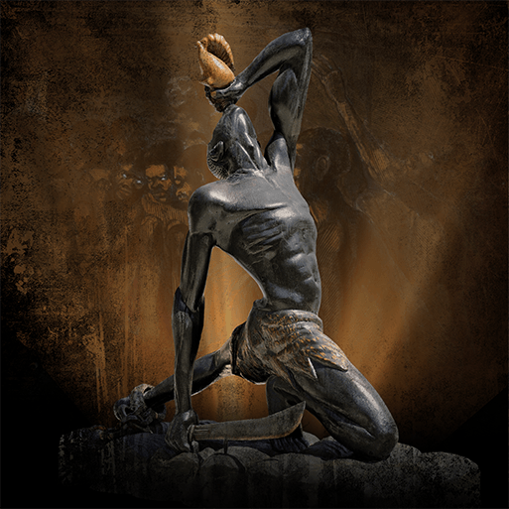  Benin  The kingdom of Benin  When and where the kingdom of Benin was  Daily life in Benin  Benin Bronzes and Benin art  The story of Eweka  What do artefacts tell us about Benin  Britain’s role in the kingdom of Benin  Development of the transatlantic slave trade; Britain's role in the slave trade; Human impact; Everyday life on plantations; Rebellion and marronage; Causes and consequences of the abolition of the slave trade and slavery;
MFL  (Spanish) | Phonetics lesson 4 (C) &  At School (P)  Regular Verbs (P)   | The Weekend (P)  World War II, Habitats or  Planets (P) | The Vikings (P)  Me In The World (P)  Family
Music | 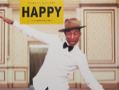  Happy  This is a six-week Unit of Work. All the learning in this unit is focused around one song: Happy, a Pop song by Pharrell Williams. The material presents an integrated approach to music where games, the dimensions of music (pulse, rhythm, pitch etc), singing and playing instruments are all linked. As well as learning to sing, play, improvise and compose with this song, children will listen and appraise other classic pop songs.  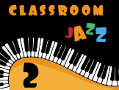  Classroom Jazz 2  This is a six-week Unit of Work that builds on previous learning. All the learning is focused around two tunes and improvising:  Bacharach Anorak and Meet The Blues. | 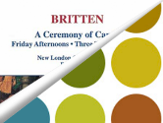  A New Year Carol  This is a six-week Unit of Work that builds on previous learning. All the learning is focused around one song from Benjamin Britten’s Friday Afternoons: A New Year Carol.  Other learning within the unit gives the opportunity to research Benjamin Britten’s life and to listen to many of his other works.  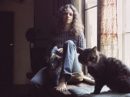  You’ve got a Friend  All the learning in this unit is focused around one song: You've Got A Friend by Carole King.  The material presents an integrated approach to music where games, the interrelated dimensions of music (pulse, rhythm, pitch etc.), singing and playing instruments are all linked. | 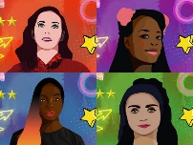  Music and Me  Music and Me is the first in a series of units focusing on inspirational women working in music, and part of Brighter Sound’s pioneering gender equality initiative both sides now.  Throughout this series, we will explore the concept of ‘identity’ – the various elements that shape us. In this unit, we start with gender, with reference to social and cultural differences.  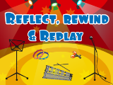  Reflect, Rewind and Replay  This Unit of Work consolidates the learning that has occurred during the year. All the learning is focused around revisiting songs and musical activities, a context for the History of Music and the beginnings of the Language of Music.
PSHE | How can we keep healthy as we grow? | How can the media influence people? | What will change as we become more independent?  Knife Crime – Danny C Foundation
Physical Education |   Unit 1: Real PE Personal: Footwork (Autumn 1)  Unit 2: Real PE Social: Dynamic Balances and Counter Balances (Autumn 1)  Unit 1: Real Gym (Autumn 2)  Premier Education: Archery (Autumn 2 Class 13) |   Unit 3: Cognitive  Dynamic Balance: On a Line  Coordination: Ball Skills (Spring 1)  Unit 1: Real Dance (Spring 1)  Unit 4: Creative  Coordination: Sending and Receiving  Counter Balance: With a Partner (Spring 2)  Unit 2: Real Gym (Spring 2) |   Unit 5: Physical  Jumping and Landing Static Balance: Floor Work (Summer 1)  Unit 6: Fitness  Sending and Receiving  Ball Chasing (Summer 1)  Athletics/Sports Day practice (Summer 2)  Premier Education: Archery (Summer 2 Class 14)
RE | Unit 34: Creation and science, conflicting or complimentary?  Unit 35: How can following God bring freedom and justice? Why do some people believe in God and some people not? | Unit 39: Why do Hindus want to be good?  Unit 40: What difference does the resurrection make to Christians? (What do Christians believe Jesus did to ‘save’ people?) | Unit 41: For Christians, what kind of king in Jesus?  Unit 42: Why do some people believe in God and some not? How does faith help people when life gets hard?  (THEMATIC)

