Overarching Principles | Unique Child: Every child is unique, is constantly learning and can be resilient, capable, confident and self-assured.  Positive Relationships: Children flourish with warm, strong & positive partnerships between all staff and parents/carers. This promotes independence across the EYFS curriculum. Children and practitioners are NOT alone – we embrace each community.  Enabling Environments: Children learn and develop well in enabling environments that are safe and secure with teaching and support from adults. Routines are established and adults respond to individual needs and passions and help children to build upon their learning over time.  Learning and Development: Children develop and learn at different rates. We must be aware of children who need greater support than others.
Characteristics of Effective Learning | Playing and Exploring  Children investigate and experience things and have a go. |  | Active Learning  Children concentrate and keep on trying if they encounter difficulties. They enjoy achievements. |  | Creating and Thinking Critically  Children have and develop their own ideas, make links between ideas, and develop strategies for doing things.
Executive Function | Executive function is a set of skills that help children regulate their behaviour and achieve goals. These skills are important for early learning and development, and are correlated with academic and social success. These skills are also interlinked with Characteristics of Effective Learning at CHPA and are taught discretely and as part of child led learning.
Executive Function | Task Initiation  Being able to initiate tasks allows children to engage in activities independently, follow instructions, and transition smoothly between different activities |  | Self-Monitoring  Developing self-monitoring skills in early childhood helps children to manage their attention, plan actions, and adapt to challenges, laying the foundation for future academic success. |  | Shifting/Flexibility  It's the mental process of smoothly transitioning between different activities, rules, or mental sets, adjusting to new information or changes in the environment
Executive Function | Emotional Control  Emotional control is closely linked to other executive functions like attention focus, inhibition (resisting impulses), and planning, as a child needs to manage their emotions to effectively engage in tasks and interactions. |  | Inhibition  Developing good inhibition skills helps children focus on tasks, follow instructions, wait their turn, and manage their emotions in challenging situations. |  | Problem Solving  In the EYFS, this might look like a child being able to follow instructions for a multi-step activity, identify different strategies to complete a puzzle, or adjust their approach when facing a challenge during play.
Executive Function | Planning  Planning has key links to the following executive function skills:  Working memory: Holding information in mind to follow a sequence of steps.  Inhibitory control: Resisting impulsive actions and staying focused on the task at hand.  Cognitive flexibility: Adapting plans as needed based on changing circumstance |  | Organising  Good organisational skills in early childhood are crucial for independent learning, managing tasks, and participating in classroom routines. Children gradually develop organisational skills as they mature, starting with simple tasks like putting toys away to more complex planning and prioritisation. |  | Time Management  Children begin developing time management skills early, learning to understand concepts like "now," "later," and "waiting" through everyday routines and activities.
Executive Function | Attentional Control  The capacity to concentrate on a particular task or activity while tuning out irrelevant stimuli, demonstrating focused attention |  | Working Memory  Working memory is considered one of the core executive functions, alongside cognitive flexibility and inhibitory control, allowing children to temporarily store and process information needed to complete a task
All of the above underpin learning across the year and are thread through taught sessions and child-initiated learning.
 | Term 1 | Term 2 | Term 3 | Term 4 | Term 5 | Term 6
Topic title –  Themes to drive the curriculum alongside children’s passions and interests. | Me and My Community  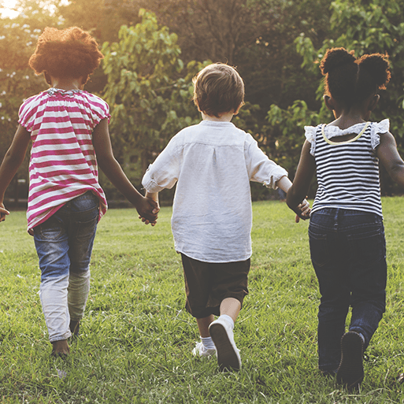  This project supports children with settling into the new rules and routines of school and encourages them to make new friends and feel confident in their class. It teaches children about being helpful, kind and thoughtful at home and at school. This project also teaches children how they are unique and special, the importance of friendship and how people in their family, school and local community are important and can help them. | Stories and Rhymes    This project supports children to develop a love of stories and reading. It encourages children to learn, retell and act out familiar and traditional tales including Cinderella, Goldilocks, Little Red Riding Hood, The Three Little Pigs and The Three Billy Goats Gruff. | Cold Places    This project teaches children about the changes that happen during winter, including the types of weather associated with winter. It also explores places that have snow all year round and the types of animals that live there | Growing    This project teaches children about food and farming and explores themes, including where food comes from, what plants and animals need to grow and survive and what constitutes a healthy lifestyle | Small animals  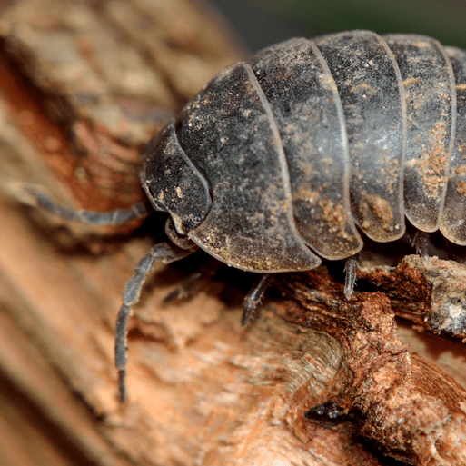  This project provides opportunities for outdoor learning and teaches children how to care for the plants and animals in their local environment and how to stay safe in the sun. This project teaches children about invertebrates that live in their gardens and local environment | At the seaside    This project teaches children about the plants and animals that live at the seaside. It also explores holidays in the past and the importance of keeping safe in the Sun
Memorable experience | Balance Bikes | Nativity | Fun in the snow | Chicks – growing from eggs | Caterpillars turning into butterflies | Ice cream
First Hand Experiences | Go on a listening walk - what can they hear.  Autumnal walk to identify signs of autumn. | Visit to the local library.  Church Visit | Winter icy morning exploration | Chicks – growing from eggs  Spring walk – signs of spring | Butterfly House Trip | Summer walk – signs of summer
Core Texts | Funnybones  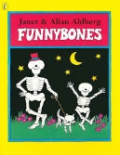  Shark in the park  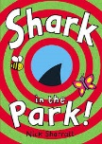  Not now Bernard  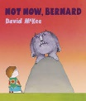  10 little dinosaurs  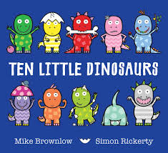 | Elmer  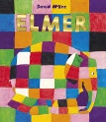  Gruffalo  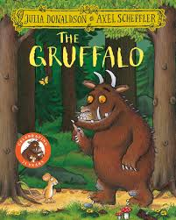  Where’s my teddy  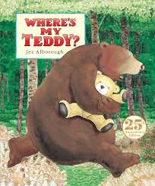  One for snail, Ten for crab  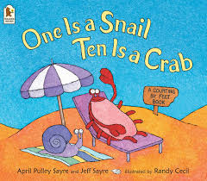 | Farmer Duck  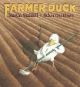  Dear Dinosaur  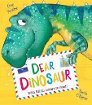  Oi Frog  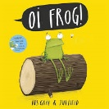  How big is a million?  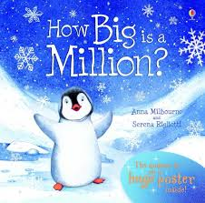 | Bog baby  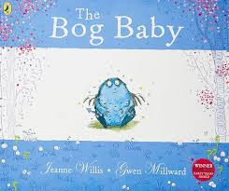  What the ladybird heard  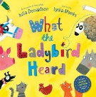  Duck in the truck  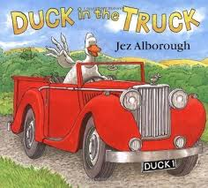  Great Pet Sale  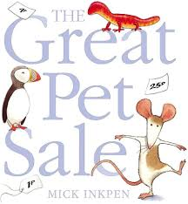 | The pig in the pond  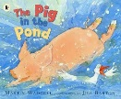  The tiger who came to tea  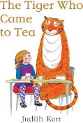  Handas surprise  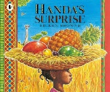  The very hungry caterpillar  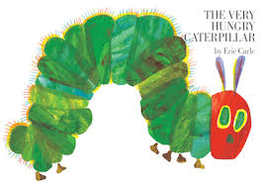 | Whatever next  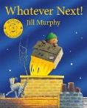  Biscuit bear  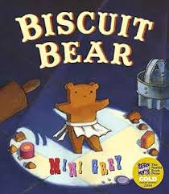  Supertato  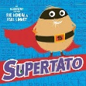  Billy’s Bucket  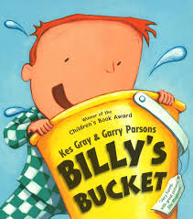
Communication and Language
The development of children’s spoken language underpins all seven areas of learning and development. Children’s back-and-forth interactions from an early age form the foundations for language and cognitive development. The number and quality of the conversations they have with adults and peers throughout the day in a language-rich environment is crucial. By commenting on what children are interested in or doing, and echoing back what they say with new vocabulary added, practitioners will build children’s language effectively. Reading frequently to children and engaging them actively in stories, non-fiction, rhymes and poems, and then providing them with extensive opportunities to use and embed new words in a range of contexts will give children the opportunity to thrive. Through conversation, story-telling and role-play, where children share their ideas with support and modelling from their teacher, and sensitive questioning that invites them to elaborate, children become comfortable using a rich range of vocabulary and language structures.
Communication and Language  Listening, attention and understanding  Speaking  ELG | Provision experiences - playing together and role play  - Know and understand how to listen carefully and why listening is important.  - Know and talk about the school rules and how they help to keep us safe.  - Engage in story times.  - Join in with familiar stories and rhymes.  Listen attentively and respond to what they hear with relevant questions, comments and actions when being read to and during whole class discussion and small group interactions. | Provision experiences - playing together and role play  - Ask questions to find out more and to check they understand what has been said to them.  - Developing social phrases and engage in story times.  - Make comments about what they have heard and ask questions to clarify their understanding.  - Hold conversations when engaged in back-and-forth exchanges with their teacher and peers.  - Use the new vocabulary taught in discussions and play. | Provision experiences - playing together and role play  - Articulate ideas and thoughts in well-formed sentences.  - Connect one idea or action to another using a range of connectives.  - Engage in non-fiction books.  - Listen to and talk about selected non-fiction to develop a deep familiarity with new knowledge and vocabulary regarding different places around the world  - Express ideas and feelings about experiences using full sentences, and begin to use past, present and future tenses with increasing accuracy.  - Showing an understanding of a broader vocabulary.  - Initiates interactions and shows an understanding of more-complex questions. | Provision experiences - playing together and role play  - Describe events in some detail.  - Use talk to help work out problems and organise thinking and activities.  - Use talk to explain how things work and why they might happen.  - Offer explanations for why things might happen, making use of recently introduced vocabulary from stories, non-fiction, rhymes and poems when appropriate.  - Use the new vocabulary taught in topic in discussions and play.  - Participate in small group, class and one-to-one discussions, offering their own ideas, using recently introduced vocabulary.  - Showing an understanding of a broader vocabulary.  - Initiates interactions and shows an understanding of more-complex questions. | Provision experiences - playing together and role play  - Describe events in some detail and talk about what they observe in the natural world and growing observations.  - Use talk to help work out problems and organise thinking and activities.  - Explain how things work and why they might happen regarding the environment.  Offer explanations for why things might happen, making use of recently introduced vocabulary from stories, non-fiction, rhymes and poems when appropriate. | Provision experiences - playing together and role play  - Listen to and talk about stories to build familiarity and understanding.  - Engage in fiction and non-fiction books and talk about what they have read and what has been read to them.  - Listen to and talk about selected non-fiction to develop a deep familiarity with new knowledge and vocabulary.  - Offer explanations for why things might happen, making use of recently introduced vocabulary from stories, non-fiction, rhymes and poems when appropriate.  Express ideas and feelings about experiences using full sentences, and begin to use past, present and future tenses with increasing accuracy.
Personal Social and Emotional Development
Children’s personal, social and emotional development (PSED) is crucial for children to lead healthy and happy lives, and is fundamental to their cognitive development. Underpinning their personal development are the important attachments that shape their social world. Strong, warm and supportive relationships with adults enable children to learn how to understand their own feelings and those of others. Children should be supported to manage emotions, develop a positive sense of self, set themselves simple goals, have confidence in their own abilities, to persist and wait for what they want and direct attention as necessary. Through adult modelling and guidance, they will learn how to look after their bodies, including healthy eating, and manage personal needs independently. Through supported interaction with other children they learn how to make good friendships, co-operate and resolve conflicts peaceably. These attributes will provide a secure platform from which children can achieve at school and in later life.
Personal, Social and Emotional Development  Self-Regulation  Managing self  Building Relationships  ELG | - Listen attentively and respond to what they hear with relevant questions, comments and actions.  - Being read to during whole-class discussions and small-group interactions;  - Make comments about what they have heard and ask questions to clarify their understanding;  - Hold conversations when engaged back-and-forth exchanges with their teachers and peers.  - Show an understanding of their own feelings and those of others and begin to regulate their behaviour accordingly.  - Set and work towards simply goals, being able to wait for what they want and control their immediate impulses when appropriate  - Give focused attention to what the teacher says, responding appropriately even when engaged in activity and show an ability to follow instructions involving several ideas or actions.  - Be confident to try new activities and show independence, resilience, and perseverance in the face of challenge  - Explain the reasons of rules, know right from wrong and try to behave accordingly,  - Manage their own basic hygiene and personal needs, including dressing, going to the toilet, and understanding the importance of healthy food choices.  - Work and play cooperatively and take turns with others  - Form positive relationships to adults and friendships with peers  - Show sensitivity to their own needs and those of others.  - Know some differences and similarities between different religious and cultural communities in this country, drawing on their experiences and what has been read in class.  - Explain some difference and similarities between life in this country and life in other countries, drawing on knowledge from stories, non-fiction texts and –when appropriate- maps. |  | - Set and work towards simple goals.  - Show resilience and perseverance in the face of a challenge.  - Identify and moderate own feelings socially and emotionally.  - Display confidence to try new activities.  - I can talk about how my body feels when I am not comfortable with something. (link with computing.  - Show an understanding of their own feelings and those of others and begin to regulate their behaviour accordingly. | - Know the importance of exercise and how to keep healthy.  - Know how to stay safe.  - Show understanding of their own feelings and those of others and begin to regulate their behaviour accordingly.  - Manage own basic hygiene and personal needs, including dressing, going to the toilet, and understanding the importance of healthy food choices.  - Explain the reasons of rules, know right from wrong and try to behave accordingly, | - Know how to be a good friend.  - Think about the perspectives of others.  - Show understanding of own feelings and those of others and begin to regulate own behaviour accordingly.  - Show sensitivity to their own and to others’ feelings.  - Begins to understand how others might be feeling, to show empathy.  - Increased confidence and resilience and this can include supporting peers.  - Understanding the importance of healthy food choices. | - Know how we grow and change.  - Be confident to try new activities and show independence, resilience and perseverance in the face of challenge.  - Show sensitivity to their own and to others’ feelings.  - Display confidence to try new activities and show resilience and perseverance in the face of a challenge.  - Explain the reasons for rules and know right from wrong.
Physical Development
Physical activity is vital in children’s all-round development, enabling them to pursue happy, healthy and active lives. Gross and fine motor experiences develop incrementally throughout early childhood, starting with sensory explorations and the development of a child’s strength, co-ordination and positional awareness through tummy time, crawling and play movement with both objects and adults. By creating games and providing opportunities for play both indoors and outdoors, adults can support children to develop their core strength, stability, balance, spatial awareness, co-ordination and agility. Gross motor skills provide the foundation for developing healthy bodies and social and emotional well-being. Fine motor control and precision helps with hand-eye co-ordination which is later linked to early literacy. Repeated and varied opportunities to explore and play with small world activities, puzzles, arts and crafts and the practice of using small tools, with feedback and support from adults, allow children to develop proficiency, control and confidence
Physical Development  Our outdoor provision is carefully selected to provide opportunities to develop gross motor skills, balance, core stability and stimulate the vestibular system.  ELG  Our provision is carefully planned to provide opportunities to develop fine motor skills. | - I can make independent choices.  - I can negotiate space safely with consideration for myself and others.  - I play co-operatively and take turns with others  Real PE (unit 1) Personal  - I can explore and experiment moving in different ways e.g. how to march, run and bounce on the spot on one and both legs.  - I can move forwards, backwards and sideways in different ways (driving arms forwards and backwards).  - I can explore how to balance on one leg.  - Use a dominant hand to be able to mark make using different shapes.  - Use a tripod grip when using mark making tools.  - Begin to copy letters.  - Hold scissors and make snips.  - Hold a fork and spoon with increasing control.  - Begin to form most letters correctly. | - I can negotiate space safely with consideration for myself and others.  - I am confident to try new challenges.  - I follow instructions involving several ideas or actions.  - I play co-operatively, take turns and encourage others  Real PE (unit 1) Personal  - I can explore and experiment moving in different ways e.g. how to march, run and bounce on the spot on one and both legs.  - I can move forwards, backwards and sideways in different ways (driving arms forwards and backwards).  - I can explore how to balance on one leg.  - Use anti-clockwise movement and retrace vertical lines.  - Hold scissors correctly and cut along a straight line and zigzagged lines.  - Use a tripod grip when using mark making tools.  - Draw lines, circles and shapes to draw pictures.  - Write taught letters using correct formation and starting in the correct place.  - Begin to hold a knife correctly and use to cut. | - I can negotiate space safely with consideration for myself and others.  - I work co-operatively with others and take turns.  - I am confident to try new challenges.  Real Gym (Unit 1) Fitness  - I can explore how to make shapes and hold balance with my body.  - I can move safely in and around low apparatus (shape, balance and travel).  - Use a tripod grip when using mark making tools.  - Hold scissors correctly and cut along a curved line.  - Write taught letters using correct formation. | - I can negotiate space safely with consideration for myself and others.  - I follow instructions involving several ideas or actions.  Real Gym (Unit 2)  Cognitive  - I can explore flight (landing techniques) and rotation (rolls).  - I use movement skills with developing strength, balance and co-ordination showing increasing control and grace.  - Hold scissors correctly and cut out large shapes.  - Write letters using the correct letter formation and control the size of letters. | - I can negotiate space safely with consideration for myself and others.  - I use ball skills with developing competence and accuracy.  - I play co-operatively and take turns with others.  - I can make independent choices.  - I persevere when trying new challenges.  Real Dance- Creative  - I can explore different standing and floor shapes with a partner and find interesting and inventive ways of moving between these shapes.  - I can put shapes into a repeatable sequence.  - I can explore the concept of circles and use circles to travel in different ways making basic turns and jumps.  - I can work with a partner to create and perform a final dance sequence.  - I can move to music.  - Hold scissors correctly and cut out small shapes.  - Write letters inline with the school handwriting policy.  - Paint using thinner paintbrushes. | - I try my best.  Real PE- Unit 5 Physical  Coordination: Sending and Receiving  - I can explore and experiment how to roll, bounce and catch different sized and weighted balls.  Agility: Reaction/Response  - I can explore running forward very quickly on a signal.  - I can explore different starting positions to see which works best.  - I can explore different ways to slow down and stop to see which works best.  - I can explore bouncing a big and small ball on the spot.  - I can throw a ball up high, let it bounce and move to catch it.  - Hold scissors correctly and cut various materials.  - Write letters inline with the school handwriting policy.  - Create drawings with details.  - Independently use a knife fork and spoon to eat a range of meals.
Literacy
It is crucial for children to develop a life-long love of reading. Reading consists of two dimensions: language comprehension and word reading. Language comprehension (necessary for both reading and writing) starts from birth. It only develops when adults talk with children about the world around them and the books (stories and non-fiction) they read with them, and enjoy rhymes, poems and songs together. Skilled word reading, taught later, involves both the speedy working out of the pronunciation of unfamiliar printed words (decoding) and the speedy recognition of familiar printed words. Writing involves transcription (spelling and handwriting) and composition (articulating ideas and structuring them in speech, before writing).
Literacy  ELG | Word Reading  New Phonemes:  s, a, t, p, i, n, m, d, g, o, c, k, ck, e, u, r, h, b,  - Orally segment and blend words.  - Beginning to recognise some individual letters by saying the sounds for them.  - Hears known initial sound phonemes.  - Beginning to link graphemes and phonemes.  - Tracks letters in word reading.  Comprehension  - Listens to a story and can give simple details about the story.  - Starts to use some of the events in their own play  Writing  - They mark make as part of their play. | Word Reading  New Phonemes:  f, l, ff, ll, ss, j, v, w, x, y, z, zz, qu, ch, sh, th, ng, long oo, ar  - Reads some meaningful key words and can orally segment and blend words.  - Begins to read words and sentences containing known sounds.  - Read text from left to right.  - Links phonemes to every letter of the alphabet and beginning to blend them in words.  - Reads HFW from Phase 2 letters and sounds.  Comprehension  - Shows an interest in reading often choosing a book to look at themselves or with friends.  Writing  - Pupils mark make consistently as part of their play and can talk about the meaning of their marks.  - Pupils have the confidence to mark make using their physical skills to increase control over tools and equipment. | Word Reading  New Phonemes:  oo(u), ow, ee, ur, ai, or  - Hear and say the phonemes  - Blend to read words using known graphemes  - Segment to spell words using known graphemes.  - Read sentences with phonetically plausible words.  - Read known HFWs.  Comprehension  - Can answer questions about the content of a book and shows an interest in reading by themselves.  - Shows a preference for a book, story type, genre, author.  - Chooses to read to friends.  - Likes to join in with reading in class.  - Identifies rhymes.  Writing  - Sentence structure is starting to be evident.  - Some phonic awareness is evident.  - Pupils are good at oral rehearsal. | Word Reading  New Phonemes:  oa, er, igh, air, oi, ear, ure  - Hear and say the phonemes  - Blend to read words using known graphemes  - Segment to spell words using known graphemes.  - Read known HFWs.  - Fluently reads CVC phase 2 words and captions and recognises some diagraphs.  - Beginning to apply knowledge of long vowels in their reading of sentences.  Comprehension  - Engages in non-fiction books.  - Listens to and talks about non-fiction books applying new knowledge and vocabulary.  - Answers and asks ‘why’ questions about text that has been read to them.  Writing  - Can compose a sentence well with some sentence structure more-consistently used.  - Phonic awareness is more evident.  - Physical control is evident. | Word Reading  CVCC, CCVC, CVC+, CCVCC words applying known phonemes  - Completes rhyming strings  - Read words consistent with their phonic knowledge by sound blending.  - Read aloud simple sentences and books that are consistent with their phonics knowledge, including some common exception words.  Comprehension  - Can answer more-complex questions about books and stories.  - Use and understand recently introduced vocabulary during discussions about stories, non-fiction, rhymes and poems and during role play.  Writing  - Writes recognisable letters and words and reads back what has been written.  - Spell words by identifying the sounds with a letter or letters. | Word Reading  CVC+, CCC, CCVCC words applying known phonemes  - Fluently reads words and sentences containing Phase 3 letters and HFWs.  - Say a sound for each letter in the alphabet and at least 10 diagraphs.  - Read words consistent with their phonic knowledge by sound blending.  Comprehension  - Demonstrate understanding of what has been read to them by retelling stories and narratives using their own words and recently introduced vocabulary.  - Anticipate where appropriate key events in stories.  Writing  - Write recognisable letters, most of which are correctly formed.  - Write simple phrases and sentences that can be read by others.
Literacy Texts | Five Minutes Peace –  Jill Murphy  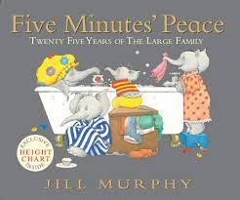  Everywhere Bear –  Julia Donaldson  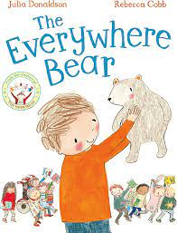  We’re Going on a Bear Hunt –  Michael Rosen  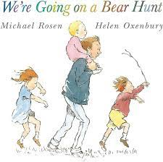  Nursery Rhymes | Goldilocks and the Three Bears –  Nicola Baxter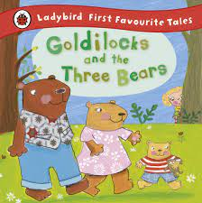  Gingerbread man –  Traditional tale  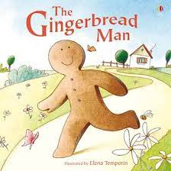  Stick Man –  Julia Donaldson  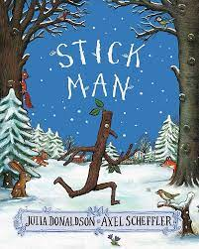  Nursery Rhymes | Arctic animals –  Jill MacDonald  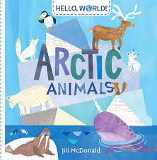  Polar Bear Polar Bear What Do You Hear? –  Bill Martin Jr  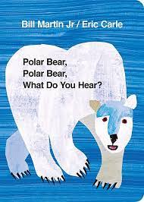  One Snowy Night (A Percy the Park Keeper Story) –  Nick Butterworth;  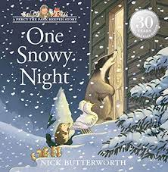 | Enormous Turnip – Traditional Tale  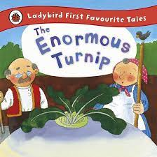  Oliver’s Vegetables – Vivian French  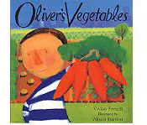  Sam Plants a Sunflower – Kate Petty  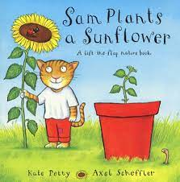 | Hungry Caterpillar –  Eric Carle  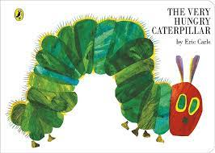  Yucky worms –  Vivian French  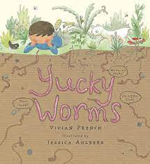  Mad about Minibeasts – Giles Andradae  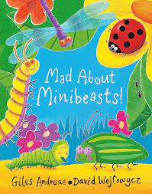 | Splash Anna Hibiscus! - Atinuke  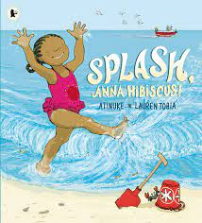  Billy’s Bucket –  Kes Gray  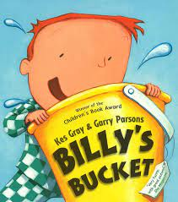  Rainbow Fish –  Marcus Pfister  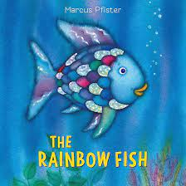
Maths
Developing a strong grounding in number is essential so that all children develop the necessary building blocks to excel mathematically. Children should be able to count confidently, develop a deep understanding of the numbers to 10, the relationships between them and the patterns within those numbers. By providing frequent and varied opportunities to build and apply this understanding – such as using manipulatives, including small pebbles and tens frames for organising counting – children will develop a secure base of knowledge and vocabulary from which mastery of mathematics is built. In addition, it is important that the curriculum includes rich opportunities for children to develop their spatial reasoning skills across all areas of mathematics including shape, space and measures. It is important that children develop positive attitudes and interests in mathematics, look for patterns and relationships, spot connections, ‘have a go’, talk to adults and peers about what they notice and not be afraid to make mistakes.
Mathematics  Mastering Number  Number & Numerical Patterns  ELG | Numbers 0- 4 (4 weeks)  Subitising  - Subitising within 3.  - Subitise objects and sounds  Counting, ordinality and cardinality  - Focus on counting skills  Composition  - Explore how all numbers are made up of 1’s.  - Focus on composition of 3 and 4.  Shape, space and measure  - Repeating patterns  - 2D shape introduction  - ABC Patterns  - 2D/3D shapes in the environment | Numbers 0- 5 (5 weeks)  Counting, ordinality and cardinality  - Focus on counting skills  - Focus on the ‘five- ness of 5’ using one hand and the die pattern for 5.  Composition  - Explore the concept of ‘whole’ and ‘part’.  - Focus on the composition of 3, 4 and 5.  Comparison  - Comparison of sets ‘just by looking’ and progressing to matching.  - Use the language of comparison: more than and fewer than, an equal number.  Shape, space and measure  - Review 3D shapes and spotting 2D shapes within 3D shapes  - Length- Vocabulary introduction  - Comparing length  - Weight- Vocabulary introduction  - Comparing weight  - ABAB repeating pattern review and ABC Pattern introduction | Numbers 0- 7 (6 weeks)  Subitising  - Subitise within 5 focusing on die patterns  - Match numerals to quantities within 5.  Counting, ordinality and cardinality  - Practise object counting skills.  - Match numerals to quantities within 10.  - Verbal counting beyond 20.  - Counting- focus on ordinality and th ‘staircase’ pattern  - See that each number is one more than the previous number.  Composition  - Focus on 5.  - Focus on 6 and 7 as ‘5 and a bit’.  - Compare sets and use language of comparison: more than, fewer than, , an equal number to.  - Make unequal sets equal.  Shape, space and measure  - Capacity Introduction  - Comparing Capacity  - Continuing an AB and ABC Pattern  - Making own AB and ABC Patterns  - Properties of shapes. | Numbers 0- 8 (5 weeks)  Counting, ordinality and cardinality  - Focus on the ‘staircase’ pattern and ordering numbers.  Composition  - Focus on 7.  - Doubles- explore how some numbers can be made with equal parts.  - Sorting numbers according to attributes- odd and even numbers.  Comparison  - Focus on ordering of numbers to 8.  - Use language of ‘less than’.  Shape, space and measure  - Recognising the relationship between the size and number of units- length  - Begin to use units to compare length.  - Recognising the relationship between the size and number of units- weight  - Begin to use units to compare weight.  - Ordering events and time | Numbers 0- 10 (6 weeks)  Counting, Ordinality and cardinality  - Counting larger sets and things that cannot be seen  Subitising  - Subitising- to 6, including in structured arrangements  Composition  - Composition- 5 ‘and a bit’.  - Composition- of 10  Comparison  - Comparison- linked to ordinality  - Play track games  Shape, space and measure  - Experience time durations (sand timers, calendars)  - Capacity: Recognising the relationship between the size and number of units.  - Capacity: Begin to use units to compare capacity.  - Continuing a pattern that ends mid unit.  - Making their own ABB/ABBC Patterns  - Properties of shape and awareness of relationships between shapes | Numbers 0- 10 (8 weeks)  Counting, Ordinality and cardinality  - Verbally counts beyond 20, recognising the patterns of the counting system.  Subitise to 5  Introduce the Rekenrek  Review and Assess:  - Automatic recall of number bonds to 5  - Composition of numbers to 10  - Comparison  - Number Pattern  - Counting  - Cohort specific planning from reviewing and assessment.  Shape, space and measure  - Uses own ideas to make models of increasing complexity, selecting blocks needed, solving problems and visualising what they will build.  - Enjoys tackling problems involving prediction and discussion of comparisons of length, weight or capacity, paying attention to fairness and accuracy.
Understanding the World
Understanding the world involves guiding children to make sense of their physical world and their community. The frequency and range of children’s personal experiences increases their knowledge and sense of the world around them – from visiting parks, libraries and museums to meeting important members of society such as police officers, nurses and fire-fighters. In addition, listening to a broad selection of stories, non-fiction, rhymes and poems will foster their understanding of our culturally, socially, technologically and ecologically diverse world. As well as building important knowledge, this extends their familiarity with words that support understanding across domains. Enriching and widening children’s vocabulary will support later reading comprehension.
Understanding the world  History  ELG  Geography/ RE  ELG  Science  ELG  Computing | Past and present  - Talks about their immediate family.  - Understands the generational relationships in a basic family tree including their siblings, mum, dad, and grandparents.  - Knows people in the school environment and their roles: Head Teacher, site manager, office manager, school cook.  - Takes an interest in the different roles of people who support their community and makes observations of their role, uniforms, transport.  - Understands that not everyone celebrates the same celebrations, but what how we celebrate are similar.  People, culture and communities  - Talks about their home and the places they go to in their immediate environment.  - Knows that some places are far away, and we cannot walk there.  - Creates different play environments -beach, city, forest, etc., in small-world play with support, naming their features; trees, river, mountains etc.  - Makes observations of landscapes in photos, books, and videos.  The natural world  - Shows curiosity in the environment around them inside and outdoors.  - Comments on unknown objects, based on their own exploration.  - Says what they can hear, see, and feel whilst outside.  - An immediate change, feeling the wind pick up, getting sunny.  - Observes and talks about the changes in nature they notice.  Photography  - I can talk about what photos show.  - I can take photos using a digital device. | Past and present  - Uses the environment (visual timetables) to sequence and discuss the day’s structure using vocabulary – now, next.  - Knows the names of the days of the week and their order.  - Remembers and talks about significant events in their own experiences.  - Understands their birthday celebrates the day that they were born.  - Knows when their birthday is (home project).  - Takes an interest in and comments on unknown objects, exploring their; textures, mass, moving parts etc. (Guided through hypothesising function.)  People, culture and communities  - Creates different play environments -beach, city, forest, etc., in small-world play with support, naming their features; trees, river, mountains etc.  - Makes observations of landscapes in photos, books, and videos.  The natural world  - Shows curiosity in the environment around them inside and outdoors.  - Comments on unknown objects, based on their own exploration.  - Says what they can hear, see, and feel whilst outside.  - An immediate change, feeling the wind pick up, getting sunny.  - Observes and talks about the changes in nature they notice.  Safety and Privacy  - I know who can help me when I am feeling worried.  - I can choose activities in my free time that help me to be healthy.  - I can show that I understand how to be kind to others. | Past and present  - Uses the vocabulary; today, tomorrow, and yesterday in the correct context.  - Answers and asks ‘why’ questions about text that has been read to them.  - Engages in non-fiction books.  People, culture and communities  - Describes the natural landscape.  - Answers and asks “why” questions.  - Knows that the country we live in is England.  - Names some hot and cold countries.  - Knows that different countries have different landscapes.  - Knows about the lifestyle of people in other countries for example: foods, home, clothing, significant buildings, languages, and culture.  - Knows what a globe is and that it represents the world.  The natural world  - Takes part in simple experiments led by an adult (floating and sinking) discussing the differences in the objects.  - Makes simple predictions with support. Carries out simple set up experiment (sorting materials) that enables them to talk about similarities –classifying.  - Names the four seasons and talks about their differences and the impact on their lives.  - Pupils use new knowledge to classify animals therefore highlighting their similarities and differences.  - Understands animals have similar features to live in specific habitat. Camouflage, fur to protect from the cold etc.  Safety and Privacy  - I can talk about how my body feels when I am not comfortable with something. (PSED – link) | Past and present  - Orders and sequences pictorial representations of their daily routines or tasks based on experience.  - Takes an interest in and comments on images of familiar situations from the past.  - Hypothesises about the function of artefacts, based on creative ideas or past experiences.  People, culture and communities  - Knows that people have different beliefs and traditions that affect their lives.  - Knows that there is a link between stories and festivals: The Easter story, Chinese New Year – The great race.  - Knows that there are many different countries in the world.  - Understands that other countries have traditional foods, significant buildings, traditional clothing and their own language like we do in England.  The natural world  - Take part in simple observations to identify parts of a plant.  - Investigate how plants grow.  - Makes simple predictions with support. Carries out simple set up experiment (sorting materials) that enables them to talk about similarities –classifying.  - Names the four seasons and talks about their differences and the impact on their lives  Digital Art  - I can select colours when painting on an iPad.  - I can draw pictures on the iPad.  - I can try the different tools that I can draw with on the iPad.  - I can use a touchscreen device purposefully. | Past and present  - Shows an understanding of the passing of time through the life cycle of plants, animals and mini beasts.  - Sequences the basic stages of human life cycle. (Year 1)  - Compares and contrasts the different stages in the life cycle of plants, animals, and mini beasts.  - Compares and contrasts the basic stages of human life cycle.  - Begins to organise/sequence their own story ideas on a story map using story stems structure as support, including the vocabulary first, next, after that and finally.  - Understand the past through settings, characters and events encountered in books read in class and storytelling.  People, culture and communities  - Draws own plans/maps of immediate environment.  - Describes the immediate environment using knowledge from observation, discussion, stories, non-fiction texts and maps.  The natural world  - Selects equipment to help them follow their own enquiry of interest, for example, which mini beasts live in the playground?  - Explore the natural world around them, making observations and drawing pictures of animals and plants.  - Shows an understanding of the passing of time through the life cycle of plants, animals, and mini beasts.  - Sequences the basic stages of human life cycle.  - Records observations in a number of ways; drawings, written work, photographs.  - Records observations to enable changes to be observed.  Technology Around Us  - I can talk about what technology is used at home.  - I can talk about what technology is used outdoors.  - I can talk about what technology is used in the world around me. | Past and present  - Begins to organise/sequence their own story ideas on a story map using story stems structure as support, including the vocabulary first, next, after that and finally.  - Understand the past through settings, characters and events encountered in books read in class and storytelling.  - Talk about the lives around them and their roles in society.  - Know some similarities and difference between things in the past and now, drawing on their experiences and what they have read in class.  - Justifies hypothesis regarding artefacts using existing knowledge or seeking more information; asking questions, building on the ideas of others, or using images and books.  People, culture and communities  - Knows the landmark buildings (including places of worship) in their local environment and discusses their importance.  - Draws own plans/maps of immediate environment.  - Makes inferences about locations in books based on previous knowledge or experiences:  - clothing worn  - buildings  - foods  - weather  - animals  - landscape.  - Explains some similarities and difference between life in this country and life in other countries, drawing on knowledge from stories, non-fiction texts and (when appropriate) maps.  - Knows we have different environments in this county; water/sea, woods, beaches, etc  The natural world  - Records observations in a number of ways; drawings, written work, photographs.  - Records observations to enable changes to be observed.  - Know some similarities and differences between the natural world around them and contrasting environments, drawings on their experiences and what has been read in class.  - Understand some important processes and changes in the natural world around them, including the seasons and changing states of matter.  Safety and Privacy  - I can explain how my work on the computer belongs to me and other people’s work belongs to them.  - I can explain what it means for something to be private.
RE | Being special: where do we belong?  - I can talk about things that are special to me and why they value these things.  - I will learn about key religious symbols for Christians, Muslims and Hindus.  - I will find out about why many Christians believe that children are special to God and learn about the story of Jesus and the children. I will find out about the welcoming ceremonies that many Muslims and Christians have for a new baby.  - I will learn out about how Hindu brothers and sisters might show their love and respect for each other at Raksha Bandhan. | Why do Christians perform Nativity plays at Christmas? (Why is Christmas special for Christians?)  - I can retell the key events from the Christian Christmas story.  - I can tell you about the term incarnation (God come to earth as a human and as God).  - I will learn about the Christian belief that this happened in Jesus.  - I will learn about who Christians believe first visited Jesus in the stable and why.  - I will find out about the timeline of the story and that most Christians believe that the wise men/Magi arrived when Jesus was one or two years old.  - I will understand that some stories change over time and that it is important for believers to return to and study the original text.  - I can tell you that some Christians perform nativity plays to retell the story so that others can find out more about the Christian belief of incarnate. | Being special: where do we belong?  - I can talk about things that are special to me and why they value these things.  - I will learn about key religious symbols for Christians, Muslims and Hindus.  - I will find out about why many Christians believe that children are special to God and learn about the story of Jesus and the children. I will find out about the welcoming ceremonies that many Muslims and Christians have for a new baby.  - I will learn out about how Hindu brothers and sisters might show their love and respect for each other at Raksha Bandhan. | Why do Christians put a cross on their Easter garden? (Why is Easter special to Christians?)  - I can recall the key events from Palm Sunday until Easter Day in the Christian Salvation story.  - I will find out about the Christian belief that Jesus saved his people from their sins by dying on the cross and rising again three days later.  - I will encounter signs and symbols linked to the celebration of Easter and be able to talk about why these are important for believers. | Which places are special and why?  - I can reflect upon places that are special in my life.  - I can find out about places that are holy and important for many Christians and Muslims.  - I can label a Churches and Mosques showing their key features.  - I can visit a place of worship (Mosque or Church). | Which stories are special and why?  - I can discuss stories that are special to me and give reasons for why they are special.  - I can listen to different religious worldviews and find out about why these might be special to a believer.  - I can learn key events and retell stories from different worldviews remembering.
Expressive Arts and Design
The development of children’s artistic and cultural awareness supports their imagination and creativity. It is important that children have regular opportunities to engage with the arts, enabling them to explore and play with a wide range of media and materials. The quality and variety of what children see, hear and participate in is crucial for developing their understanding, self-expression, vocabulary and ability to communicate through the arts. The frequency, repetition and depth of their experiences are fundamental to their progress in interpreting and appreciating what they hear, respond to and observe.
Expressive Arts and Design  Art and DT  ELG  Role play / dance / music | Creating with materials  - I know some different tools to use when painting  - I know the names of colours  - I can mix some colours  - I develop my own ideas and then decide which materials to use to bring my ideas to life  - I can join some materials together  - I can join materials together in different ways e.g., Sellotape, glue etc.  - I can select materials for a purpose and explain my choices  - I know how to select colours for a purpose and mix them appropriately  - I can add finer details to my drawings  - I can work alongside my peers on models, or art work sharing resources cooperatively  - I can share my ideas.  - I can develop my ideas and decide which materials to use.  - I can create closed shapes and use these shapes to create objects  Being imaginative and expressive  - Develops preference for forms of expression.  - Creates movement in response to music.  - Sings to themselves and makes up own songs.  - Engages in imaginative role-play based on own first-hand experiences that includes roles and simple narrative, for example, having dinner together, going to the shops.  - Uses movement to express feelings.  - To know twenty nursery rhymes off by heart.  - To know the stories of some of the nursery rhymes.  - To know that we can move with the pulse of the music.  - To know that the words of songs can tell stories and paint pictures.  - To sing or rap nursery rhymes and simple songs from memory.  - Songs have sections.  - A performance is sharing music |  | Creating with materials  - I can share my ideas.  - I can develop my ideas and decide which materials to use.  - I can create closed shapes and use these shapes to create objects.  - I can share my creation and explain how I made it.  - I know how to mix colours accurately  - I know how to improve and refine my ideas  - I can select appropriate materials for the task set  - I can join different materials in different ways and show increased ability to problem solve  - I can use scissors and one-handed tools to create art safely and more accurately  - I can explore different techniques e.g., collage, print, paint, to create art  Digital -  - I can select colours when painting on an iPad.  - I can draw pictures on the iPad.  - I can try the different tools that I can draw with on the iPad.  - I can use a touchscreen device purposefully.  Being imaginative and expressive  - To know twenty nursery rhymes off by heart.  - To know the stories of some of the nursery rhymes.  - To know that we can move with the pulse of the music.  - To know that the words of songs can tell stories and paint pictures.  - To sing or rap nursery rhymes and simple songs from memory.  - Songs have sections.  - A performance is sharing music.  - Uses available resources to create props to support role-play.  - Develops storylines with detail in their pretend play, for example, someone’s birthday, they sing and create a party.  - Creates scenarios in collaboration with others where they have different roles.  - Plans and communicates collaboratively about their play.  - Notices what adults do, imitating what is observed and then doing it spontaneously when the adult is not there.  - Adjusts movement to the sound of instruments, e.g., walks, jumps, hops to the sound of a beating drum.  - Replicates familiar choreographed dances, e.g., imitate dance and movements associated with pop songs.  - Choreographs his or her own dances to familiar music, individually or in small groups. |  | Creating with materials  - I can understand how things work.  - I can use a range of tools safely and carefully.  - I can share my ideas.  - I can draw a variety of objects with increased detail and shapes, some based on detailed observations.  - I can select own painting techniques, resources and tools to create representations.  - I know which primary colours are mixed to make secondary colours.  - I can explain the process they went through when making and the choices they made.  - I can create collaboratively sharing ideas, resources and skills.  - Safely uses and explores a variety of materials, tools, and techniques, experimenting with colour, design, texture, form and function.  - Shares their creation, explaining the process they have used, makes use of props and materials when role playing characters in narratives and stories.  - Explains the process they went through when making and the choices they made.  - Creates collaboratively sharing ideas, resources and skills.  - Returns to and builds on their previous learning, refining ideas and developing their ability to represent them.  - Creates collaboratively sharing ideas, resources and skills.  - Effectively selects own resources and fixings for their desired project.  - Beginning to understand and show some awareness of stability and balance when adding 3D components together.  - Explains the processes they went through whilst making and the choices they made.  - Evaluates and edits their work throughout the making process.  Being imaginative and expressive  Real Dance- Creative  - I can explore different standing and floor shapes with a partner and find interesting and inventive ways of moving between these shapes.  - I can put shapes into a repeatable sequence.  - I can explore the concept of circles and use circles to travel in different ways making basic turns and jumps.  - I can work with a partner to create and perform a final dance sequence.  - I can move to music.  - To know twenty nursery rhymes off by heart.  - To know the stories of some of the nursery rhymes.  - To know that we can move with the pulse of the music.  - To know that the words of songs can tell stories and paint pictures.  - To sing or rap nursery rhymes and simple songs from memory.  - To know songs have sections.  - A performance is sharing music.  - Invents, adapts and recounts narratives and stories with peers and their teacher.

