Year 6 Maths WB 20.4.20
Time

Activity 1: Months and Years
- Look at a calendar- How many days does each month have?
- How many days in a year?
- How many days in a leap year?
- How many months in a year?
- Start on 1 May. Count backwards 10 days. What date is it?
- Start on 15 November. Count forwards 14 days. What date is it?
- It is 15 January in a leap year. How many days are left in the year?

Activity 2: Hours in a day
- How many hours in one day?
- How many hours in half a day?
- It is 1 o’clock on Wednesday. What time and day is 24 hours later?
- It is 5 o’clock on Saturday. What time and days is 24 hours earlier?
- How many hours is there in 2 days?
- How many days in a week? How many hours in a week?
- Aki is starting a sponsored silence. He starts at 8 o’clock in the evening.
It is 6 o’clock in the evening on the next day. How long has he been silent.
How many hours does he have to go?

Activity 3: Estimating Time

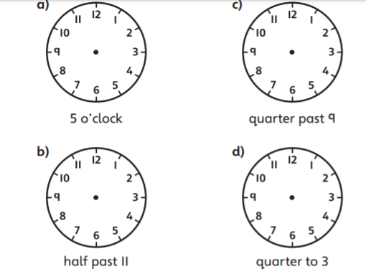

Where would the little and the big hands be pointing on these clocks? Write the answer in your books.

- The hour hand on a clock is more than half-way between 11 and 12. Which of these times could it be.
Quarter to 12
Quarter past 12
Ten past 11
Twenty-five to 12
Half past 11
Five to 12

- How many minutes in:
Half an hour
Quarter of an hour
Three quarters of an hour

Practical Activities that Fit:
Estimate how long you think it will take and then time yourself!
How long will it take you to complete 20 star jumps?
How long will it take you to jump 10 times?

Activity 4: Telling time to 5 minutes
Remember each number on a clock stands for 5! Remember to count in 5’s.
You can always read a clock at different points in the day and tell someone the time!
- What time does each clock show?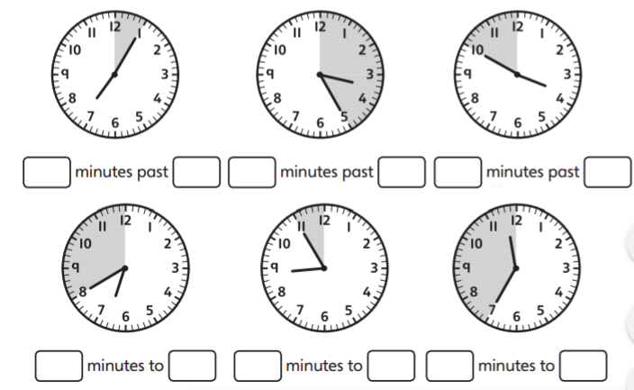
- The minute hand on a station clock is pointing to the 4. The hour hand is pointing between the 6 and 7. What time it is?
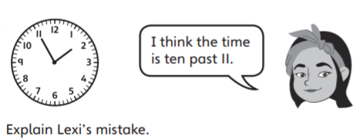
3.

How many can you do in 5?
How many star jumps in 5 minutes?
How many jumps in 5 minutes?
How many sit ups in 5 minutes?
How many lunges in 5 minutes?

Activity 5: Telling the time to the minuteWhat time does the clock show?
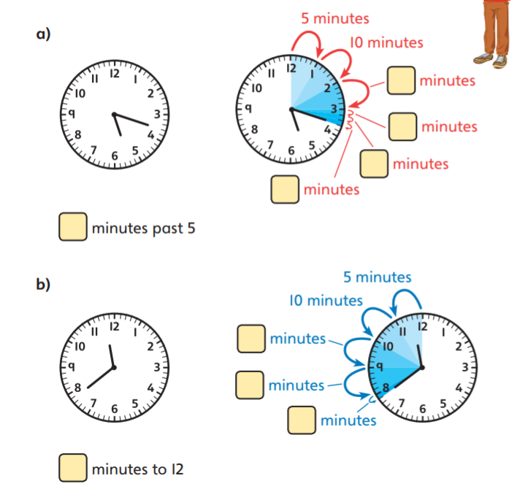
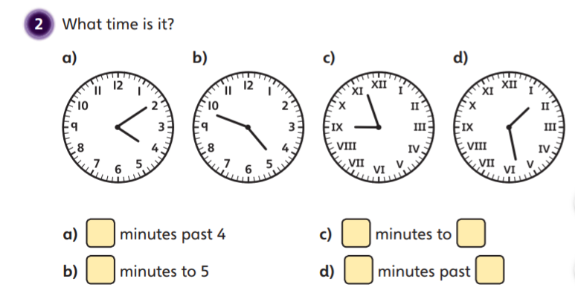

- Practise reading the time to a minute using a clock in your house.

Practical Ideas
How many start jumps in 3 minutes?
How many pencils/ pens can you collect in 7 minutes?
How many minutes can you stay hidden from someone in your house for?

Websites to support you:
https://www.bbc.co.uk/bitesize/topics/zkfycdm
https://www.bbc.co.uk/bitesize/topics/zhk82hv/articles/zcmdwxs
https://www.busythings.co.uk/blog/teaching-children-how-to-tell-the-time-hints-and-tips/
https://www.theschoolrun.com/maths/telling-the-time

