Y6 Curriculum Planning Document – W/C 20th April 2020
Mathematics
Please use the following White Rose resources which will focus on content that pupils would have experience in school during the Summer Term. This content that is covered links directly with our current mathematics scheme within school, Power Maths, just delivered in a different format.
Using this link - https://whiterosemaths.com/homelearning/year-6/ - please access the ‘Summer Term – Week 1’ tab to access the 5 different lessons for this upcoming week:
Lesson 1 – Vertically opposite angles
Lesson 2 – Angles in a triangle
Lesson 3 – Angles in a triangle – special cases
Lesson 4 – Angles in a triangle – missing angles
Friday Maths Challenge!
There is a video for each lesson that children can watch prior to completing the downloadable activity. The independent activity and the answers are also located next to the video – please make sure that your child records their answers in their exercise book provided by school – there is no need to print any resources! Please feel free to also complete any work from your CGP workbooks alongside the guidance above.
English (Reading, Writing and SPaG)
Feel free to use your CPG workbooks to complete one session per day. There is plenty of work within the Reading and SPaG workbooks for you to choose from. We have decided not to set specific pages as each individual child has completed work that is specific to their needs, therefore it is more appropriate for you to work through these at your leisure.
Below are a range of other activities that can be used to cater for English lessons this week:
https://www.pobble365.com/ - Pobble is great way to experiment with creative writing. You will be given a different picture per day to stimulate your learning. Have a go at some of the sections (Perfect Picture, Sentence Challenge or Sick Sentences!) or use the story starter to continue a story of your own!
Weekly Spelling List
Cough
Through
Though
Although
Dough
Thought
Ought
Fought
Nought
Brought
Thorough
Borough

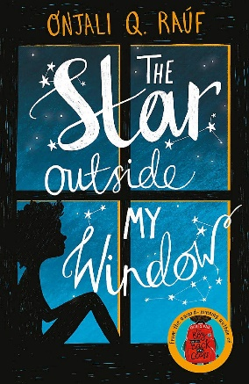
Message from Mr Stewart: I have been reading books during isolation, ones that I thought I may be able to recommend to you! The Star Outside my Window is one that had me hooked –you really connect with the characters whilst reading. Aniyah and her younger brother are foster children and are working on a mission to name a new star after their Mother. Follow their incredible adventure and discuss how being kind and supportive of others can be really rewarding. From the award-winning author Onjali Rauf along with many recommendations from children your age! Go for it and let me know what you think. I have another one on the go at the moment…
Other Curriculum Areas
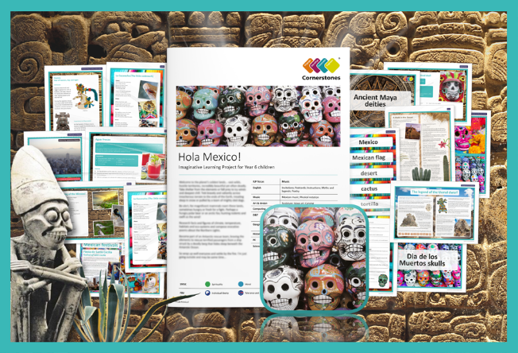
Hola Mexico! – Our new cross-curricular topic for Summer Term 1.
Get ready to explore this unique country, from its towering temples and stunning geography to its pulsing rhythms and fun-packed festivals. Tummy Rumbling? Concoct a traditional fruit cocktail or delicious Mexican meal. What’s on your shopping list this week? Make sure you go steady with the spices though!
Discover the mysterious world of the ancient Maya civilisation. Make their chocolate, yes learn how to and actually make your own chocolate! Learn about their poetry, play their ball game and follow their curious rituals. Feel like celebrating? Design a flute, grab a drum if you have one (or borrow a saucepan) and create your own tribe – make as much noise as you like, as long as that is okay with your parents of course! Go and use the ideas below or go and find out about all of this for yourself, let’s find out if you have what it takes to be chief of the tribe…
We have recommended 5 different activities to have a go at completing this week:
Science - Find out about Mexican flowers, trees and animals. Some are very different to those found in the UK! Record what you learn in a notebook. Be creative! How can you publish this information?
History - Research and find out more about Maya hieroglyphs and symbols. Can you write your name or a short message to a friend? Maybe translate your writing from the Pobble website!
Spanish - In Mexico, the most common spoken language is Spanish. Can you find out how to say some new phrases in Spanish? Do you know anyone who speaks Spanish? Impress them with a Spanish conversation!
PE - https://www.youtube.com/channel/UCAxW1XT0iEJo0TYlRfn6rYQ - Joe Wicks provides a 30 minute workout every morning from 9:00am. This is a great way to start your morning, I have done these myself and they are challenging! The stream goes live from 9:00am, so don’t miss it!
D&T – Create your own Aguas Frescas! This is a refreshing Mexican drink, consisting of fresh fruit, sugar, water and ice.
Ingredients:
- 900g of watermelon, seeded and chopped into 3cm cubes
- 115ml cold water
- 24 mint leaves
- 8 tablespoons of caster sugar
- Slices of lime
- Ice cubes
Method:
- Put the watermelon and the water into a blender, and blend until smooth.
- Share the mint leaves, sugar and lime slices amongst eight glasses and pour in the blended juice.
- Add ice to each glass, stir and serve for a delicious and fruity taste of Mexico!

